Contents
- Intent Statement
- Implementation
- at EHC on a page
- in EYFS
- LTP
- Skills & Progression
- Year group specific Substantive Knowledge
(and how to check it)
- Lesson Design
- Lesson sequencing and planning support for each term – including retrieval

Science Curriculum

Intent Statement

At Endsleigh Holy Child, we encourage children to be inquisitive throughout their time at the school and beyond. Science plays a vital part in our pupils becoming active global citizens. The Science curriculum fosters a healthy curiosity in children about our world and universe, which promotes respect for the living and non-living. We believe science encompasses the acquisition of knowledge, concepts, skills and positive attitudes. The pupils achieve this through working scientifically within the strands of enquiry.

Throughout the topics of study, the children will acquire and develop the key knowledge and vocabulary that has been identified within each unit and across each year group. The key knowledge identified by each year group is informed by the national curriculum and builds towards identified phase ‘end points’ in accordance with National Curriculum expectations. The working scientifically skills are mapped to support progression within the strands of enquiry throughout the school. This model allows children to build upon their prior knowledge and skills while increasing their enthusiasm for the topics, thus embedding this procedural knowledge into the long-term memory.
The curriculum is designed to ensure that children are able to acquire key scientific knowledge through practical experiences; using equipment, conducting experiments, building arguments and explaining concepts confidently. Children are encouraged to ask questions and be curious about their surroundings and a love of science is nurtured through a whole school ethos and a varied science curriculum striving to ignite a passion for the sciences in all pupils.

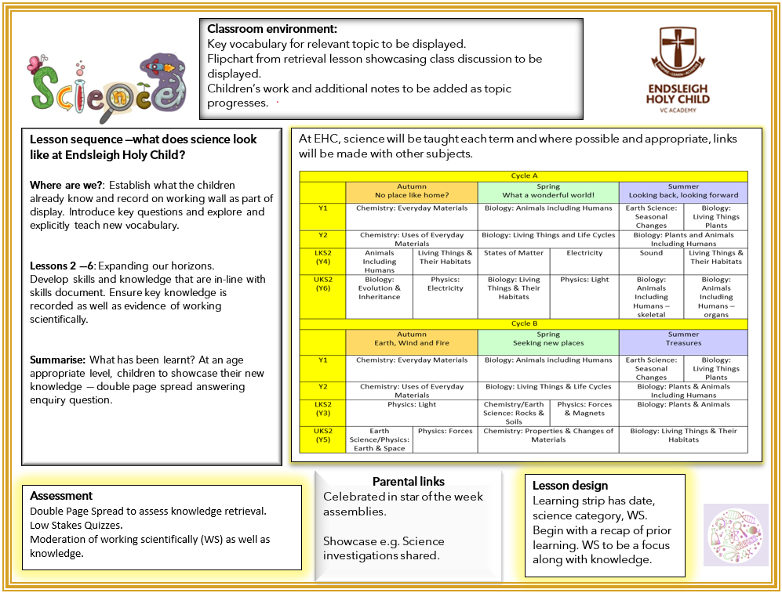
Science on a page

Science in EYFS
The following aspects in KS1 and beyond link back to the EYFS preparation:
• Comments and asks questions about aspects of their familiar world such as the place where they live or the natural world
• Talks about why things happen and how things work
• Developing an understanding of growth, decay and changes over time
• Begin to understand the effect their behaviour can have on the environment
• Looks closely at similarities, differences, patterns and change in nature
• Talks about the features of their own immediate environment and how environments might vary from one another
• Makes observations of animals and plants and explains why some things occur, and talks about changes

Development Matters Objectives
3-4 | Reception
- Use all their senses in hands-on exploration of natural materials.  - Explore collections of materials with similar and/or different properties.  - Talk about what they see, using a wide vocabulary.  - Explore how things work.  - Plant seeds and care for growing plants.  - Understand the key features of the life cycle of a plant and an animal.  - Begin to understand the need to respect and care for the natural environment and all living things.  - Explore and talk about different forces they can feel.  - Talk about the differences between materials and changes they notice. | - Explore the natural world around them.  - Describe what they see, hear and feel whilst outside.  - Understand the effect of changing seasons on the natural world around them.

The Natural World ELG
Children at the expected level of development will:
• Explore the natural world around them, making observations and drawing pictures of animals and plants;
• Know some similarities and differences between the natural world around them and contrasting environments, drawing on their experiences and what has been read in class;
• Understand some important processes and changes in the natural world around them, including the seasons and changing states of matter.

No Place Like Home: Autumn
F1 | F2
- Can I use all my senses in hands-on exploration of natural materials? (3-4) | - Can I use all my senses in hands-on exploration of natural materials? (3-4)  - Can I understand the effect of changing seasons on the natural world around me? (Rec)  - Can I describe what I see, hear and feel whilst outside? (Rec)  - Can I explore the natural world around me? (Rec)

What a Wonderful World: Winter / Growing
F1 | F2
Can I use all my senses in hands-on exploration of natural materials? (3-4)  Can I plant seeds and care for growing plants? (3-4)  Can I understand the key features of the life cycle of a plant and animal? (3-4)  Can I begin to understand the need to respect and care for the natural environment and all living things? (3-4) | Can I plant seeds and care for growing plants? (3-4)  Can I understand the key features of the life cycle of a plant and animal? (3-4)  Can I begin to understand the need to respect and care for the natural environment and all living things? (3-4)  Can I understand the effect of changing seasons on the natural world around me? (Rec)  Can I describe what I see, hear and feel whilst outside? (Rec)  Can I explore the natural world around me? (Rec)

Looking Back, Looking Forward: Materials & Recycling
F1 | F2
Can I explore collections of materials with similar and/or different properties? (3-4)  Can I explore and talk about different forces I can feel? (3-4)  Can I talk about the differences between materials and changes I notice? (3-4) | Can I explore collections of materials with similar and/or different properties? (3-4)  Can I explore and talk about different forces I can feel? (3-4)  Can I talk about the differences between materials and changes I notice? (3-4)  Can I describe what I see, hear and feel whilst outside? (Rec)  Can I explore the natural world around me? (Rec)  ELG: Children at the expected level of development will:  - Explore the natural world around them, making observations and drawing pictures of animals and plants;  - Know some similarities and differences between the natural world around them and contrasting environments, drawing on their experiences and what has been read in class;  - Understand some important processes and changes in the natural world around them, including the seasons and changing states of matter.

Long Term Plan: Cycle A
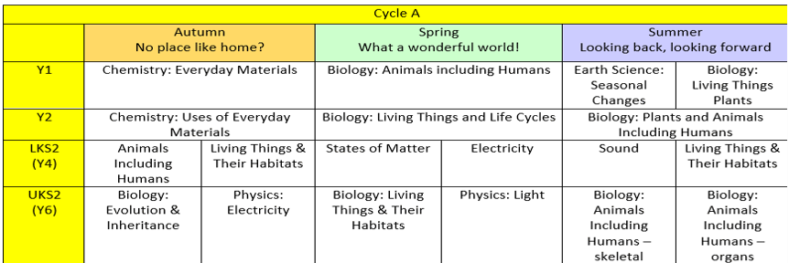

Long Term Plan: Cycle B

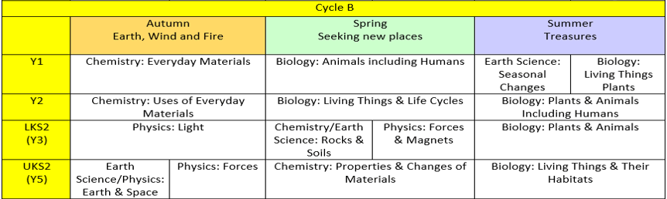

Knowledge: Working Scientifically, Physics, Chemistry, Biology & Earth Science

 | Year 1 | Year 2 | Year 3 | Year 4 | Year 5 | Year 6
Working Scientifically | Know that science is a way to understand our world by carefully thinking about it and testing our guesses with observations and experiments  Know that we can ask questions about the world and that when we observe the world to answer these questions, this is science  Know that we can use magnifying glasses to observe objects closely  Know that we can test our questions to see if they are true  Know that objects can be identified or sorted into groups based on their observable properties  Know that we can write down numbers and words or draw pictures to record what we find | Know that we can ask questions about the world and that when we observe the world to answer these questions, this is science  Know that we can use magnifying glasses to observe objects closely  Know that we can test our questions to see if they are true  Know that objects can be identified or sorted into groups based on their observable properties  Know that we can write down numbers and words or draw pictures to record what we find | Know that we can ask questions and answer them by setting up scientific enquiries  Know how to make relevant predictions that will be tested in a scientific enquiry  Know that in a fair test one thing is altered (independent variable) and one thing that may change as a result is measured (dependent variable) while all other conditions are kept the same  Know how to use a range of equipment to measure accurately, including thermometers, data loggers, rulers and stopwatches  Know how to draw bar charts; how to label a diagram using lines to connect information to the diagram; how to use a coloured key how to draw a neat table; how to draw a classification key; how to show the relationship between an independent variable in a two-way table; and how to label specific results in a two-way table  Know – with structured guidance - how to write a simple scientific enquiry write-up including an introduction, a list of equipment, a numbered method, a detailing of results and a conclusion  Know how to precis a scientific enquiry write-up into a brief oral discussion of what was found in a scientific enquiry  Know that scientific enquiries can suggest relationships, but that they do not prove whether a prediction is true  Know that scientific enquiries are limited by the accuracy of the measurements (and measuring equipment) and by the extent to which conditions can vary even, and that repeating enquiries, measurements and taking measures to keep conditions as consistent as possible can improve an enquiry  Know that the conclusions of scientific enquiries can lead to further questions, where results can be clarified or extended to different contexts (e.g. effect of changing sunlight on a plant – does this work with other plants / different types of light / etc)  Know that they can draw conclusions from the findings of other scientists  Know that a theory is an explanation of observations that has been tested to some extent and that a hypothesis is an explanation that has not yet been tested, but that can be tested through a scientific enquiry | Know that we can ask questions and answer them by setting up scientific enquiries  Know how to make relevant predictions that will be tested in a scientific enquiry  Know that in a fair test one thing is altered (independent variable) and one thing that may change as a result is measured (dependent variable) while all other conditions are kept the same  Know how to use a range of equipment to measure accurately, including thermometers, data loggers, rulers and stopwatches  Know how to draw bar charts; how to label a diagram using lines to connect information to the diagram; how to use a coloured key how to draw a neat table; how to draw a classification key; how to show the relationship between an independent variable in a two-way table; and how to label specific results in a two-way table  Know – with structured guidance - how to write a simple scientific enquiry write-up including an introduction, a list of equipment, a numbered method, a detailing of results and a conclusion  Know how to precis a scientific enquiry write-up into a brief oral discussion of what was found in a scientific enquiry  Know that scientific enquiries can suggest relationships, but that they do not prove whether a prediction is true  Know that scientific enquiries are limited by the accuracy of the measurements (and measuring equipment) and by the extent to which conditions can vary even, and that repeating enquiries, measurements and taking measures to keep conditions as consistent as possible can improve an enquiry  Know that the conclusions of scientific enquiries can lead to further questions, where results can be clarified or extended to different contexts (e.g. effect of changing sunlight on a plant – does this work with other plants / different types of light / etc)  Know that they can draw conclusions from the findings of other scientists  Know that a theory is an explanation of observations that has been tested to some extent and that a hypothesis is an explanation that has not yet been tested, but that can be tested through a scientific enquiry | Know how to choose appropriate variables to test a hypothesis (e.g. plant height as a dependent variable when measuring effect of light on plant growth)  Know how to identify conditions that were imperfectly controlled and can explain how these might affect results  Know how to accurately use further measuring devices, including digital and analogue scales, measuring cylinders and beakers, recognizing the relative accuracy of each device  Know how and when to repeat measurements, how to find an average of a set of measurements and how to recognize and remove outliers from a set of data, justifying the removal as a potential mis-measurement  Know how to independently write a simple scientific enquiry write-up including an introduction, a list of equipment, a numbered method, a detailing of results and a conclusion  Know how to present brief oral findings from an enquiry, speaking clearly and with confidence and using notes where necessary  Know examples of instances where scientific evidence has been used to support or refute ideas or arguments (e.g. fossil records as evidence of natural selection) | Know how to choose appropriate variables to test a hypothesis (e.g. plant height as a dependent variable when measuring effect of light on plant growth)  Know how to identify conditions that were imperfectly controlled and can explain how these might affect results  Know how to accurately use further measuring devices, including digital and analogue scales, measuring cylinders and beakers, recognizing the relative accuracy of each device  Know how and when to repeat measurements, how to find an average of a set of measurements and how to recognize and remove outliers from a set of data, justifying the removal as a potential mis-measurement  Know how to independently write a simple scientific enquiry write-up including an introduction, a list of equipment, a numbered method, a detailing of results and a conclusion  Know how to present brief oral findings from an enquiry, speaking clearly and with confidence and using notes where necessary  Know examples of instances where scientific evidence has been used to support or refute ideas or arguments (e.g. fossil records as evidence of natural selection)
Physics |  |  | Know that science is a way to understand our world by carefully thinking about it and testing our guesses with observations and experiments  Know that light is a form of energy  Know that energy comes in different forms and can be neither created nor destroyed, only changed from one form to another  Know that we need light to see things and that darkness is the absence of light  Know that light travels in straight lines  Know that light is reflected when it travels from a light source and then ‘bounces’ off an object  Know that everything that we can see is either a light source or something that is reflecting light from a light source into our eyes  Know that the Sun is a light source, but that the Moon is not and is merely reflecting light from the Sun  Know that many light sources give off light and heat  Know that the Sun gives off light and heat when hydrogen turns into helium  Know that filaments in traditional bulbs heat up until they glow, giving off light and heat  Know that fluorescent bulbs glow when electricity adds energy to a gas within the bulb  Know that opaque objects block light creating shadows and that light passes easily through transparent objects  Know that opacity/transparency and reflectiveness are properties of a material  Know that sunglasses can protect eyes from sunlight but looking at the Sun directly – even with sunglasses – can damage the eyes  Know that as objects move towards a light source, the size of the shadow increases  Know how to show the changing of shadow size by drawing a diagram with straight lines representing light  Know that a data logger can keep track of light levels and that this can be plotted on a graph to show how this changes over the course of a day  Know that Hasan Ibn al-Haytham - sometimes known as Alhazen - was a scientist and mathematician during early Islamic civilisation  Know that al-Haytham was the first to explain that we see objects because light reflects from objects into our eyes  Know that al-Haytham was an early pioneer of the scientific method which used evidence to find things out about the world  Know that science is a way to understand our world by carefully thinking about it and testing our guesses with observations and experiments  Know that metal is a material from which objects can be made  Know that as objects move across a surface there is friction when they rub against each other and that sometimes this friction is larger or smaller  Know that applying forces to objects can change their shape  Know that the roughness of a material is an example of a property  Know that a force can be thought of as a push or a pull  Know that there are different types of contact force: impact forces (when two surfaces collide), frictional forces (when two surfaces are already in contact) and strain forces (when an elastic material is stretched or squashed)  Know that objects move differently on rough and smooth surfaces; objects resist movement more on rough surfaces because there is higher friction as the object moves  Know that there are also non-contact forces that can act between objects without them touching and that magnetism is an example of a non-contact force  Know that magnets have two poles called north and south  Know that like poles (south-south and north-north) of two magnets repel each other and that opposite poles of two magnets (north-south) attract each other  Know that there is a magnetic field around a magnet which is strongest at each pole (see diagram below)  Know that some materials are magnetic, meaning that they are attracted to a magnet, while other materials are non-magnetic | Know that sound is generated when an object vibrates; some of the energy from the vibrating object is transferred to the air, making the air particles move  Know that sound is a form of energy that transfers in a longitudinal wave - like that seen in a slinky - not a transverse wave - like that seen in water ripples Know that sound travels through a medium (e.g. particles in the air) and thus sounds does not travel through a vacuum which has no particles in it at all  Know that longitudinal sound waves are detected in the ear by humans and that the brain interprets this as the sounds we hear  Know that sound travels at different speeds through different objects; it travels at around 340 metres per second in air, much slower than light travels; this is why we often hear thunder after we see lightning as the light reaches our eye before the sound reaches our ears  Know that pitch is how high or low a sound is and that this is determined by how many vibrations per second are being made by the vibrating object; the number of vibrations per second is called frequency  Know that volume is how loud or quiet a sound is and that this is determined by the amount of energy in the wave (e.g. from how hard or soft a percussion instrument is hit)  Know that the volume of a sound is quieter if the listener is further away from the object  Know that there are many kinds of jobs as a scientist including communicator scientist, teacher scientist, technician scientist, explorer scientist, entrepreneur scientist, regulator scientist, investigator scientist and developer scientist  Know that investigator scientists to make connections between different areas of science  Know that developer scientists find new uses for scientific discoveries that other people hadn’t thought of  Know that electrical energy is one of many forms of energy  Know that static electricity is an imbalance of charged particles on a material; it does not operate by flowing around a complete circuit  Know that current electricity is the flow of charged particles called electrons around a circuit  Know that current electricity is the form of electricity that we use in our lives in lights, computers, televisions, etc  Know that electrical current flows well through some materials, called electrical conductors, and poorly through other materials, called electrical insulators  Know that conductors have free electrons (tiny, negatively charged particles) and that when electrical current flows around a conductor the electrons move  Know that electrical conductivity (how well a material conducts electricity) is an example of a property  Know that metals are good electrical conductors  Know that a chemical reaction inside a cell produces the charged particles that can flow around a circuit  Know that more than one cell lined up to work together is called a battery  Cells, batteries and the mains are all sources of electrical energy  Know that electrical current can flow if there is a complete circuit  Know that wires – which contain a conductor inside them, usually made of metal – can allow electrical current to flow around a circuit  Know that when electrical current flows through a circuit components within that circuit – such as buzzers which make a noise and bulbs which emit light – begin to work  Know that a switch functions by completing or breaking a complete circuit  Know how to construct a simple circuit using components  Know that exposure to high levels of electrical current can be dangerous  Know that Michael Faraday was a scientist who studied electricity  Know that he invented the electric motor and showed that the movement of a magnet could create electricity, which is the reason we can generate electricity to power our world  Know that he is considered “the father of electricity” | Know that a force is measured in a unit called Newtons, named after a British scientist called Sir Isaac Newton who discovered lots about gravity and how planets move  Know that Newton was undoubtedly one of the greatest scientists who ever lived, a genius who discovered a great deal about forces, including gravity, mathematics and light  Know that pull forces can be measured using a device called a force meter  Know that the amount of matter (stuff) in an object is its mass  Know that gravity is a force that acts between all objects in the universe, but that it acts much more strongly between objects that have more mass and that are close together  Know that unsupported objects are pulled towards the Earth by the force of gravity  Know that acceleration is a change in speed and that unbalanced forces acting on an object cause it to accelerate  Know that air resistance is a force felt by an object as it moves through the air; it is caused by the object bumping into the gas particles that make up air; the quicker an object moves, the more gas particles it bumps into and the more air resistance it experiences  Know that a falling object will accelerate until its air resistance matches the gravitational force pulling it down; at this point, the object will continue to move at this speed (called its terminal velocity) without getting any quicker or slowing down (see diagram below)  Know that a parachute’s shape increases the air resistance that a falling object experiences, giving it a much lower terminal velocity  Know that water resistance is a force felt by an object as it moves through water; it is caused by the object bumping into the water particles  Know that the shape of an object determines how much air resistance or water resistance it experiences; shapes of object that experience little air resistance or water resistance are described as streamlined  Know how to draw a force diagram with arrows representing the different forces acting on an object  Know that a lever is a rigid length pivoting around a fulcrum  Know that a pulley is a wheel with a fulcrum that supports a moving cable or belt (see diagram below)  Know that a gear is a rotating wheel with cut teeth that mesh with the teeth of another gear so that turning one gear turns an adjacent gear in the opposite direction  Know that gears, levers and pulleys are simple machines that are used to allow a smaller force to have a greater effect; they do this by moving a smaller force over a longer distance at one end of the machine, which the machine turns into a larger forcer over a small distance at the other end | Know that translucent objects allow some light to pass through, but some of the light changes direction as it passes through the object; this means that an something seen through a translucent object is not clearly defined (see diagram below)  Know that when light passes from one medium to another (e.g. from air to water), it changes direction; this is called refraction; this happens because light travels at different speeds in different media  Know that white light comprises all the colours of light  Know that white light refracted by two surfaces in a prism will spread out so that all of its constituent colours can be seen; this array of colours is called a spectrum; it happens because the different colours that constitute white light travel at different speeds  Know how to draw a diagram to show why the shape of a shadow will match the shape of an object  Know that when light reflects off an object, the angle of incidence is equal to the angle of reflection  Know that a periscope takes advantage of the predictable angles of incidence and reflection to allow an image to be shown to a viewer  Know how to draw simple circuit diagrams  Know the recognized symbols for a battery, bulb, motor, buzzer and wire  Know how to predict whether components will function in a given circuit, depending on whether or not the circuit is complete; whether or not a switch is in an on or off position; and whether or not there is a cell to provide electrical current to the circuit  Know that voltage is a measure of the power of a cell to produce electricity; it is a measure of the ‘push’ of electric current, not the size of the electric current  Know that as the number and voltage of cells in a circuit increases, the brightness of a bulb or the volume of a buzzer will increase (though too high a voltage may ‘blow’ the bulb or buzzer)  Know that two bulbs in a circuit can be wired up to create a series circuit or a parallel circuit; if one bulb blows in a series circuit the other will not shine as the circuit has been broken; in contrast, if one bulb blows in a parallel circuit (see diagram below), there will still be a complete circuit for the other bulb so it will continue to shine; use this knowledge to explain the advantages of using parallel circuits (e.g. in the lighting in homes)
Chemistry | Know that an object is made from/of a material and know some examples of materials in the real world  Know that materials can be hard, soft, strong, weak, absorbent, heavy, light, solid and runny, smooth and rough; these descriptions denote the properties of a material  Know from observation how to distinguish between materials made of wood, plastic, glass, metal, water, rock  Know that matter (stuff) is made from tiny building blocks | Know that science is a way to understand our world by carefully thinking about it and testing our guesses with observations and experiments  Know that objects are made from materials such as wood, plastic, glass, metal, water, rock  Know that materials have properties such as being hard, soft, strong, weak, absorbent, heavy, light, solid, runny, smooth and rough; these descriptions denote the properties of a material  Know that matter (stuff) is made from tiny building blocks  Know that materials can have useful properties for a given job (including being waterproof, strong, hard, soft, flexible, rigid, light or heavy.)  Know that many types of plastic are waterproof, that steel (a type of metal) is strong, that rock is hard, that cotton wool is soft, that rubber is flexible, that rock is rigid, that polystyrene (a type of plastic) is light and that iron (a type of metal) is heavy,  Know that when objects move across a surface there is friction when they rub against each other and that sometimes this friction is larger or smaller  Know that applying forces to objects can change their shape, by squeezing, stretching, bending and twisting  Know that Isambard Kingdom Brunel was a famous scientist who used materials to build impressive and important things; know that he was an engineer  Know that Brunel lived in the Victorian era and that he designed steamships, railways, bridges, tunnels and dockyards |  | Know that things are composed of a matter commonly in one of three states of matter: solid, liquid or gas  Know that things are made of particles (tiny building blocks) and that these are organized differently in different states (see diagram below)  Know that materials can change state when temperature changes  Know that there are bonds between the particles (building blocks) in a solid; as temperature increases, these bonds are somewhat overcome as the particles absorb energy and solids can change into liquids; with a further increase in temperature, the particles become even more energetic and the bonds are overcome entirely so the liquid changes into a gas  Know that when solids turn into liquids, this is called melting and that the reverse process is called freezing (see diagram below)  Know that when liquids turn into gases, this is called evaporation and that the reverse process is called condensation (see diagram below)  Know that when a solid turns into a gas without passing through the liquid state, this is called sublimation (see diagram below)  Know that the melting point of water is 0º C and that the boiling point of water is 100º C  Know that water flows around our world in a continuous process called the water cycle (see diagram below)  Know that, along with evaporation, water on the Earth’s surface moves to the air in a process called transpiration in which water turns into water vapour (gas) on the surface of leaves on plants  Know that rain condenses in clouds and falls to earth as rain, snow or hail in a process called precipitation  Know that water flows across the land in rivers and streams in a process called surface run-off and under the ground as groundwater | Know that materials can be sorted in a variety of ways based on their properties  Know that in some solid materials the bonds between particles break when surrounded by a liquid; this allows the liquid to absorb the solid; when this happens, the solid is called a solute, the liquid is called a solvent and the result is a solution; when a solid does dissolve in a liquid it is described as being soluble in that solvent (e.g. sugar in water); when it cannot it is insoluble (e.g. sand in water)  Know that a given amount of solvent can only absorb a certain amount of solid before no more will dissolve; when this happens the liquid is said to be saturated  Know that when a solvent is evaporated from a solution, the original solute is left behind; the remaining solid will often form crystals – the slower the solvent evaporates, the larger the crystals that will be formed  Know how to dissolve a solute in a solvent and then how to evaporate the solvent to recover the solute  Know that a reversible change is one that can be reversed and that examples of this are mixing, dissolving and changes of state where no chemical reaction takes place  Know that an irreversible change is one that cannot be reversed and that examples of this often involve a chemical change where a new material is made, often a gas (e.g. burning, boiling an egg, the reaction of bicarbonate of soda and acid)  Know that filtering allows solids and liquids to be separated and that sieving allows solids made up of different sizes parts to be separated  Know how to separate a mixture of sand, salt and small stones by sieving (to remove the small stones), followed by dissolving in water (so the salt is absorbed), followed by filtering to remove the sand from the mixture, followed finally by evaporation of the water to recover the salt.  Know that materials’ different properties can be tested through acting upon them, including testing to find whether materials are magnetic, thermally conductive and electrically conductive; know that the various properties of different materials make them suitable for a given function  Know how to explain orally and in writing the reasons why various materials are suited or unsuited to a function  Know that Marie Curie was a genius physicist, earning two Nobel Prizes  She discovered two new elements (the building blocks of everything) and made discoveries that suggested that atoms - which were thought to be the smallest building blocks - could be divided into smaller building blocks still
Biology | Know that a trout is an example of a fish; a frog is an example of an amphibian; a lizard is an example of a reptile; a robin is an example of a bird; a rabbit and a human are examples of a mammal and explore further examples of each animal type  Know that herbivorous animals eat plants; carnivorous animals eat other animals; omnivorous animals eat both animals and plants  Know that a cat is an example of a carnivore; that a rabbit is an example of a herbivore; know that many humans are examples of omnivores (though not vegetarians)  Know that fish, amphibians, reptiles, birds and mammals are similar in that they have internal skeletons and organs; these are known as vertebrates, which means they are animals that have a backbone  Know that fish are different to other animals in having gills so that they can breathe underwater and scaly skin  Know that amphibians are different to other animals in that they begin their lives with gills but then develop lungs and breathe on land  Know that reptiles are different to other animals in that they breathe air and have scaly skin  Know that birds are different to other animals in that they have feathers and wings  Know that mammals are different to other animals in that they have fur/hair and they feed milk to their young  Know that feet, legs, arms, hands, torso, head, skin, ears, eyes, nose, mouth and tongue are parts of the body and identify them  Know that eyes are associated with sight, ears with sound, nose with smell, tongue with taste and skin with touch  Know that Ibn Sina (known also as Avicenna) was a scientific genius during early Islamic civilisation  Know that he wrote books about medicine and healing people  Know that he helped guide the modern world towards the idea of using evidence in medicine  Know that he also made major contributions to other areas of science, mathematics and philosophy  Know a rose bush, a sunflower and a dandelion by sight  Know an oak tree, a birch tree and a horse chestnut tree by sight  Know that evergreen trees maintain their leaves throughout the year and that deciduous trees shed their leaves in autumn  Know that a flowering plants consist of roots, stem, leaves and flowers, and that a tree’s stem is called a trunk  Know that there are many kinds of jobs as a scientist including communicator scientist and teacher scientist  Know that teacher scientists teach others - often children - about science  Know that communicator scientists help the world to understand about science  Know that David Attenborough is a famous communicator scientist who has created and presented some of the most famous television programmes ever made about plants and animals | Know that dandelions, rose bushes, grass, ash trees, birch trees and conifers trees are examples of plants.  Know that trees can be deciduous or evergreen.  Know that a trout is an example of fish, a frog is an example of an amphibian; a lizard is an example of a reptile; a robin is an example of a bird; a rabbit and a human are examples of a mammal  Know that herbivorous animals eats plants; a carnivorous animal eats other animals; omnivorous animals eat both animals and plants  Know that living things move, grow, consume nutrients and reproduce; that dead things use to do these things, but no longer do; and that things that never lived have never done these things.  Know that there are many kinds of jobs as a scientist including communicator scientist, teacher scientist, technician scientist and explorer scientist  Know that technician scientists are scientists that help other scientists to do their job  Know that explorer scientists try to find out new things that no one has ever learned before; many of the most famous scientists in history were explorer scientists  Know that light is a form of energy  Know that plants absorb energy from the Sun; that this energy is consumed by herbivorous animals; and that carnivorous animals eat other animals  Know that the arrows on a food chain show the direction that the energy travels  Know that polar bears are an example of an animal adapted to its environment – thick fur for warmth and oily paw pads to ensure that they don’t freeze to the ice  Know that sharks are another example – smooth skin and streamlined shape for quick swimming; and gills for breathing underwater  Know that cacti are an example of a plant adapted to its environment – thick skin keeps a store of water safe; sharp spikes keep animals from stealing the water  Know that pine trees are adapted to their environment in that they have thick bark and pine cones to protect against cold winters  Know that woodlice live under logs – an example of a microhabitat - as they need somewhere dark and damp so that they do not dry out  Know that frogs can live in ponds – an example of a microhabitat - as they water in which to lay their eggs (frogspawn)  Know that science is a way to understand our world by carefully thinking about it and testing our guesses with observations and experiments  Know that living things move, grow, consume nutrients and reproduce; that dead things use to do these things, but no longer do; and that things that never lived have never done these things  Know that seeds and bulbs need to be buried underground in soil and that they will grow into adult plants under the right conditions (water, warmth)  Know that plants that are deprived of light, food or air will not grow and will die.  Know that plants and animals produce offspring that grow into adults.  Know that George Washington Carver was a practical scientist and inventor  Know that he helped farmers in America to grow more crops by showing them the benefits of growing different things at different times and of using fields for different crops  Know that animals, including humans, need food, water and air to survive  Know the basic food groups: fruit and vegetables, carbohydrates, protein, dairy, fat and sugary foods  Know that proteins are good for growth, carbohydrates for energy and fruit and vegetables provide vitamins and minerals which help keep us healthy (e.g. calcium for healthy bones and teeth)  Know that more than half of our diet should be made up of carbohydrates, fruit and vegetables (see diagram below)  Know that fats and sugary foods should be eaten rarely and in small amounts  Know that people need to exercise often to help their body stay strong and fit  Know that keeping clean, including washing and brushing teeth, is an important part of staying healthy | Know that science is a way to understand our world by carefully thinking about it and testing our guesses with observations and experiments  Know that evergreen trees maintain their leaves throughout the year and that deciduous trees shed their leaves in autumn  Know that flowering plants consist of roots, stem, leaves and flowers, and that a tree’s stem is called a trunk  Know that living things move, grow, consume nutrients and reproduce; that dead things use to do these things, but no longer do; and that things that never lived have never done these things.  Know that plants absorb energy from the Sun; that this energy is consumed by herbivorous animals; and that carnivorous animals eat other animals.  Know that seeds and bulbs need to be buried underground in soil and that they will grow into adult plants under the right conditions (water, warmth)  Know that the arrows on a food chain show the direction that the energy travels.  Know that plants that are deprived of light, food or air will not grow and will die.  Know that animals, including humans, need food, water and air to survive  Know that there are food groups: fruit and vegetables, carbohydrates, protein, dairy, fat and sugary foods  Know that more than half of our diet should be made up of carbohydrates, fruit and vegetables  Know that fats and sugary foods should be eaten rarely and in small amounts  Know that different parts of plants have one or more functions (jobs)  Know that the roots collect water and minerals from the soil, and hold the plant firmly in the ground  Know that the stem holds up the leaves so that they can gather light to make food and holds up the flowers so that they can receive pollen and disperse their fruits; know that the stem also transports water and minerals from the roots to the other parts of the plant  Know that the leaves make food by absorbing light and using its energy to turn carbon dioxide and water into carbohydrates  Know that the function of a flower is reproduction, where flowers of the same kind exchange pollen – made by an anther – in a process called fertilisation, and a structure in the flower’s ovary called an ovule becomes a seed; the ovary then becomes a fruit which helps the seed leave the plant in a process called dispersal  Know that animals, including humans, have a skeleton made up of solid objects  Know that some animals (such as insects) have an exoskeleton – a solid covering on the outside of their body  Know that many invertebrates (such as earthworms and slugs) have water held inside by muscles which acts like a skeleton  Know that skeletons provide support for muscles and protect the body; for example, the rib cage protects the vital organs in the human body  Know that human skeletons are made up of bones and cartilage  Know that muscles can only contract, so they must be arranged in pairs in the body so that as one contracts the other loosens  Know that excess of a food group can cause ill health, such as tooth decay due to excess sugar  Know that excess fat from fatty foods such as butter and cheese - and created in the body from excess calories – builds up in the body and can cause obesity  Know that excess body fat can lead to heart disease and increases the strain on joints and growing bones  Know that there are many kinds of jobs as a scientist including communicator scientist, teacher scientist, technician scientist, explorer scientist, entrepreneur scientist and regulator scientist  Know that entrepreneur scientists are people who use things learned in science to start new businesses and make money  Know that regulator scientists use science to make sure things that people use are reliable and safe | Know that food passes through the body with the nutrients being extracted and the waste products excreted, and that this process is called digestion  Know that the process of digestion involves breaking complex foodstuffs into simpler building blocks that can be absorbed by the body  Know that the process of digestion begins with food being chewed in the mouth by the teeth and saliva added  Know that a human has three types of teeth – incisors, canines and molars – and that these each perform different functions  Know that incisors slice food, canines tear food (especially meat) and that molars grind food  Know that children develop an initial set of teeth which are gradually replaced between the ages of 6 and 12  Know that food is squeezed down the oesphagus towards the stomach in a wave-like action called peristalsis (see diagram below)  Know that the stomach releases acid and enzymes to continue breaking down the food; the stomach is an organ; an organ is a part of living thing that is self-contained and has a specific important job  Know that further enzymes and bile break down the food further as it moves through the duodenum towards the small intestine  Know that the small intestine adds more enzymes and then absorbs the nutrients  Know that the large intestine absorbs water from the undigested food  Know that undigested food is stored in the rectum before being excreted through a muscle called the anus  Know that a food chain traces the path of energy through a habitat  Know that the arrows in a food chain show the direction that energy is travelling through a habitat  Know that all energy for a food chain initially comes from the Sun which is absorbed and turned into energy by plants which are called producers  Know that consumers take in energy by eating  Know that an animal that is eaten by another is called prey, and that an animal that eats other animals is called a predator  Know that the first consumer in a food chain is called a primary consumer, the second is called a secondary consumer and above it is called a tertiary consumer  Know that animals can be grouped based on their physical characteristics (e.g. vertebrates and invertebrates) and based on their behavior (e.g. herbivores, carnivores and omnivores)  Know that living things are divided into kingdoms: the animal kingdom, plants, fungi, bacteria, and single-celled organisms  Know that a species is a group of living things have many similarities that can reproduce together produce offspring  Know that a classification key uses questions to sort and identify different living things  Know how to use a classification key to identify living things  Know how to create a classification key to sort plants on the school premises  Know that changes to the environment can make it more difficult for living things to survive and reproduce; in extreme cases this leads to extinction, where an entire species dies  Know that human activity – such as climate change caused by pollution - can change the environment for many living things, endangering their existence  Know that many species of living things have already been made extinct as a result of human activity  Know that the polar bear is a famous example of climate change endangering the existence of a species; as the climate changes and gets warmer, the sea ice on which polar bears live reduces in amount making it harder for them to survive and reproduce  Know that Carl Linnaeus was a famous scientist who studied life and created a system for sorting living things into different groups  Know that the concept of species and kingdoms (such as the animal kingdom or the plant kingdom) was his invention, and that all living things are given a name that uses his method of classification | Know that the life cycle of a living thing is a series of stages of development starting with a fertilized egg in animals or a seed in many plants  Know that in most mammals (e.g. dogs) a fertilized egg develops in the womb into an embryo and is then born and fed on milk before it is weaned onto the food that is adapted to eat; it then develops to maturity in a period called adolescence after which it can reproduce and the cycle can begin again  Know that in amphibians (e.g. frogs) a fertilized egg develops into an embryo and then hatches into a tadpole; the tadpole develops adult characteristics, metamorphoses into the adult form after which it can reproduce and the cycle can begin again (see diagram below)  Know that in many insects (e.g. butterflies) a fertilized egg develops into wingless feeding form called a larva (caterpillar); the larva feeds then later becomes a pupa (chrysalis) with a protective cocoon; inside this cocoon, the pupa metamorphoses into the adult butterfly after which it can reproduce and the cycle can begin again (Know that in birds (e.g. robins) a fertilized egg hatches in a nest (a hatchling) and is fed by its parents until it is ready to fly (i.e. becomes a fledgling); it then leaves the nest and grows into an adult after which it can reproduce and the cycle can begin again  Know that humans go through stages of development; they begin as fertilized eggs and then develop into embryos before developing into babies; once they are born, these newborn babies become infants (roughly 2 months to 2 years) then into young children (roughly 2-12 years old); children develop into adults during adolescence (roughly 12-16 years old) at which age they become physically capable of reproduction; as adults develop into old age (roughly 55+ years old) they experience changes in their body which require them to move more carefully and rest more frequently  NB: the changes of adolescence in humans is taught as part of mandatory sex and relationship education; it must be taught with due sensitivity to children’s backgrounds and must reflect the PSHE curriculum | Know that there are three types of micro-organism: viruses, fungi and bacteria; of these three, viruses are often not really considered to be alive by many scientists mainly because they don’t have the ‘machinery’ to reproduce inside them  Know that germs are disease-causing micro-organisms  Know that an arthropod is an invertebrate with a hard, external skeleton and jointed limbs  Know that insects are a type of arthropod; their bodies consist of six legs, a head, a thorax and an abdomen; most insects also have a pair of antennae and a pair of wings (e.g. wasp) (see diagram below)  Know that an arachnid (e.g. spider) is a type of arthropod with eight legs and no antennae or wings (see diagram below)  Know that a crustacean is a type of arthropod with two pairs of antennae (e.g. woodlouse) (see diagram below)  Know that a myriapod is an arthropod with a flat and long or cylindrical body and many legs (e.g. centipede) (see diagram below)  Know that Jane Goodall is an anthropologist, most famous for her study of chimpanzees, of which she is considered the world’s foremost expert  Know that Goodall discovered that chimpanzees are much more intelligent than they had ever been thought to be  Know that Goodall is also a conservationist and environmentalist, which means she does important work to help protect the planet, in particular animal habitats  Know that all life on Earth began from a single point around 4.5 thousand million years ago  Know that living things change over time and that this gradual change is called evolution  Know that natural selection is the cause of this change; natural selection works as there is natural variation within a species; there is also competition to survive and reproduce and that members of a species with advantageous characteristics survive and reproduce - these characteristics are passed down to their offspring; members of a species with less advantageous characteristics do not survive and reproduce – these characteristics are not passed down to offspring (see diagram below)  Know that offspring vary and are not identical to their parents  Know that the gradual change of species over millions of years can be observed by looking at examples of fossils  Know that Charles Darwin posited this theory of evolution by natural selection  Know that Darwin was a naturalist whose theory of evolution by natural selection developed while travelling through the Amazon rainforest  Know that Darwin’s theory is accepted as fact by the scientific community  Know that Darwin did not know similarities were passed between parents and their offspring; know DNA, a chemical discovered in the 20th century, is contains the “code” that passes on information between parents and their offspring in all living things  Know the names of key bones in the body, including the rib cage, cranium, mandible, sternum, vertebrae, femur, tibia, fibula, patella, humerus, radius and ulna; know how to label these on a diagram of the human body  Know that an adult human body has 206 bones, the longest of which is the femur  Know that the heart and lungs are organs protected by the ribcage and understand this as a part of the skeleton  Know that the heart beats, pumping blood around the body and that blood vessels carry the blood; arteries carry blood away from the heart; veins carry blood towards the heart; capillaries are tiny blood vessels that connect arteries and veins  Know that the heart is composed of four chambers: two atria and two ventricles; the aorta is the largest artery in the body and most major arteries branch off from it (see diagram below)  Know that blood travels around the body transporting nutrients that have been absorbed into the bloodstream from digestion; blood also absorbs oxygen from the lungs and carries it around the body which is used to power the body; this use of oxygen to create energy is called respiration  Know that when we exercise, our heart beats more frequently so that the oxygen that is used around the body can be replenished; it returns to a resting heart rate afterwards; fitter people tend to have lower resting heart rates  Know that drugs are chemicals that have an impact on the natural chemicals in a person’s body; know that drugs can be harmful or helpful, depending on what they are and how they are used; know that all drugs can be harmful if overused  Know that paracetamol and aspirin are examples of drugs that can be helpful as a painkiller  Know that cannabis and cocaine are examples of illegal drugs that can have serious negative effects  Know that alcohol and tobacco are examples of drugs that are legal to adults but that can have serious negative effects, such as liver disease and lung disease, respectively  Know that there are many kinds of jobs as a scientist that fall into these categories: communicator scientist, developer scientist, entrepreneur scientist, explorer scientist, investigator scientist, regulator scientist, teacher scientist, technician scientist, policy scientist and business scientist  https://sciencecouncil.org/about-science/10-types-of-scientist/  Know that policy scientists use their science and technical knowledge, as well as their understanding of government and policy making, to ensure that legislation and policy have a sound evidence base. Some policy scientists describe themselves as 75% scientist and 25% politician.  Know that a business scientist helps businesses to make evidence-informed decisions
Earth Science | Know that days are longer in the summer and shorter in winter  Know that weather changes through the year, getting hotter in the summer and colder in the winter  Know that the four seasons are spring, summer, autumn and winter and know the order of the cycle  Know that the winter is likely to bring ice on the ground when water freezes due to the cold  Know that the Earth orbits the Sun with one orbit constituting a year of 365/366 days |  | Know that the Earth has a solid crust made up of tectonic plates with molten rock beneath  Know that there are three kinds of rocks: igneous, sedimentary and metamorphic  Know that granite and basalt are types of igneous rock and that igneous rocks form from molten rock below the Earth’s crust  Know that limestone and sandstone are types of sedimentary rock which form when small, weathered fragments of rock or shell settle and stick together, often in layers  Know that marble and slate are types of metamorphic rock which form when rocks in Earth’s crust get squashed and heated in processes such as when tectonic plates press against each other  Know that fossils form when a plant or animal dies and is quickly covered with silt or mud so that it cannot be rotted by microbes or eaten by scavenging animals; in time layers of sediment build, squashing the mud and turning it to stone around the dead plant or animal; the materials in the body are replaced by minerals that flow in water through the rock, leaving a rock in the shape of the animal or plant that was once there  Know that fossils can help us learn about things that lived long ago  Know that soil is made from tiny particles of rock broken down by the action of weather (weathering)  Know that Zhang Heng was a genius in many areas: he was a scientist, mathematician, poet, inventor and artist  Know that Zhang Heng invented the world’s first seismoscope that was able to detect where and when earthquakes had happened (when the Earth’s tectonic plates suddenly shift causing massive vibrations |  | Know that the universe comprises all matter and space in existence  Know that a celestial body is a large object in the universe  Know that a star is an exceptionally hot ball of gas, originally made from hydrogen and helium  Know that the Sun is a star  Know that a planet (e.g Earth) is defined as a spherical celestial body that orbits a star and that has cleared the neighbourhood of its orbit of other objects, some of which crash into the planet and others that become moons of that planet  Know it was once thought that everything orbited the Earth, but that scientists like Copernicus and Galileo used telescopes and measurement to show that the Earth orbited the Sun  The Sun and the objects that orbit it are collectively known as our Solar System  Know that there are eight major planets in our solar system: Mercury, Venus, Earth, Mars, Jupiter, Saturn, Uranus, Neptune  Know that a satellite orbits a planet and that moons are natural satellites  Know that humans have sent man-made satellites into orbit that assist with telecommunication  Know that all the planets in the solar system orbit the Sun and that the further away they are from the Sun, the longer their orbit  Know that the Earth spins around an imaginary line through its centre called an axis and that this axis is tilted relative to the Earth’s orbit  Know that night and day are the result of the Earth rotating on its axis  Know that the tilt of the Earth towards and away from the Sun’s light as the Earth orbits the Sun leads to the seasons as during winter the light is spread over a wider area (see diagram below)  Know that the Moon orbits the Earth roughly every 28 days  Know that as the Moon orbits the Sun, different parts of it are lit up by the Sun, which is why we see a different shape lit up on the Moon as the lunar cycle progresses; these are called phases of the Moon  Know that a solar eclipse occurs when the Moon is between the Sun and the Earth, casting a shadow on the Earth; a lunar eclipse occurs when the Earth is between the Sun and the Moon, casting a shadow on the Moon  Know that Katherine Johnson was a scientist and mathematician from America  She worked for NASA and her calculations and work were critical to the success of the first and subsequent manned space flights  She was one of the first black women to attend an integrated university in her state, West Virginia, having been handpicked due to her ability
aluating
Food

Mechanisms/Mechanical Systems

Knowledge Preload to assist with retrieval

Background Information
In collaboration with Hull Collaborative Academy Trust (HCAT), we developed a preload system in which knowledge was identified that would link with future learning. Whether it be specific vocabulary or application of scientific skills, its ‘current’ topic was identified as well as the future topic in which it would be taught further along the pupils’ learning journey here at EHC.

The preload documents work alongside unit overviews and knowledge strands which track a science topic across the learning journey from EYFS through to Y6
This development of our science curriculum follows the process of our research, especially on the retrieval and retainment of key knowledge throughout a pupil’s learning journey through well sequenced lessons and long term plans.

The knowledge preload documents form a vital part of the sequencing of our long term plans and give extra opportunity for exposure to subject specific knowledge and vocabulary to aid future learning.

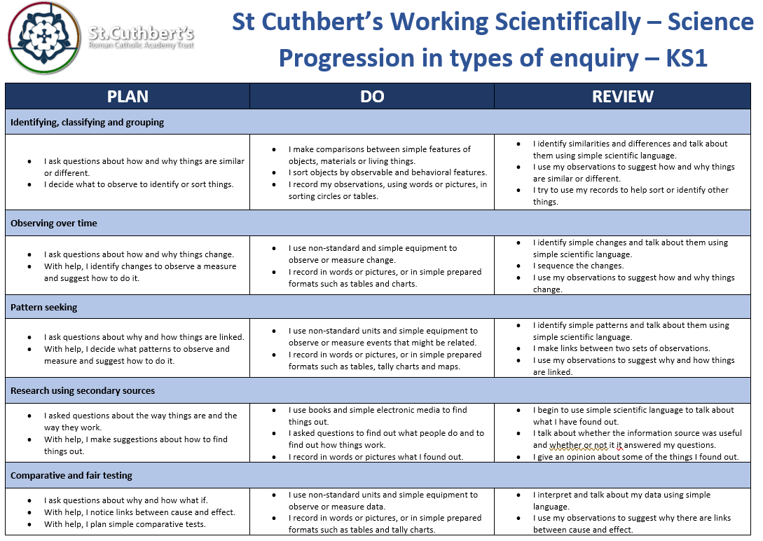
Working Scientifically: Progression within Enquiry
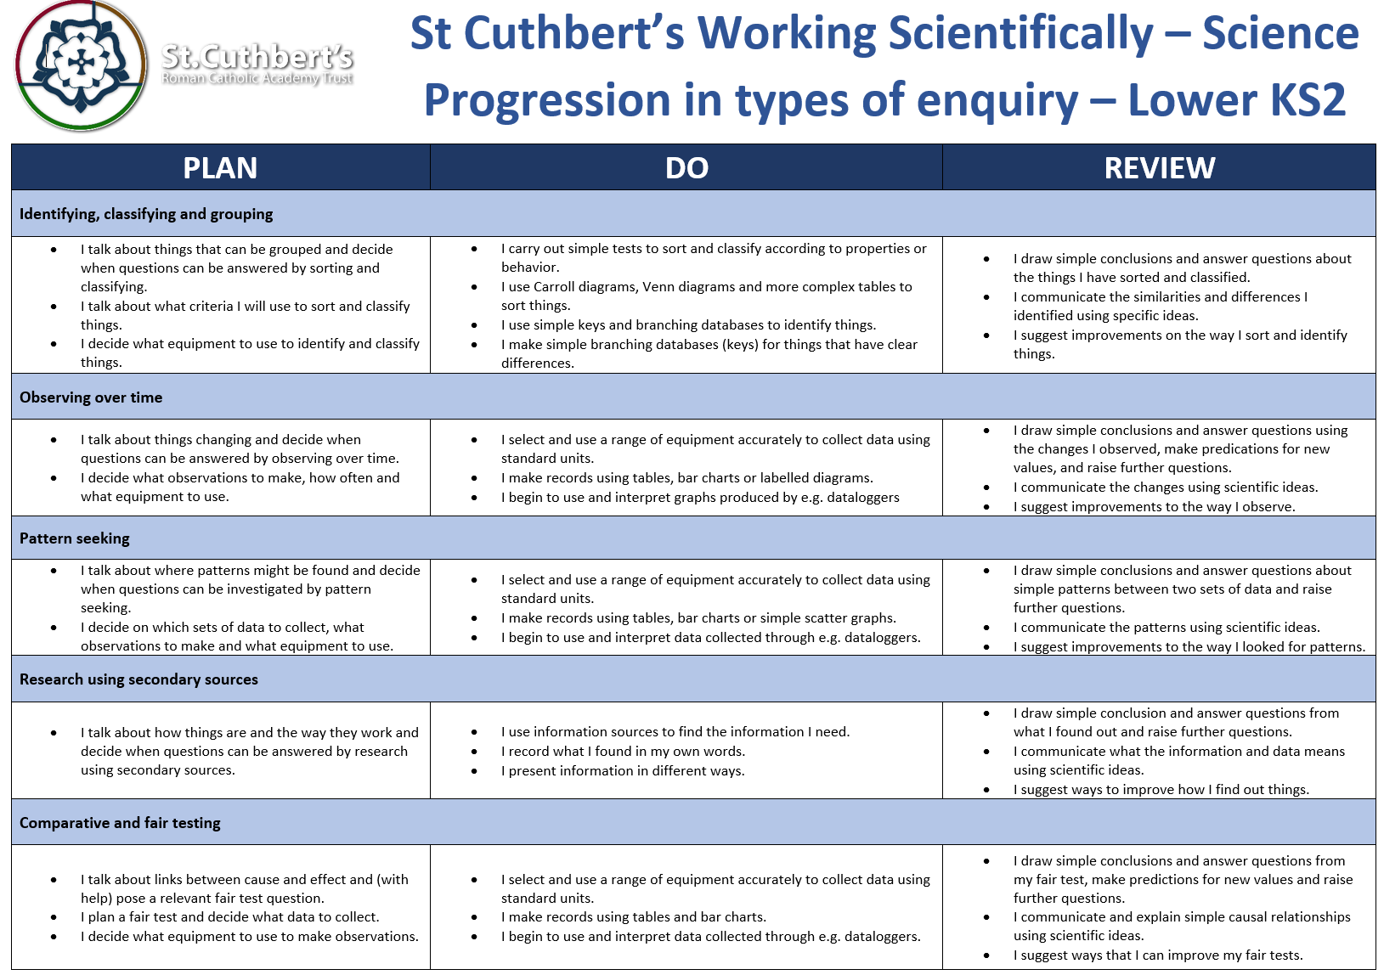
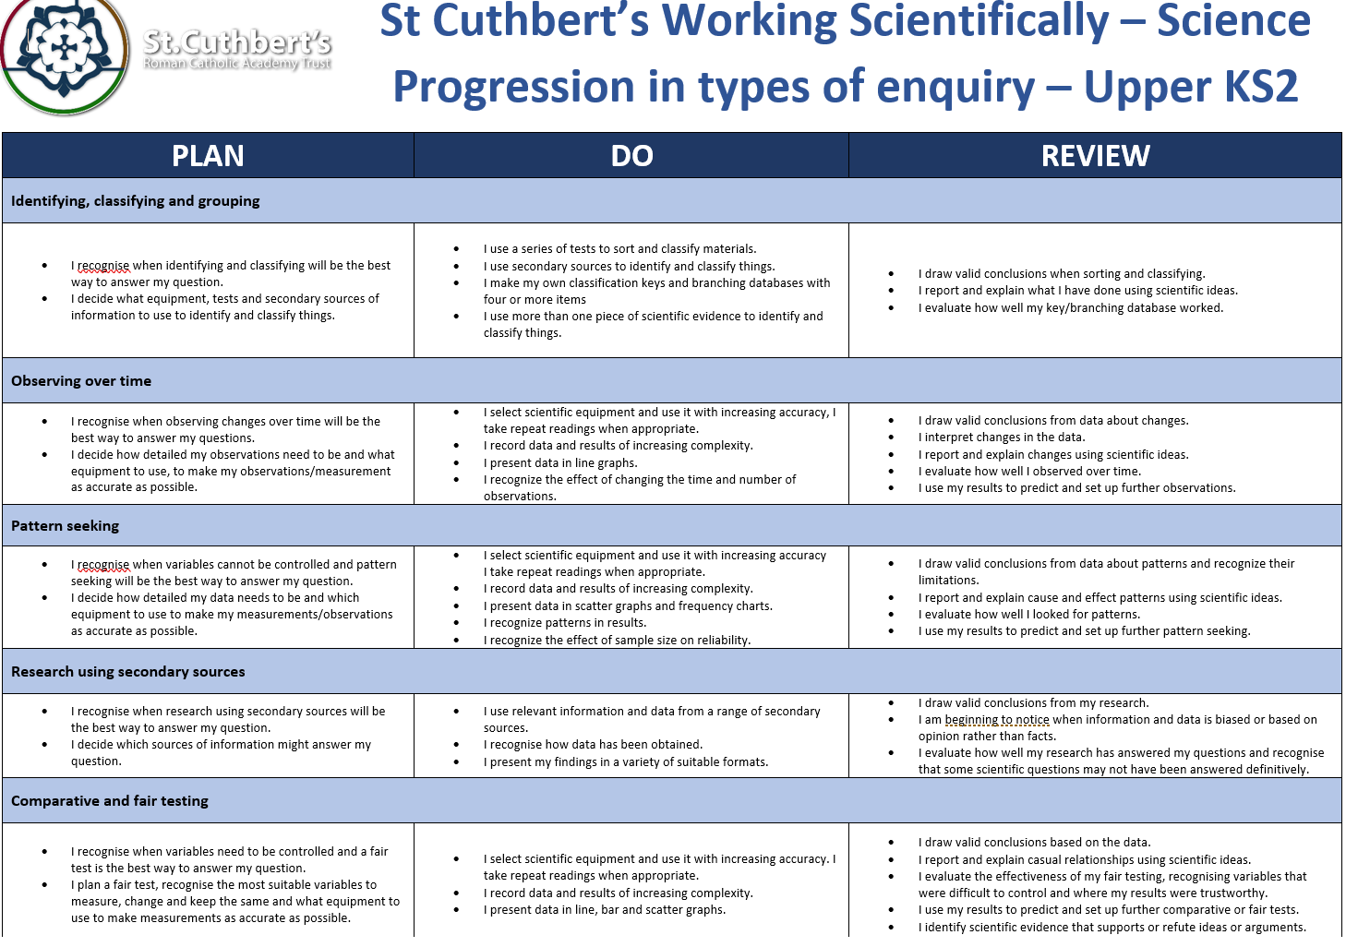
Curriculum Enhancements

Science Week
Implementation:

Impact:

KS1 Planning:
Cycle A

KS1 – Autumn 1 Chemistry: Everyday materials
Lesson | Retrieval | Key Vocab | Component
1 | - Science is a way to understand our world by carefully thinking about it and testing our guesses with observations and experiments | - Equipment | - Know that an object is made from/of a material and know some examples of materials in the real world
2 | - Previous Lesson | - Absorption  - Matter  - Property  - Wood  - Plastic  - Glass  - Metal  - Water  - rock | - Know that materials can be:  - hard, soft, strong, weak, absorbent, heavy, light, solid and runny, smooth and rough; these descriptions denote the properties of a material.
3
4
5
6 | - Collate all previous learning | - Recap topic vocab | - End of Topic overview: Double Page Spread, quiz etc.
KS1 – P
KS1 – Autumn 2 Chemistry: Everyday materials
Lesson | Retrieval | Key Vocab | Component
1 | - Previous Lesson  - Previous Lesson  - Previous Lesson  - Previous Lesson | - Absorption  - Matter  - Property  - Wood  - Plastic  - Glass  - Metal  - Water  - rock | - Know from observation how to distinguish between materials made of wood, plastic, glass, metal, water, rock
2
3
4
5 | - Previous Lesson | - Matter | - Know that matter (stuff) is made from tiny building blocks.
6 | - Collate all previous learning | - Recap topic vocab | - End of Topic overview: Double Page Spread, quiz etc.

KS1 – Spring 1 – Animals Including Humans
Lesson | Retrieval | Key Vocab | Component
1 | - Know that science is a way to understand our world by carefully thinking about it and testing our guesses with observations and experiments | - Energy  - Growth  - Habitat  - Fish  - Amphibian  - Reptile  - Bird  - Mammal  - Offspring  - Carnivore  - Herbivore  - Omnivore  - Vertebrate  - Skeleton  - Organ | - Know that a trout is an example of a fish; a frog is an example of an amphibian; a lizard is an example of a reptile; a robin is an example of a bird; a rabbit and a human are examples of a mammal and explore further/other examples of each animal type.
2 | - Previous Lesson |  | - Know that herbivorous animals eat plants; carnivorous animals eat other animals; omnivorous animals eat both animals and plants.
3 | - Previous Lesson |  | - Know that a cat is an example of a carnivore; that a rabbit is an example of a herbivore; know that many humans are examples of omnivores (though not vegetarians)
4 | - Previous Lesson |  | - Know that fish, amphibians, reptiles, birds and mammals are similar in that they have internal skeletons and organs; these are known as vertebrates, which means they are animals that have a backbone.
5 | - Previous Lesson |  | - Know that fish are different to other animals in having gills so that they can breathe underwater and scaly skin.  - Know that amphibians are different to other animals in that they begin their lives with gills but then develop lungs and breathe on land
6 | - Collate all previous learning | - Recap topic vocab | - End of Topic overview: Double Page Spread, quiz etc.

KS1 – Spring 2 – Animals Including Humans
Lesson | Retrieval | Key Vocab | Component
1 | - Know that science is a way to understand our world by carefully thinking about it and testing our guesses with observations and experiments (retrieval) | - Energy  - Growth  - Habitat  - Fish  - Amphibian  - Reptile  - Bird  - Mammal  - Offspring  - Carnivore  - Herbivore  - Omnivore  - Vertebrate  - Skeleton  - Organ | - Know that reptiles are different to other animals in that they breathe air and have scaly skin.
2 | - Previous Lesson |  | - Know that birds are different to other animals in that they have feathers and wings
3 | - Previous Lesson |  | - Know that mammals are different to other animals in that they have fur/hair and they feed milk to their young
4 | - Previous Lesson |  | - Know that feet, legs, arms, hands, torso, head, skin, ears, eyes, nose, mouth and tongue are parts of the body and identify them.  - Know that eyes are associated with sight, ears with sound, nose with smell, tongue with taste and skin with touch
5 | - Previous Lesson |  | - Know that Ibn Sina (known also as Avicenna) was a scientific genius during early Islamic civilisation  - Know that he wrote books about medicine and healing people  - Know that he helped guide the modern world towards the idea of using evidence in medicine  - Know that he also made major contributions to other areas of science, mathematics and philosophy
6 | - Collate all previous learning | - Recap topic vocab | - End of Topic overview: Double Page Spread, quiz etc.

KS1 – Summer 1 – Earth Science – Seasonal Changes
Lesson | Retrieval | Key Vocab | Component
1 | - Science is a way to understand our world by carefully thinking about it and testing our guesses with observations and experiments (retrieval) | - Energy  - Freezing  - Melting  - Orbit  - Reflection  - Sun  - Clouds  - Wind  - Snow  - Ice  - Spring  - Summer  - Autumn  - Winter  - (NB: the Sun and the Earth are capitalized when being discussed in an astronomical context.) | - Know that days are longer in the summer and shorter in winter
2 | - Previous Lesson |  | - Know that weather changes through the year, getting hotter in the summer and colder in the winter  - Know that the four seasons are spring, summer, autumn and winter and know the order of the cycle
3
4 | - Previous Lesson |  | - Know that the winter is likely to bring ice on the ground when water freezes due to the cold
5 | - Previous Lesson |  | - Know that the Earth orbits the Sun with one orbit constituting a year of 365/366 days
6 | - Collate all previous learning | - Recap topic vocab | - End of Topic overview: Double Page Spread, quiz etc.

KS1 – Summer 2 – Biology – Living Things - Plants
Lesson | Retrieval | Key Vocab | Component
1 | - Know that science is a way to understand our world by carefully thinking about it and testing our guesses with observations and experiments (retrieval) | - Component  - Energy  - Growth  - Deciduous  - Evergreen  - Flower  - Plant  - Tree  - Structure  - Roots  - Stem  - Leaf  - Trunk  - Flower | - Know a rose bush, a sunflower and a dandelion (or similar) by sight.
2 | - Previous Lesson |  | - Know an oak tree, a birch tree and a horse chestnut tree by sight
3 | - Previous Lesson |  | - Know that evergreen trees maintain their leaves throughout the year and that deciduous trees shed their leaves in autumn
4 | - Previous Lesson |  | - Know that a flowering plants consist of roots, stem, leaves and flowers, and that a tree’s stem is called a trunk
5 | - Previous Lesson |  | - Know that there are many kinds of jobs as a scientist including communicator scientist and teacher scientist  - Know that teacher scientists teach others - often children - about science  - Know that communicator scientists help the world to understand about science  - Know that David Attenborough is a famous communicator scientist who has created and presented some of the most famous television programmes ever made about plants and animals
6 | - Collate all previous learning | - Recap topic vocab | - End of Topic overview: Double Page Spread, quiz etc.

LKS2 Planning:
Cycle A

LKS2 – Autumn 1: Animals Including Humans. Why are animals and humans important?
Lesson | Retrieval | Key Vocab | Component
1 | - Retrieval lesson. | - Move  - Grow  - Consume  - Nutrients  - reproduce | - What is a living thing?  - Know that living things move, grow, consume nutrients and reproduce
2 | - Previous Lesson | - Digestion  - Excretion  - Absorbed  - Intestines  - Stomach  - Rectum  - Oesophagus | - How do we digest our food?  - Know that food passes through the body with the nutrients being extracted and the waste products excreted, and that this process is called digestion  - Know that the process of digestion involves breaking complex foodstuffs into simpler building blocks that can be absorbed by the body
3 | - Previous Lesson on digestion and food’s journey. | - Saliva  - Acid  - Incisors  - Canines  - Molars | - What role do our teeth play?  - Know that the process of digestion begins with food being chewed in the mouth by the teeth and saliva added  - Know that a human has three types of teeth – incisors, canines and molars – and that these each perform different functions  - Know that incisors slice food, canines tear food (especially meat) and that molars grind food  - Know that children develop an initial set of teeth which are gradually replaced between the ages of 6 and 12
4 | - Previous Lesson and digestion | - Oesophagus  - Acid  - Enzymes  - Intestines | - What is the role of the oesophagus?  - Know that food is squeezed down the oesophagus towards the stomach in a wave-like action called peristalsis (see diagram below)  - Know that the stomach releases acid and enzymes to continue breaking down the food; the stomach is an organ; an organ is a part of living thing that is self-contained and has a specific important job  - Know that further enzymes and bile break down the food further as it moves through the duodenum towards the small intestine  - Know that the small intestine adds more enzymes and then absorbs the nutrients  - Know that the large intestine absorbs water from the undigested food  - Know that undigested food is stored in the rectum before being excreted through a muscle called the anus
5 | - Previous Lesson | - Predator  - Consumer  - Primary predator  - Secondary predator  - Tertiary predator | - Know that a food chain traces the path of energy through a habitat  - Know that the arrows in a food chain show the direction that energy is travelling through a habitat  - Know that all energy for a food chain initially comes from the Sun which is absorbed and turned into energy by plants which are called producers  - Know that consumers take in energy by eating  - Know that an animal that is eaten by another is called prey, and that an animal that eats other animals is called a predator  - Know that the first consumer in a food chain is called a primary consumer, the second is called a secondary consumer and above it is called a tertiary consumer (see diagram below)
6 | - Double Page Spread

LKS2 – Autumn 2: Living Things & Their Habitats – Are some animals more alike than others?
Lesson | Retrieval | Key Vocab | Component
1 | - Living Things knowledge | - Mammals  - Birds  - Features | - Are all animals the same?
2 | - Previous Lesson | - Classification key  - Identify | - How can we classify living things?  - Know that a classification key uses questions to sort and identify different living things (see diagram below)  - Know how to use a classification key to identify living things
3 | - Previous Lesson | - Classification key | - Do plants have enough characteristics to be classified?  - Know how to create a classification key to sort plants on the school premises.
4 | - Previous Lesson | - Environment  - Survival  - Reproduce  - Extinction  - Pollution  - Habitat | - How do the changes to the environment affect the living things?  - Know that changes to the environment can make it more difficult for living things to survive and reproduce; in extreme cases this leads to extinction, where an entire species dies  - Know that human activity – such as climate change caused by pollution - can change the environment for many living things, endangering their existence  - Know that many species of living things have already been made extinct as a result of human activity  - Know that the polar bear is a famous example of climate change endangering the existence of a species; as the climate changes and gets warmer, the sea ice on which polar bears live reduces in amount making it harder for them to survive and reproduce
5 | - Previous Lesson | - Species  - Kingdoms | - Why do we need to sort animals?  - Know that Carl Linnaeus was a famous scientist who studied life and created a system for sorting living things into different groups  - Know that the concept of species and kingdoms (such as the animal kingdom or the plant kingdom) was his invention, and that all living things are given a name that uses his method of classification
6 | - Double Page Spread

LKS2 – Spring 1: States of Matter - Does water always melt at the same speed?
Lesson | Retrieval | Key Vocab | Component
1 | - Retrieval Lesson | - Matter | - What makes up an object?  - Know that an object is made from/of a material  - Know that materials can be hard, soft, strong, weak, absorbent, heavy, light, solid and runny, smooth and rough; these descriptions denote the properties of a material  - Know that matter (stuff) is made from tiny building blocks
2 | - Previous Lesson | - Matter  - Solid  - Liquid  - Gas  - States  - Particles | - What are the three states something can be in?  - Know that things are composed of a matter commonly in one of three states of matter: solid, liquid or gas  - Know that things are made of particles (tiny building blocks) and that these are organized differently in different states
3  4 | - Previous Lesson | - Bonds  - Particles  - Absorb  - Energy  - Freezing  - Evaporation  - boiling point  - condensation  - reversible  - sublimation | - What impact does temperature have?  - Know that materials can change state when temperature changes  - Know that there are bonds between the particles (building blocks) in a solid; as temperature increases, these bonds are somewhat overcome as the particles absorb energy and solids can change into liquids; with a further increase in temperature, the particles become even more energetic and the bonds are overcome entirely so the liquid changes into a gas  - Know that when solids turn into liquids, this is called melting and that the reverse process is called freezing  - Know that when liquids turn into gases, this is called evaporation and that the reverse process is called condensation  - Know that when a solid turns into a gas without passing through the liquid state, this is called sublimation  - Know that the melting point of water is 0o C and that the boiling point of water is 100o C
5  6 | - Previous two lessons | - Water cycle  - Continuous precipitation  - Transpiration  - Surface runoff process | - What makes the water cycle so important?  - Know that water flows around our world in a continuous process called the water cycle  - Know that, along with evaporation, water on the Earth’s surface moves to the air in a process called transpiration in which water turns into water vapour (gas) on the surface of leaves on plants  - Know that rain condenses in clouds and falls to earth as rain, snow or hail in a process called precipitation  - Know that water flows across the land in rivers and streams in a process called surface run-off and under the ground as groundwater

LKS2 – Spring 2:Electricity - Does electricity flow easily through all objects?
Lesson | Retrieval | Key Vocab | Component
1 | - Retrieval Lesson | - Energy  - Material  - Matter | - What is energy?  - Know that an object is made from/of a material  - Know that metal is a material from which objects can be made.  - Know that matter (stuff) is made from tiny building blocks  - Know that energy comes in different forms and can be neither created nor destroyed, only changed from one form to another
2 | - Previous Lesson | - Current electricity  - Static electricity  - Charged particles | - What is current electricity?  - Know that electrical energy is one of many forms of energy  - Know that static electricity is an imbalance of charged particles on a material; it does not operate by flowing around a complete circuit  - Know that current electricity is the flow of charged particles called electrons around a circuit  - Know that current electricity is the form of electricity that we use in our lives in lights, computers, televisions, etc
3 | - Previous Lesson | - Current  - Flows  - Conductors  - Insulators | - How does an electrical current flow?  - Know that electrical current flows well through some materials, called electrical conductors, and poorly through other materials, called electrical insulators  - Know that conductors have free electrons (tiny, negatively charged particles) and that when electrical current flows around a conductor the electrons move  - Know that electrical conductivity (how well a material conducts electricity) is an example of a property  - Know that metals are good electrical conductors
4  5 | - Previous Lesson | - Chemical reaction  - Cell  - Charged particles | - How does conductivity help the flow?  - Know that a chemical reaction inside a cell produces the charged particles that can flow around a circuit  - Know that more than one cell lined up to work together is called a battery  - Cells, batteries and the mains are all sources of electrical energy  - Know that electrical current can flow if there is a complete circuit  - Know that wires – which contain a conductor inside them, usually made of metal – can allow electrical current to flow around a circuit  - Know that when electrical current flows through a circuit components within that circuit – such as buzzers which make a noise and bulbs which emit light – begin to work  - Know that a switch functions by completing or breaking a complete circuit  - Know how to construct a simple circuit using components
6 | - Retrieval | - Motor  - Magnet | - What have been some of our electrical discoveries?  - Know that Michael Faraday was a scientist who studied electricity  - Know that he invented the electric motor and showed that the movement of a magnet could create electricity, which is the reason we can generate electricity to power our world  - Know that he is considered “the father of electricity”

LKS2 – Summer 1: Sound - How do instruments make different sounds?
Lesson | Retrieval | Key Vocab | Component
1 | - Retrieval Focus | - Vibrates  - Particles | - Can you silence sound?  - Know that energy comes in different forms and can be neither created nor destroyed, only changed from one form to another (retrieval)  - Know that sound is generated when an object vibrates; some of the energy from the vibrating object is transferred to the air, making the air particles move
2 | - Previous Lesson | - Longitudinal wave  - Medium  - Particles  - Vacuum | - How does sound travel?  - Know that sound is a form of energy that transfers in a longitudinal wave - like that seen in a slinky - not a transverse wave - like that seen in water ripples.  - Know that sound travels through a medium (e.g. particles in the air) and thus sounds does not travel through a vacuum which has no particles in it at all
3 | - Previous Lesson | - Vibration  - Cochlea  - Stirrup | - How does our brain help us to hear?  - Know that longitudinal sound waves are detected in the ear by humans and that the brain interprets this as the sounds we hear.
4 | - Previous Lesson | - Vibration  - Wave s | - Can sound travel at a range of speeds?  - Know that sound travels at different speeds through different objects; it travels at around 340 metres per second in air, much slower than light travels; this is why we often hear thunder after we see lightning as the light reaches our eye before the sound reaches our ears
5 | - Previous Lesson | - Pitch  - Vibrations  - Frequency  - Volume | - Can a high volume sound have a low pitch?  - Know that pitch is how high or low a sound is and that this is determined by how many vibrations per second are being made by the vibrating object; the number of vibrations per second is called frequency  - Know that volume is how loud or quiet a sound is and that this is determined by the amount of energy in the wave (e.g. from how hard or soft a percussion instrument is hit)  - Know that the volume of a sound is quieter if the listener is further away from the object
6 | - Collate all previous learning | - Recap topic vocab | - End of Topic overview: Double Page Spread, quiz etc.

LKS2 – Summer 2: Living Things & Their Habitats
Lesson | Retrieval | Key Vocab | Component
1 | - Retrieval Focus | - Adapted  - Environment  - Characteristics | - How have animals adapted tp their environment?  - Know that living things move, grow, consume nutrients and reproduce; that dead things use to do these things, but no longer do; and that things that never lived have never done these things.  - Know that polar bears are an example of an animal adapted to its environment – thick fur for warmth and oily paw pads to ensure that they don’t freeze to the ice.  - Know that a trout is an example of fish, a frog is an example of an amphibian; a lizard is an example of a reptile; a robin is an example of a bird; a rabbit and a human are examples of a mammal
2 | - Retrieval Focus | - Herbivore  - Carnivore  - Omnivore | - Does an environment influence a diet?  - Know that herbivorous animals eats plants; a carnivorous animal eats other animals; omnivorous animals eat both animals and plants
3 | - Retrieval Focus | - Fish  - Amphibians  - Reptiles  - Birds  - mammals | - What’s the same and what is different?  - Know that fish, amphibians, reptiles, birds and mammals are similar in that they have internal skeletons and organs; these are known as vertebrates, which means they are animals that have a backbone  - Know that fish are different to other animals in having gills so that they can breathe underwater and have scaly skin  - Know that amphibians are different to other animals in that they begin their lives with gills but then develop lungs and breath on land  - Know that reptiles are different to other animals in that they breath air and have scaly skin  - Know that birds are different to other animals in that they have feathers and wings  - Know that mammals are different to other animals in that they have fur/hair and they feed milk to their young.
4 | - Previous Lesson | - Physical characteristics | - Is it the physical characteristics that help us to classify?  - Know that animals can be grouped based on their physical characteristics (e.g. vertebrates and invertebrates) and based on their behavior (e.g. herbivores, carnivores and omnivores)
5 | - Previous Lesson | - Kingdoms  - Plants  - Fungi  - Bacteria  - Single cell  - Organisms | - What are the kingdoms?  - Know that living things are divided into kingdoms: the animal kingdom, plants, fungi, bacteria, and single-celled organisms
6 | - Previous Lesson | - Species  - Reproduce  - Offspring | - Know that a species is a group of living things have many similarities that can reproduce together produce offspring

UKS2 Planning:
Cycle A

UKS2 – Autumn 1: Evolution & Inheritance - Why do different species of animals look different?
Lesson | Retrieval | Key Vocab | Component
1 | - Previous Learning.  - Use knowledge strands. | - Fossils  - Evolution  - extinction | - Who was Mary Anning?  - Research of famous scientist and contribution to theory of evolution.
2 | - Mary Anning’s discovery  - Know that a species is a group of living things have many similarities that can reproduce together produce offspring. | - Inherit  - Variation  - Reproduction  - Characteristic | - Do all offspring produced look the same?  - Know that offspring vary and are not identical to their parents.  - Characteristics are passed down to offspring.
3 | - Previous Lesson | - Adaptation  - Advantageous | - How do animals adapt to suit their environment?  - Living things change over time and the change is gradual.  - Natural variation within a species.  - Advantageous characteristics survive.
4 | - What make dis/advantageous characteristics in animals. | - Adaptation  - Evolution  - Variations  - Darwin | - What happens if animals do not adapt?  - Know that living things change over time and that this gradual change is called evolution.  - Rainforest canopy – monkeys – variations/similarities.
5 | - How species change over time. | - Species | - How does human behaviour impact species?  - Know that living things change over time and that this gradual change is called evolution.
6 | - Previous Lesson | - Natural selection | - What was Charles Darwin’s theory?  - Know that Charles Darwin posited this theory of evolution by natural selection  - Know that Darwin was a naturalist whose theory of evolution by natural selection developed while travelling through the Amazon rainforest  - Know that Darwin’s theory is accepted as fact by the scientific community  - Know that Darwin did not know similarities were passed between parents and their offspring; know DNA, a chemical discovered in the 20th century, is contains the “code” that passes on information between parents and their offspring in all living things

UKS2 – Autumn 2: Electricity - Is it possible to change how bright a bulb is or how loud a buzzer is?
Lesson | Retrieval | Key Vocab | Component
1 | - Know that exposure to high levels of electrical current can be dangerous. | - Conductor  - Energy | - What are the dangers of electricity?
2 | - Previous Lesson | - Alternating Current  - Direct Current  - Filament | - What’s the importance of the major discoveries in electricity?  - Research comprehension
3 | - Previous Lesson | - Circuit  - Cell, switch, current electricity  - Complete/incomplete | - What are the symbols in a circuit?  - Simple circuit diagrams  - Circuit diagrams including battery, bulb, motor, buzzer, wire.  - Know how to predict whether components will function in a given circuit, depending on whether or not the circuit is complete; whether or not a switch is in an on or off position; and whether or not there is a cell to provide electrical current to the circuit
4 | - Previous Lesson | - Voltage  - Filament  - Electrons | - Why might a bulb not light up in a complete circuit?  - Know that voltage is a measure of the power of a cell to produce electricity; it is a measure of the ‘push’ of electric current, not the size of the electric current  - Know that as the number and voltage of cells in a circuit increases, the brightness of a bulb or the volume of a buzzer will increase (though too high a voltage may ‘blow’ the bulb or buzzer)
5 | - Previous Lesson | - Series circuit  - Parallel circuit | - What makes a series/parallel circuit?  - Know that two bulbs in a circuit can be wired up to create a series circuit or a parallel circuit; if one bulb blows in a series circuit the other will not shine as the circuit has been broken; in contrast, if one bulb blows in a parallel circuit (see diagram below), there will still be a complete circuit for the other bulb so it will continue to shine; use this knowledge to explain the advantages of using parallel circuits (e.g. in the lighting in homes)
6 | - Topic | - All recap | - Double Page Spread

UKS2 – Spring 1: Living Things & Their Habitats (Classification)
Lesson | Retrieval | Key Vocab | Component
1 | - Know that animals can be grouped based on their physical characteristics (e.g. vertebrates and invertebrates) and based on their behaviour (e.g. herbivores, carnivores and omnivores) | - Characteristics  - Mammals  - Birds  - Reptiles  - Amphibians  - Fish  - Mollusc | - What is a living thing and how many types?  - Know that living things move, grow, consume nutrients and reproduce; that dead things use to do these things, but no longer do; and that things that never lived have never done these things  - Know that fish, amphibians, reptiles, birds and mammals are similar in that they have internal skeletons and organs; these are known as vertebrates, which means they are animals that have a backbone
2 | - Previous Lesson | - Classification key | - What are the best ways to classify animals?  - Create classification keys with range of questions to show understanding of characteristics.
3 | - Previous Lesson | - Kingdom  - Phylum
4 | - Previous Lesson | - Anthropod  - Arachnid | - What is an anthropod?  - Know that an arthropod is an invertebrate with a hard, external skeleton and jointed limbs  - Know that insects are a type of arthropod; their bodies consist of six legs, a head, a thorax and an abdomen; most insects also have a pair of antennae and a pair of wings (e.g. wasp)  - Know that an arachnid (e.g. spider) is a type of arthropod with eight legs and no antennae or wings
5 | - Previous Lesson | - Virus  - Bacteria  - Fungi  - Micro organism | - Are bacteria, virus and fungi the same?  - Know that there are three types of micro-organism: viruses, fungi and bacteria; of these three, viruses are often not really considered to be alive by many scientists mainly because they don’t have the ‘machinery’ to reproduce inside them  - Know that germs are disease-causing micro-organisms
6 | - Previous Lesson | - Anthropologist | - What has been Jane Goodall’s impact?  - Know that Jane Goodall is an anthropologist, most famous for her study of chimpanzees, of which she is considered the world’s foremost expert  - Know that Goodall discovered that chimpanzees are much more intelligent than they had ever been thought to be  - Know that Goodall is also a conservationist and environmentalist, which means she does important work to help protect the planet, in particular animal habitats

UKS2 – Spring 2: Light - Why can I hear round corners but not see round corners?
Lesson | Retrieval | Key Vocab | Component
1 | - Retrieval of how sound travels | - Longitudinal Wave  - Travel  - Medium | - How do we hear things? Does this link to sight?  - Know that sound is generated when an object vibrates; some of the energy from the vibrating object is transferred to the air, making the air particles move  - Know that sound is a form of energy that transfers in a longitudinal wave - like that seen in a slinky - not a transverse wave - like that seen in water ripples (see diagram below)  - Know that sound travels through a medium (e.g. particles in the air) and thus sounds does not travel through a vacuum which has no particles in it at all  - Know that longitudinal sound waves are detected in the ear by humans and that the brain interprets this as the sounds we hear
2 | - Previous Lesson | - Reflected  - Source | - How do we see things?  - Know that we need light to see things and that darkness is the absence of light  - Know that light travels in straight lines  - Know that light is reflected when it travels from a light source and then ‘bounces’ off an object  - Know that everything that we can see is either a light source or something that is reflecting light from a light source into our eyes
3 | - Previous Lesson | - Translucent  - Transparent  - Opaque | - Translucent, Transparent or opaque?  - Know that translucent objects allow some light to pass through, but some of the light changes direction as it passes through the object; this means that an something seen through a translucent object is not clearly defined.  - Know that when light passes from one medium to another (e.g. from air to water), it changes direction; this is called refraction; this happens because light travels at different speeds in different media
4 | - How does light travel? | - Angle of incidence  - Angle of reflection  - Refraction  - Spectrum | - Does light always travel in same direction?  - Know that white light comprises all the colours of light  - Know that white light refracted by two surfaces in a prism will spread out so that all of its constituent colours can be seen; this array of colours is called a spectrum; it happens because the different colours that constitute white light travel at different speeds
5 | - Opaque | - Opaque | - How does a shadow form and what affects it?  - Know how to draw a diagram to show why the shape of a shadow will match the shape of an object
6 | - Angles of incidence and reflection | - Angle of incidence  - Angle of reflection  - Periscope | - How does a periscope work?  - Know that when light reflects off an object, the angle of incidence is equal to the angle of reflection  - Know that a periscope takes advantage of the predictable angles of incidence and reflection to allow an image to be shown to a viewer

UKS2 – Summer 1: Animals Including Humans – skeletal
Lesson | Retrieval | Key Vocab | Component
1 | - Retrieval lesson itself  - Previous study of humans. Use knowledge strands | - Diet  - Carbohydrates  - Fruit and vegetables  - Balanced diet  - Nutrients | - What makes a person physically healthy?  - Know that more than half of our diet should be made up of carbohydrates, fruit and vegetables  - Know that fats and sugary foods should be eaten rarely and in small amounts  - Know that getting the right amount of each food group (including over half of the diet made up of fruit, vegetables and carbohydrates) is called a balanced diet  - Know that a lack of a nutrient can cause ill health; for example, a lack of vitamin D leads to a disease called rickets  - Know that excess of a food group can cause ill health, such as tooth decay due to excess sugar
2 | - Retrieval lesson itself. | - Digestion  - Excretion  - Oesophagus  - Intestine | - How do we digest our food?  - Food passes through the body with the nutrients being extracted and the waste products excreted, and this process is called digestion  - The process of digestion involves breaking complex foodstuffs into simpler building blocks that can be absorbed by the body  - Know that food is squeezed down the oesophagus towards the stomach in a wave-like action called peristalsis  - Know that the stomach releases acid and enzymes to continue breaking down the food; the stomach is an organ; an organ is a part of living thing that is self-contained and has a specific important job  - Know that further enzymes and bile break down the food further as it moves through the duodenum towards the small intestine  - Know that the small intestine adds more enzymes and then absorbs the nutrients  - Know that the large intestine absorbs water from the undigested food  - Know that undigested food is stored in the rectum before being excreted through a muscle called the anus
3 | - Previous Lesson | - All listed to the right. | - Which bones are vital to everyday life?  - Know the names of key bones in the body, including the rib cage, cranium, mandible, sternum, vertebrae, femur, tibia, fibula, patella, humerus, radius and ulna; know how to label these on a diagram of the human body.
4 | - Previous Lesson | - Tendons  - Ligaments  - Joints | - Which is more important, muscles or bones?  - Know that an adult human body has 206 bones, the longest of which is the femur.  - Tendons, ligaments and joints  - Key muscles in the body
5 | - Previous Lesson |  | - How does skeletal system protect muscles?  - Know that the heart and lungs are organs protected by the ribcage and understand this as a part of the skeleton.
6

UKS2 – Summer 2: Animals Including Humans – organs
Lesson | Retrieval | Key Vocab | Component
1 | - Previous Lesson | - Veins  - Capillaries  - Vessels  - Arteries  - Atria  - Ventricles  - Aorta | - How does the heart keep the body going?  - Know that the heart beats, pumping blood around the body and that blood vessels carry the blood; arteries carry blood away from the heart; veins carry blood towards the heart; capillaries are tiny blood vessels that connect arteries and veins  - Know that the heart is composed of four chambers: two atria and two ventricles; the aorta is the largest artery in the body and most major arteries branch off from it
2 | - Previous Lesson | - Respiration  - Circulatory system  - Bloodstream | - What is the role of our blood?  - Know that blood travels around the body transporting nutrients that have been absorbed into the bloodstream from digestion; blood also absorbs oxygen from the lungs and carries it around the body which is used to power the body; this use of oxygen to create energy is called respiration
3 | - Previous Lesson | - Replenished  - Resting heart rate | - What is the benefit of exercise?  - Know that when we exercise, our heart beats more frequently so that the oxygen that is used around the body can be replenished; it returns to a resting heart rate afterwards; fitter people tend to have lower resting heart rates
4 | - Previous Lesson | - Chemicals  - Paracetamol  - Aspirin  - Disease | - Are all drugs bad for us?  - Know that drugs are chemicals that have an impact on the natural chemicals in a person’s body; know that drugs can be harmful or helpful, depending on what they are and how they are used; know that all drugs can be harmful if overused  - Know that paracetamol and aspirin are examples of drugs that can be helpful as a painkiller  - Know that cannabis and cocaine are examples of illegal drugs that can have serious negative effects  - Know that alcohol and tobacco are examples of drugs that are legal to adults but that can have serious negative effects, such as liver disease and lung disease, respectively
5 | - Collate all previous learning | - Recap topic vocab | - End of Topic overview: Double Page Spread, quiz etc.
6

LKS2 – Summer 2

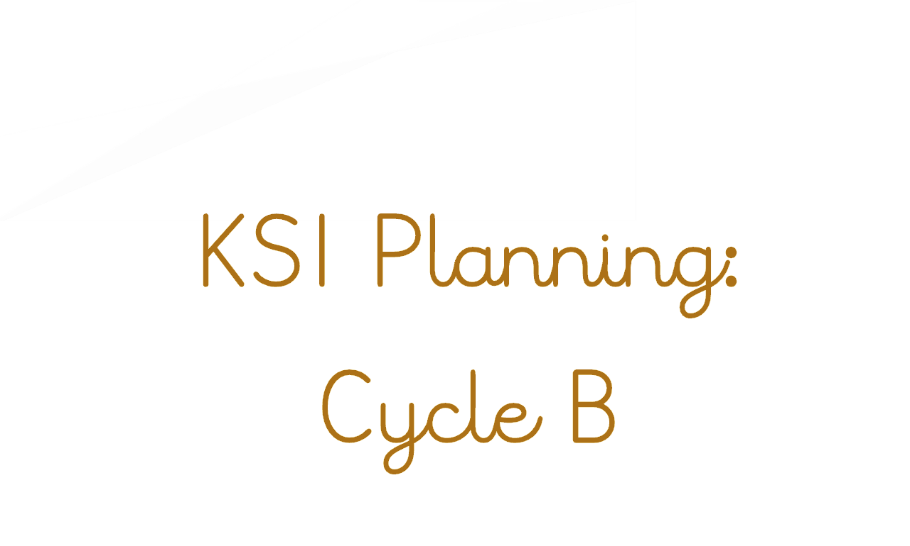

KS1 – Autumn 1: Use of Everyday Materials
Lesson | Retrieval | Key Vocab | Component
1 | - Know that science is a way to understand our world by carefully thinking about it and testing our guesses with observations and experiments | - Retrieval vocab:  - absorption  - Matter  - property  - New vocab:  - Conductor  - Brick  - Paper  - Cardboard  - Friction  - Movement  - Suitability  - Surface  - Stretch  - Twist  - Waterproof  - Deformation  - Flexible  - Rigid | - Know that objects are made from materials such as wood, plastic, glass, metal, water, rock  - Know that materials have properties such as being hard, soft, strong, weak, absorbent, heavy, light, solid, runny, smooth and rough; these descriptions denote the properties of a material  - Know that matter (stuff) is made from tiny building blocks
2
3 | - Previous Lesson  - Previous Lesson  - Previous Lesson |  | - Know that materials can have useful properties for a given job (including being waterproof, strong, hard, soft, flexible, rigid, light or heavy)
4
5
6 | - Collate all previous learning | - Recap topic vocab | - End of Topic overview: Double Page Spread, quiz etc.

KS1 – Autumn 2: Use of Everyday Materials continued
Lesson | Retrieval | Key Vocab | Component
1 | - Previous Lesson | - Conductor  - Brick  - Paper  - Cardboard  - Friction  - Movement  - Suitability  - Surface  - Stretch  - Twist  - Waterproof  - Deformation  - Flexible  - Rigid | - Know that many types of plastic are waterproof, that steel (a type of metal) is strong, that rock is hard, that cotton wool is soft, that rubber is flexible, that rock is rigid, that polystyrene (a type of plastic) is light and that iron (a type of metal) is heavy.
2
3 | - Previous Lesson  - Previous Lesson |  | - Know that when objects move across a surface there is friction when they rub against each other and that sometimes this friction is larger or smaller
4
5 | - Previous Lesson |  | - Know that applying forces to objects can change their shape, by squeezing, stretching, bending and twisting
6 | - Collate all previous learning | - Recap topic vocab | - End of Topic overview: Double Page Spread, quiz etc.

KS1 – Spring 1 – Biology – Living Things & Life Cycles
Lesson | Retrieval | Key Vocab | Component
1 | - Science is a way to understand our world by carefully thinking about it and testing our guesses with observations and experiments  - Previous Lesson | - Birth  - Decay  - Energy  - Reproduction  - Microhabitat  - Dead  - life cycle  - food chain  - source  - nutrients  - consumption  - environment | - Know that dandelions, rose bushes, grass, ash trees, birch trees and conifers trees are examples of plants.  - Know that trees can be deciduous or evergreen.  - Know that a trout is an example of fish, a frog is an example of an amphibian; a lizard is an example of a reptile; a robin is an example of a bird; a rabbit and a human are examples of a mammal  - Know that herbivorous animals eats plants; a carnivorous animal eats other animals; omnivorous animals eat both animals and plants
2
3 | - Previous Lesson  - Previous Lesson |  | - Know that living things move, grow, consume nutrients and reproduce; that dead things use to do these things, but no longer do; and that things that never lived have never done these things.
4
5 | - Previous Lesson |  | - Know that there are many kinds of jobs as a scientist including communicator scientist, teacher scientist, technician scientist and explorer scientist  - Know that technician scientists are scientists that help other scientists to do their job  - Know that explorer scientists try to find out new things that no one has ever learned before; many of the most famous scientists in history were explorer scientists
6 | - Collate all previous learning | - Recap topic vocab | - End of Topic overview: Double Page Spread, quiz etc.

KS1 – Spring 1 – Biology – Living Things & Life Cycles Continued
Lesson | Retrieval | Key Vocab | Component
1 | - Previous Lesson | - Birth  - Decay  - Energy  - Reproduction  - Microhabitat  - Dead  - life cycle  - food chain  - source  - nutrients  - consumption  - environment | - Know that light is a form of energy  - Know that plants absorb energy from the Sun; that this energy is consumed by herbivorous animals; and that carnivorous animals eat other animals  - Know that the arrows on a food chain show the direction that the energy travels
2
3 | - Previous Lesson |  | - Know that polar bears are an example of an animal adapted to its environment – thick fur for warmth and oily paw pads to ensure that they don’t freeze to the ice  - Know that sharks are another example – smooth skin and streamlined shape for quick swimming; and gills for breathing underwater  - (For the above, alternative appropriate options may be given)
4 | - Previous Lesson |  | - Know that cacti are an example of a plant adapted to its environment – thick skin keeps a store of water safe; sharp spikes keep animals from stealing the water  - Know that pine trees are adapted to their environment in that they have thick bark and pine cones to protect against cold winters  - (For the above, alternative appropriate options may be given)
5 | - Previous Lesson |  | - Know that woodlice live under logs – an example of a microhabitat - as they need somewhere dark and damp so that they do not dry out  - Know that frogs can live in ponds – an example of a microhabitat - as they water in which to lay their eggs (frogspawn)  - (For the above, alternative appropriate options may be given)
6 | - Collate all previous learning | - Recap topic vocab | - End of Topic overview: Double Page Spread, quiz etc.

KS1 – Summer 1 – Biology – Plants and Animals Including Humans
Lesson | Retrieval | Key Vocab | Component
1 | - Know that science is a way to understand our world by carefully thinking about it and testing our guesses with observations and experiments | - Offspring  - Adult  - Bulb  - Seed  - Survival  - Temperature  - Hygiene  - Exercise | - Know that living things move, grow, consume nutrients and reproduce; that dead things use to do these things, but no longer do; and that things that never lived have never done these things
2 | - Previous Lesson |  | - Know that seeds and bulbs need to be buried underground in soil and that they will grow into adult plants under the right conditions (water, warmth)
3 | - Previous Lesson |  | - Know that plants that are deprived of light, food or air will not grow and will die.
4 | - Previous Lesson |  | - Know that plants and animals produce offspring that grow into adults.
5 | - Previous Lesson |  | - Know that George Washington Carver was a practical scientist and inventor  - Know that he helped farmers in America to grow more crops by showing them the benefits of growing different things at different times and of using fields for different crops
6 | - Collate all previous learning | - Recap topic vocab | - End of Topic overview: Double Page Spread, quiz etc.

KS1 – Summer 2 – Biology – Plants and Animals Including Humans Continued
Lesson | Retrieval | Key Vocab | Component
1 | - Previous Lesson | - Offspring  - Adult  - Bulb  - Seed  - Survival  - Temperature  - Hygiene  - Exercise | - Know that animals, including humans, need food, water and air to survive  - Know the basic food groups: fruit and vegetables, carbohydrates, protein, dairy, fat and sugary foods
2 | - Previous Lesson |  | - Know that proteins are good for growth, carbohydrates for energy and fruit and vegetables provide vitamins and minerals which help keep us healthy (e.g. calcium for healthy bones and teeth)  - Know that more than half of our diet should be made up of carbohydrates, fruit and vegetables (see diagram below)  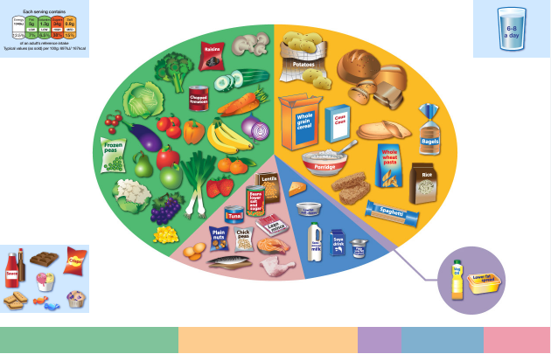
3 | - Previous Lesson |  | - Know that fats and sugary foods should be eaten rarely and in small amounts
4 | - Previous Lesson |  | - Know that people need to exercise often to help their body stay strong and fit
5 | - Previous Lesson |  | - Know that keeping clean, including washing and brushing teeth, is an important part of staying healthy
6 | - Collate all previous learning | - Recap topic vocab | - End of Topic overview: Double Page Spread, quiz etc.
LKS2 Planning:
Cycle B

LKS2 – Autumn 1: Light
Lesson | Retrieval | Key Vocab | Component
1 | - Previous Lesson | - Energy  - Property  - Photon | - What is light?  - Know that light is a form of energy.
2 | - Previous Lesson | - energy | - Can energy be destroyed?  - Know that energy comes in different forms and can be neither created nor destroyed, only changed from one form to another
3 | - Previous Lesson | - Data logger | - What is darkness?  - Know that we need light to see things and that darkness is the absence of light
4 | - Previous Lesson | - Beam  - Travels  - straight | - How does light travel?  - Know that light travels in straight lines
5 | - Previous Lesson | - reflection  - mirror  - incident ray  - source | - Does light ‘bounce’?  - Know that light is reflected when it travels from a light source and then ‘bounces’ off an object
6 |  |  | - What do we see?  - Know that everything that wee can see is either a light source or something that is reflecting light from a light source into our eyes.

LKS2 – Autumn 2: Light
Lesson | Retrieval | Key Vocab | Component
1 | - Previous Lesson | - Sun  - Moon  - Opaque  - Transparent | - Is the Moon a light source?  - Know that the Sun is a light source, but that the Moon is not and is merely reflecting light from the Sun  - Know that many light sources give off light and heat  - Know that the Sun gives off light and heat when hydrogen turns into helium
2 | - Previous Lesson |  | - Are bulbs filled with energy too?  - Know that filaments in traditional bulbs heat up until they glow, giving off light and heat  - Know that fluorescent bulbs glow when electricity adds energy to a gas within the bulb
3 | - Previous Lesson |  | - Can you block light?  - Know that opaque objects block light creating shadows and that light passes easily through transparent objects  - Know that opacity/transparency and reflectiveness are properties of a material  - Know that sunglasses can protect eyes from sunlight but looking at the Sun directly – even with sunglasses – can damage the eyes
4 | - Previous Lesson |  | - How can a shadow be altered?  - Know that as objects move towards a light source, the size of the shadow increases  - Know how to show the changing of shadow size by drawing a diagram with straight lines representing light
5 | - Previous Lesson |  | - Can we track light?  - Know that a data logger can keep track of light levels and that this can be plotted on a graph to show how this changes over the course of a day
6 |  |  | - Who found out how we can see?  - Know that Hasan Ibn al-Haytham - sometimes known as Alhazen - was a scientist and mathematician during early Islamic civilisation  - Know that al-Haytham was the first to explain that we see objects because light reflects from objects into our eyes  - Know that al-Haytham was an early pioneer of the scientific method which used evidence to find things out about the world
Colour Theory, Sketching and paintin
LKS2 – Spring 1 Rocks & Fossils Can rocks tell us about the past, the present and the future?
Lesson | Retrieval | Key Vocab | Component
1 | - What do I already know? Flipchart for working wall. | - Extinction  - Particle  - Igneous  - Metamorphic  - Sedimentary  - Paleontologist  - Weathering  - molten rock  - crust  - tectonic plates  - scavengers  - fossil | - Know that rock is a type of solid material. (Retrieval)  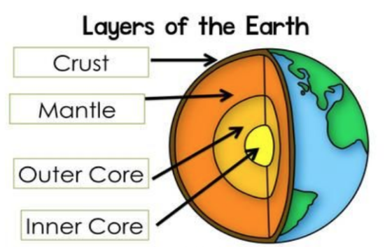  - Know that applying forces to objects can change their shape, by squeezing, stretching, bending and twisting (retrieval)  - Know that the Earth has a solid crust made up of tectonic plates with molten rock beneath (see diagram)
2 | - Previous Lesson |  | - Know that there are three kinds of rocks: igneous, sedimentary and metamorphic  - Know that granite and basalt are types of igneous rock and that igneous rocks form from molten rock below the Earth’s crust  - Know that limestone and sandstone are types of sedimentary rock which form when small, weathered fragments of rock or shell settle and stick together, often in layers  - Know that marble and slate are types of metamorphic rock which form when rocks in Earth’s crust get squashed and heated in processes such as when tectonic plates press against each other
3 | - Previous Lesson |  | - Know that fossils form when a plant or animal dies and is quickly covered with silt or mud so that it cannot be rotted by microbes or eaten by scavenging animals; in time layers of sediment build, squashing the mud and turning it to stone around the dead plant or animal; the materials in the body are replaced by minerals that flow in water through the rock, leaving a rock in the shape of the animal or plant that was once there  - Know that fossils can help us learn about things that lived long ago
4 | - Previous Lesson |  | - Know that soil is made from tiny particles of rock broken down by the action of weather (weathering)
5 | - Previous Lesson |  | - Know that Zhang Heng was a genius in many areas: he was a scientist, mathematician, poet, inventor and artist  - Know that Zhang Heng invented the world’s first seismoscope that was able to detect where and when earthquakes had happened (when the Earth’s tectonic plates suddenly shift causing massive vibrations
6 | - From the entire topic to answer the question for DPS |  | - Double Page Spread

LKS2 – Spring 2 Forces & Magnets
Lesson | Retrieval | Key Vocab | Component
1 | - What do I already know? Flipchart for working wall. | - Magnetic  - non-magnetic  - pole  - north  - south  - sliding friction  - static friction  - elastic  - resist  - attraction  - repulsion | - Potential recap of prior learning inc:  - Know that a force can be thought of as a push or a pull  - Know that there are different types of contact force: impact forces (when two surfaces collide), frictional forces (when two surfaces are already in contact) and strain forces (when an elastic material is stretched or squashed)  - Know that metal is a material from which objects can be made  - Know that as objects move across a surface there is friction when they rub against each other and that sometimes this friction is larger or smaller
2 | - Previous Lesson |  | - Know that objects move differently on rough and smooth surfaces; objects resist movement more on rough surfaces because there is higher friction as the object moves  - Know that applying forces to objects can change their shape  - Know that the roughness of a material is an example of a property
3 | - Previous Lesson |  | - Know that objects move differently on rough and smooth surfaces; objects resist movement more on rough surfaces because there is higher friction as the object moves.
4 | - Previous Lesson |  | - Know that there are also non-contact forces that can act between objects without them touching and that magnetism is an example of a non-contact force  - Know that magnets have two poles called north and south  - Know that like poles (south-south and north-north) of two magnets repel each other and that opposite poles of two magnets (north-south) attract each other  - Know that there is a magnetic field around a magnet which is strongest at each pole
5 | - Previous Lesson |  | - Know that some materials are magnetic, meaning that they are attracted to a magnet, while other materials are non-magnetic
6 | - Collate all previous learning | - Recap topic vocab | - End of Topic overview: Double Page Spread, quiz etc.

LKS2 – Summer 1: Plants and animals including humans
Lesson | Retrieval | Key Vocab | Component
1 | - Components recapping prior learning across first 2 lessons. | - Extinction  - Fruit  - Nectar  - Anther  - Ovary  - Ovule  - Petal  - Pollen  - Stigma  - Style  - Stamen  - Function  - Exchange  - Dispersal  - Fertilization  - Vitamin  - balanced diet  - cartilage  - invertebrate  - contract  - loosen  - ribcage  - insect | - Know that science is a way to understand our world by carefully thinking about it and testing our guesses with observations and experiments  - Know that evergreen trees maintain their leaves throughout the year and that deciduous trees shed their leaves in autumn  - Know that flowering plants consist of roots, stem, leaves and flowers, and that a tree’s stem is called a trunk  - Know that living things move, grow, consume nutrients and reproduce; that dead things use to do these things, but no longer do; and that things that never lived have never done these things.  - Know that plants absorb energy from the Sun; that this energy is consumed by herbivorous animals; and that carnivorous animals eat other animals.  - Know that seeds and bulbs need to be buried underground in soil and that they will grow into adult plants under the right conditions (water, warmth)  - Know that the arrows on a food chain show the direction that the energy travels.  - Know that plants that are deprived of light, food or air will not grow and will die.  - Know that animals, including humans, need food, water and air to survive  - Know that there are food groups: fruit and vegetables, carbohydrates, protein, dairy, fat and sugary foods  - Know that more than half of our diet should be made up of carbohydrates, fruit and vegetables  - Know that fats and sugary foods should be eaten rarely and in small amounts
2
3 | - Previous Lesson |  | - Know that different parts of plants have one or more functions (jobs)  - Know that the roots collect water and minerals from the soil, and hold the plant firmly in the ground  - Know that the stem holds up the leaves so that they can gather light to make food and holds up the flowers so that they can receive pollen and disperse their fruits; know that the stem also transports water and minerals from the roots to the other parts of the plant  - Know that the leaves make food by absorbing light and using its energy to turn carbon dioxide and water into carbohydrates
4
5 | - Previous Lesson |  | - Know that the function of a flower is reproduction, where flowers of the same kind exchange pollen – made by an anther – in a process called fertilisation, and a structure in the flower’s ovary called an ovule becomes a seed; the ovary then becomes a fruit which helps the seed leave the plant in a process called dispersal (see diagram below)  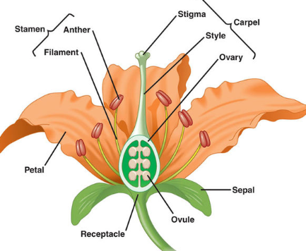
6 | - Collate all previous learning | - Recap topic vocab | - End of Topic overview: Double Page Spread, quiz etc.

LKS2 – Summer 2: Plants and animals including humans continued
Lesson | Retrieval | Key Vocab | Component
1 | - Know that science is a way to understand our world by carefully thinking about it and testing our guesses with observations and experiments. | - Extinction  - Fruit  - Nectar  - Anther  - Ovary  - Ovule  - Petal  - Pollen  - Stigma  - Style  - Stamen  - Function  - Exchange  - Dispersal  - Fertilization  - Vitamin  - balanced diet  - cartilage  - invertebrate  - contract  - loosen  - rib cage  - insect | - Know that proteins are good for growth, carbohydrates for energy and fruit and vegetables provide vitamins and minerals which help keep us healthy (e.g. calcium for healthy bones and teeth)  - Know that getting the right amount of each food group (including over half of the diet made up of fruit, vegetables and carbohydrates) is called a balanced diet
2 | - Previous Lesson |  | - Know that lack of a nutrient can cause ill health; for example, a lack of vitamin D leads to a disease called rickets
3 | - Previous Lesson |  | - Know that animals, including humans, have a skeleton made up of solid objects  - Know that some animals (such as insects) have an exoskeleton – a solid covering on the outside of their body  - Know that many invertebrates (such as earthworms and slugs) have water held inside by muscles which acts like a skeleton
4 | - Previous Lesson |  | - Know that skeletons provide support for muscles and protect the body; for example, the rib cage protects the vital organs in the human body  - Know that human skeletons are made up of bones and cartilage  - Know that muscles can only contract, so they must be arranged in pairs in the body so that as one contracts the other loosens
5 | - Previous Lesson |  | - Know that skeletons provide support for muscles and protect the body; for example, the rib cage protects the vital organs in the human body  - Know that human skeletons are made up of bones and cartilage  - Know that muscles can only contract, so they must be arranged in pairs in the body so that as one contracts the other loosens
6 | - Collate all previous learning | - Recap topic vocab | - End of Topic overview: Double Page Spread, quiz etc.

ear Six – Textile
UKS2 Planning:
Cycle B
UKS2 – Autumn 1: Earth & Space
Lesson | Retrieval | Key Vocab | Component
1 | - Retrieval of prior learning | - Potentially:  - absorption, energy, freezing, melting, orbit, reflection, wave, Sun, spring, summer, autumn, winter  - (NB: the Sun and the Earth are capitalized when being discussed in an astronomical context.) | - What do we already know about Earth & Space?  - Know that days are longer in the summer and shorter in winter  - Know that weather changes through the year, getting hotter in the summer and colder in the winter  - Know that Earth orbits the Sun with one orbit constituting a year of 365/366 days  - Know that light is a form of energy  - Know that we need light to see things and that darkness is the absence of light  - Know that light travels in straight lines  - Know that everything that we can see is either a light source or something that is reflecting light from a light source into our eyes  - Know that the Sun is a light source, but that the Moon is not and is merely reflecting light from the Sun  - Know that many light sources give off light and heat  - Know that the Sun gives off light and heat when hydrogen turns into helium
2 |  | - universe, star, constellation, celestial body. | - What makes up the universe?  - Know that the universe comprises all matter and space in existence  - Know that a celestial body is a large object in the universe  - Know that a star is an exceptionally hot ball of gas, originally made from hydrogen and helium  - Know that the Sun is a star  - Know that a planet (e.g Earth) is defined as a spherical celestial body that orbits a star and that has cleared the neighbourhood of its orbit of other objects, some of which crash into the planet and others that become moons of that planet  - Know it was once thought that everything orbited the Earth, but that scientists like Copernicus and Galileo used telescopes and measurement to show that the Earth orbited the Sun
3 |  | - planet, satellite, sphere, solar system, celestial body | - What is in our Solar System?  - Know that a celestial body is a large object in the universe  - Know that a star is an exceptionally hot ball of gas, originally made from hydrogen and helium  - Know that the Sun is a star  - Know that a planet (e.g Earth) is defined as a spherical celestial body that orbits a star and that has cleared the neighbourhood of its orbit of other objects, some of which crash into the planet and others that become moons of that planet  - Know it was once thought that everything orbited the Earth, but that scientists like Copernicus and Galileo used telescopes and measurement to show that the Earth orbited the Sun  - Know that there are eight major planets in our solar system: Mercury, Venus, Earth, Mars, Jupiter, Saturn, Uranus, Neptune  - Know that a satellite orbits a planet and that moons are natural satellites  - Know that humans have sent man-made satellites into orbit that assist with telecommunication
4 |  | - planet, sphere, constellation, axis, rotating, rotation | - What orbits what and why?  - Know that all the planets in the solar system orbit the Sun and that the further away they are from the Sun, the longer their orbit  - Know that the Earth spins around an imaginary line through its centre called an axis and that this axis is tilted relative to the Earth’s orbit  - Know that night and day are the result of the Earth rotating on its axis
5 |  | - solar system, eclipse, star, axis, celestial body, Moon, rotating, lunar, solar, rotation, tilt | - Why do we have seasons?  - Know that the tilt of the Earth towards and away from the Sun’s light as the Earth orbits the Sun leads to the seasons as during winter the light is spread over a wider area (see diagram below)  - Know that the Moon orbits the Earth roughly every 28 days  - Know that as the Moon orbits the Sun, different parts of it are lit up by the Sun, which is why we see a different shape lit up on the Moon as the lunar cycle progresses; these are called phases of the Moon  - Know that a solar eclipse occurs when the Moon is between the Sun and the Earth, casting a shadow on the Earth; a lunar eclipse occurs when the Earth is between the Sun and the Moon, casting a shadow on the Moon
6 |  |  | - How do we explore space?  - Know that Katherine Johnson was a scientist and mathematician from America  - She worked for NASA and her calculations and work were critical to the success of the first and subsequent manned space flights  - She was one of the first black women to attend an integrated university in her state, West Virginia, having been handpicked due to her ability

UKS2 – Autumn 2: Forces
Lesson | Retrieval | Key Vocab | Component
1 | - Previous Lesson | - Retrieval vocab: energy, matter, particle, surface, friction, force, stretch, squash, rotation, rough, smooth, sliding friction, static friction | - What do you already know?  - Know that a force can be thought of as a push or a pull  - Know that as objects move across a surface there is friction when they rub against each other and that sometimes this friction is larger or smaller.  - Know that applying forces to objects can change their shape.  - Know that the roughness of a material is an example of a property  - Know that there are three types of contact force: impact forces (when two surfaces collide), frictional forces (when two surfaces are already in contact) and strain forces (when an elastic material is stretched or squashed).  - Know that objects move differently on rough and smooth surfaces; objects resist movement more on rough surfaces because there is higher friction as the object moves
2 | - Previous Lesson | - Newton, matter | - How do we measure force?  - Know that a force is measured in a unit called Newtons, named after a British scientist called Sir Isaac Newton who discovered lots about gravity and how planets move  - Know that Newton was undoubtedly one of the greatest scientists who ever lived, a genius who discovered a great deal about forces, including gravity, mathematics and light  - Know that pull forces can be measured using a device called a force meter  - Know that the amount of matter (stuff) in an object is its mass
3 | - Previous Lesson | - acceleration, gravity, | - What is the impact of gravity?  - Know that gravity is a force that acts between all objects in the universe, but that it acts much more strongly between objects that have more mass and that are close together  - Know that unsupported objects are pulled towards the Earth by the force of gravity  - Know that acceleration is a change in speed and that unbalanced forces acting on an object cause it to accelerate
4 | - Previous Lesson | - acceleration, air resistance, buoyancy, terminal velocity, water resistance, | - How does air resistance influence an object?  - Know that air resistance is a force felt by an object as it moves through the air; it is caused by the object bumping into the gas particles that make up air; the quicker an object moves, the more gas particles it bumps into and the more air resistance it experiences  - Know that a falling object will accelerate until its air resistance matches the gravitational force pulling it down; at this point, the object will continue to move at this speed (called its terminal velocity) without getting any quicker or slowing down (see diagram below)  - Know that a parachute’s shape increases the air resistance that a falling object experiences, giving it a much lower terminal velocity  - Know that water resistance is a force felt by an object as it moves through water; it is caused by the object bumping into the water particles  - Know that the shape of an object determines how much air resistance or water resistance it experiences; shapes of object that experience little air resistance or water resistance are described as streamlined
5 | - Previous Lesson | - force meter, velocity, weight | - How can a diagram depict force?  - Know how to draw a force diagram with arrows representing the different forces acting on an object (see diagram below)  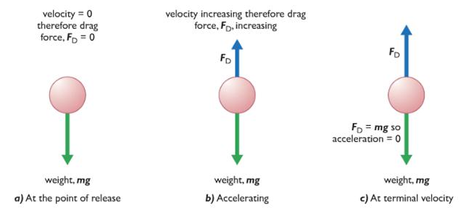
6 |  | - effort, fulcrum, load, leaver, pulley, gears | - How can we create a greater force?  - Know that a lever is a rigid length pivoting around a fulcrum (see diagram below)  - Know that a pulley is a wheel with a fulcrum that supports a moving cable or belt (see diagram below)  - Know that a gear is a rotating wheel with cut teeth that mesh with the teeth of another gear so that turning one gear turns an adjacent gear in the opposite direction (see diagram below)  - Know that gears, levers and pulleys are simple machines that are used to allow a smaller force to have a greater effect; they do this by moving a smaller force over a longer distance at one end of the machine, which the machine turns into a larger forcer over a small distance at the other end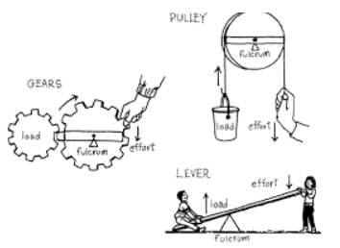

UKS2 – Spring 1 – Chemistry – Properties and Changes of Materials
Lesson | Retrieval | Key Vocab | Component
1 | - Previous Lesson | - Irreversible  - Dissolve  - Soluble  - Insoluble  - Solvent  - Solute  - Solution  - Filter  - Sieve  - Saturation  - Crystallization  - Thermal  - Chemistry | - Know that a given amount of solvent can only absorb a certain amount of solid before no more will dissolve; when this happens the liquid is said to be saturated
2 | - Previous Lesson |  | - Know that when a solvent is evaporated from a solution, the original solute is left behind; the remaining solid will often form crystals – the slower the solvent evaporates, the larger the crystals that will be formed
3 | - Previous Lesson |  | - Know how to dissolve a solute in a solvent and then how to evaporate the solvent to recover the solute
4 | - Previous Lesson |  | - Know that a reversible change is one that can be reversed and that examples of this are mixing, dissolving and changes of state where no chemical reaction takes place
5 | - Previous Lesson |  | - Know that an irreversible change is one that cannot be reversed and that examples of this often involve a chemical change where a new material is made, often a gas (e.g. burning, boiling an egg, the reaction of bicarbonate of soda and acid)
6 | - Previous Lesson |  | - Know that filtering allows solids and liquids to be separated and that sieving allows solids made up of different sizes parts to be separated

UKS2 – Spring 2 – Chemistry – Properties and Changes of Materials
Lesson | Retrieval | Key Vocab | Component
1 | - Previous Lesson | - Irreversible  - Dissolve  - Soluble  - Insoluble  - Solvent  - Solute  - Solution  - Filter  - Sieve  - Saturation  - Crystallization  - Thermal  - Chemistry | - Know how to separate a mixture of sand, salt and small stones by sieving (to remove the small stones), followed by dissolving in water (so the salt is absorbed), followed by filtering to remove the sand from the mixture, followed finally by evaporation of the water to recover the salt.
2
3 | - Previous Lesson |  | - Know that materials’ different properties can be tested through acting upon them, including testing to find whether materials are magnetic, thermally conductive and electrically conductive; know that the various properties of different materials make them suitable for a given function.
4
5 | - Previous Lesson |  | - Know how to explain orally and in writing the reasons why various materials are suited or unsuited to a function
6 | - Previous Lesson |  | - Know that Marie Curie was a genius physicist, earning two Nobel Prizes  - She discovered two new elements (the building blocks of everything) and made discoveries that suggested that atoms - which were thought to be the smallest building blocks - could be divided into smaller building blocks still

UKS2 – Summer 1 – Biology – Living Things and Their Habitats
Lesson | Retrieval | Key Vocab | Component
1 | - Know that science is a way to understand our world by carefully thinking about it and testing our guesses with observations and experiments | - life cycle  - life span  - embryo  - womb  - weaned  - adolescence  - metamorphosis  - pupa  - larva  - chrysalis  - caterpillar  - tadpole  - hatchling  - fledgling  - insect | - Retrieval Focus:  - Know that science is a way to understand our world by carefully thinking about it and testing our guesses with observations and experiments  - Know that living things move, grow, consume nutrients and reproduce; that dead things use to do these things, but no longer do; and that things that never lived have never done these things  - Know that a trout is an example of fish, a frog is an example of an amphibian; a lizard is an example of a reptile; a robin is an example of a bird; a rabbit and a human are examples of a mammal  - Know that fish, amphibians, reptiles, birds and mammals are similar in that they have internal skeletons and organs; these are known as vertebrates, which means they are animals that have a backbone  - Know that fish are different to other animals in having gills so that they can breathe underwater and have scaly skin  - Know that amphibians are different to other animals in that they begin their lives with gills but then develop lungs and breathe on land  - Know that reptiles are different to other animals in that they breath air and have scaly skin  - Know that birds are different to other animals in that they have feathers and wings  - Know that mammals are different to other animals in that they have fur/hair and they feed milk to their young  - Know that different parts of plants have one or more functions (jobs)  - Know that roots collect water and minerals from the soil, and hold the plant firmly in the ground  - Know that the stem holds up the leaves so that they can gather light to make food and holds up the flowers so that they can receive pollen and disperse their fruits; the stem also transports water and minerals from the roots to the other parts of the plant  - Know that the leaves make food by trapping light and using its energy to turn carbon dioxide and water into carbohydrates  - Know that the function of a flower is reproduction, where flowers of the same kind exchange pollen – made by an anther – in a process called fertilisation, and a structure in the flower’s ovary called an ovule becomes a seed; the ovary then becomes a fruit which helps the seed leave the plant in a process called dispersal
2 | - Previous Lesson |  | - Know that the life cycle of a living thing is a series of stages of development starting with a fertilized egg in animals or a seed in many plants  - Know that in most mammals (e.g. dogs) a fertilized egg develops in the womb into an embryo and is then born and fed on milk before it is weaned onto the food that is adapted to eat; it then develops to maturity in a period called adolescence after which it can reproduce and the cycle can begin again (see diagram below)  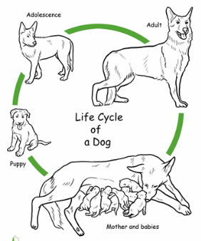
3 | - Previous Lesson |  | - Know that in amphibians (e.g. frogs) a fertilized egg develops into an embryo and then hatches into a tadpole; the tadpole develops adult characteristics, metamorphoses into the adult form after which it can reproduce and the cycle can begin again (see diagram below)  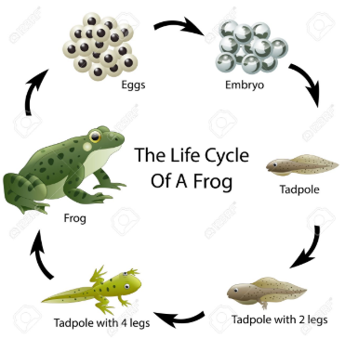
4 | - Previous Lesson |  | - Know that in many insects (e.g. butterflies) a fertilized egg develops into wingless feeding form called a larva (caterpillar); the larva feeds then later becomes a pupa (chrysalis) with a protective cocoon; inside this cocoon, the pupa metamorphoses into the adult butterfly after which it can reproduce and the cycle can begin again (see the diagram below)  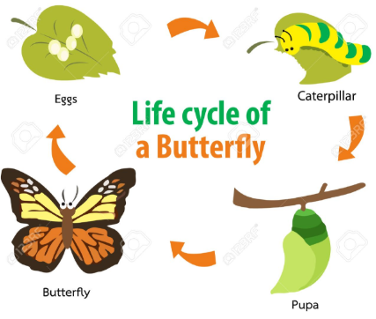
5 | - Previous Lesson |  | - Know that in birds (e.g. robins) a fertilized egg hatches in a nest (a hatchling) and is fed by its parents until it is ready to fly (i.e. becomes a fledgling); it then leaves the nest and grows into an adult after which it can reproduce and the cycle can begin again (see diagram below)  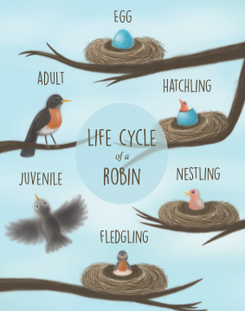
6 | - RSE recap | - RSE focus | - Know that humans go through stages of development; they begin as fertilized eggs and then develop into embryos before developing into babies; once they are born, these newborn babies become infants (roughly 2 months to 2 years) then into young children (roughly 2-12 years old); children develop into adults during adolescence (roughly 12-16 years old) at which age they become physically capable of reproduction; as adults develop into old age (roughly 55+ years old) they experience changes in their body which require them to move more carefully and rest more frequently

UKS2 – Summer 2 n/a
Lesson | Retrieval | Key Vocab | Component
1 | - Previous Lesson
2 | - Previous Lesson
3 | - Previous Lesson
4 | - Previous Lesson
5 | - Previous Lesson
6

