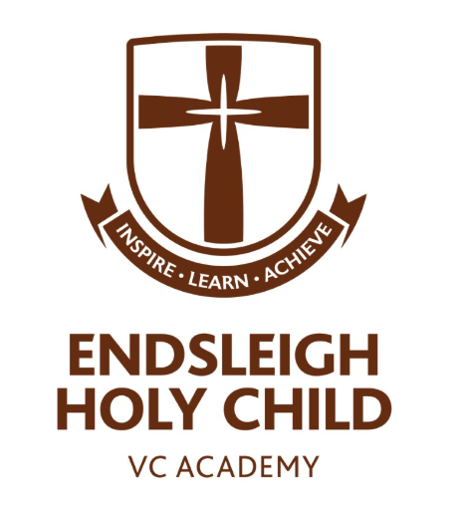

Reading

at
Endsleigh Holy Child VC Academy

Contents

- Intent – page 3
- Implementation – page 4
- Expectations for Teaching – page 5
- Whole-class Reading – page 6
- The National Curriculum – page 7
- Long Term Plans – page 11
- National Curriculum Objective Mapping – page 24
- Progression of Skills – page 32
- VIPERS – page 40
- Assessment – page 43
- Endsleigh Reading Spine – page 44
- Home Reading – page 47

Intent
Reading is a priority at Endsleigh Holy Child VC Academy and we firmly believe in teaching pupils the value in reading for pleasure, as well as the academic benefits.

We believe that all pupils should have the opportunity to be fluent, confident readers who are able to successfully comprehend and understand a wide range of texts. We want pupils to develop a love of reading, a good knowledge of a range of authors, and be able to understand more about the world in which they live through the knowledge they gain from texts. By the end of their time at primary school, all children should be able to read fluently, and with confidence, in any subject.

Implementation

Reading is taught daily at Endsleigh. In the Early Years Foundation Stage, pupils are immersed in books and reading from the beginning of their time at our school. Through this, children begin to learn that print contains meaning, and that reading and books are exciting and fun. During their independent learning time, pupils have the opportunity to apply their phonic and word knowledge, and practise using the context of a text, and knowledge of grammatical structures, to check that what they are reading makes sense.

At the appropriate stage in their learning, pupils in Foundation 1 begin to receive direct phonics teaching, following the Read, Write, Inc. phonics programme. All children in Foundation 2 receive daily phonics teaching, following the Read, Write, Inc. phonics programme. Children are also introduced informally to whole class reading sessions where texts are shared and discussed, giving pupils the opportunity to demonstrate understanding when talking with others about their reading. Whole class reading sessions follow the Talk Through Stories programme.
Pupils in Key Stage 1 continue with the Read, Write, Inc. programme throughout Year 1. They are also introduced to more formal whole class reading sessions. Pupils may continue with Read, Write, Inc. phonics teaching into Year 2, if required. All pupils in Years 1-6 receive whole class reading lessons, following the requirements of the National Curriculum. To ensure that our pupils are familiar with all of the reading domains within the National Curriculum, reading lessons across Years 1-6 incorporate the VIPERS method.
At Endsleigh, we aim to ensure that our teaching of reading enables pupils across the school to read fluently and confidently in any subject. Children are given the opportunity to apply their reading skills through wider curriculum lessons such as RE, History, Geography and Science. Children are encouraged to use the skills they have been taught in their reading lessons to both retrieve and infer information from a text.
There are many opportunities to develop reading for pleasure and a love of books at Endsleigh, and children speak positively about reading. A number of incentives promote reading at home. In school, class teachers ensure that quality time is devoted to reading aloud to their classes, providing pupils with the experience of texts that they may not be able to access independently. Class teachers are supported with their selection of high-quality texts through the Endsleigh ‘Reading Spine’ but are also encouraged to share their own enthusiasms and new finds to engage pupils and instil a love of reading that extends beyond a child’s time at Endsleigh.

Expectations for Teaching
The Long-Term plan specifies the texts that will be covered in each class, for each term. The narrative core text must be taught, as well as texts belonging to the non-fiction text type.
These texts need to be added to throughout the term, to supplement teaching and learning. Class teachers must use their professional judgement, knowledge of children’s literature and the pupils in their class to select appropriate texts. Texts used to supplement the narrative core text may be fiction, non-fiction or poetry. For example, a story by the same author, a story with a similar theme, a non-fiction text linked to themes or events in the story, or a song that links to the story or themes within the story.
Fiction and non-fiction should both be taught across the week, with a balance of fiction being taught for three days, and non-fiction taught for two days.
It is the expectation that reading is taught every day, with a minimum of three pieces of evidence recorded in books. Evidence in books should be both fiction and non-fiction each week.
Poetry should be taught in the penultimate week of each half term. For the specified poems, see the Poetry Anthology.
Texts may also be used where they link to the wider curriculum, or events throughout the year. For example, non-fiction texts linked to History or Geography, or texts linked to Anti-Bullying Week or Remembrance.

Whole-Class Reading
At Endsleigh Holy Child VC Academy, we teach reading through a whole-class guided reading approach. Pupils receive a reading lesson each day, building on skills and knowledge.
Through whole-class guided reading, all pupils experience a quality text, with some pupils (where needed) supported to access it, through pre-reading activities and support to decode. Within a reading lesson, all pupils complete a reading response task and are able to be supported by the class teacher, if required. This ensures that pupils make progress. With whole-class reading lessons, the class teacher has direct impact on all pupils. Teachers are able to intervene with pupils working independently; providing support or challenging pupils where necessary.
Whole-class guided reading enables pupils to deepen their knowledge of texts and stories. Class teachers are able to plan quality-first reading lessons, with carefully-prepared activities that allow pupils to explore texts in detail and meet the requirements of the National Curriculum. Teachers are also able to drive quality discussion around texts and model the skills required in retrieving and inferring information.

The National Curriculum
The programmes of study for reading at key stages 1 and 2 consist of two dimensions:
- word reading
- comprehension (both listening and reading).
It is essential that teaching focuses on developing pupils’ competence in both dimensions; different kinds of teaching are needed for each.
Skilled word reading involves both the speedy working out of the pronunciation of unfamiliar printed words (decoding) and the speedy recognition of familiar printed words. Underpinning both is the understanding that the letters on the page represent the sounds in spoken words. This is why phonics should be emphasised in the early teaching of reading to beginners (i.e. unskilled readers) when they start school.
Good comprehension draws from linguistic knowledge (in particular of vocabulary and grammar) and on knowledge of the world. Comprehension skills develop through pupils’ experience of high-quality discussion with the teacher, as well as from reading and discussing a range of stories, poems and non-fiction. All pupils must be encouraged to read widely across both fiction and non-fiction to develop their knowledge of themselves and the world in which they live, to establish an appreciation and love of reading, and to gain knowledge across the curriculum. Reading widely and often increases pupils’ vocabulary because they encounter words they would rarely hear or use in everyday speech. Reading also feeds pupils’ imagination and opens up a treasure-house of wonder and joy for curious young minds.
It is essential that, by the end of their primary education, all pupils are able to read fluently, and with confidence, in any subject in their forthcoming secondary education.

Year 1
Word Reading
Pupils should be taught to:
- apply phonic knowledge and skills as the route to decode words
- respond speedily with the correct sound to graphemes (letters or groups of letters) for all 40+ phonemes, including, where applicable, alternative sounds for graphemes
- read accurately by blending sounds in unfamiliar words containing GPCs that have been taught
- read common exception words, noting unusual correspondences between spelling and sound and where these occur in the word
- read words containing taught GPCs and –s, –es, –ing, –ed, –er and –est endings
- read other words of more than one syllable that contain taught GPCs
- read words with contractions [for example, I’m, I’ll, we’ll], and understand that the apostrophe represents the omitted letter(s)
- read aloud accurately books that are consistent with their developing phonic knowledge and that do not require them to use other strategies to work out words
- re-read these books to build up their fluency and confidence in word reading

Comprehension
Pupils should be taught to:
- develop pleasure in reading, motivation to read, vocabulary and understanding by:
  - listening to and discussing a wide range of poems, stories and non-fiction at a level beyond that at which they can read independently
  - being encouraged to link what they read or hear read to their own experiences
  - becoming very familiar with key stories, fairy stories and traditional tales, retelling them and considering their particular characteristics
  - recognising and joining in with predictable phrases
  - learning to appreciate rhymes and poems, and to recite some by heart
  - discussing word meanings, linking new meanings to those already known
- understand both the books they can already read accurately and fluently and those they listen to by:
  - drawing on what they already know or on background information and vocabulary provided by the teacher
  - checking that the text makes sense to them as they read and correcting inaccurate reading
  - discussing the significance of the title and events
  - making inferences on the basis of what is being said and done
  - predicting what might happen on the basis of what has been read so far
- participate in discussion about what is read to them, taking turns and listening to what others say
- explain clearly their understanding of what is read to them.

Year 2
Word Reading
Pupils should be taught to:
- continue to apply phonic knowledge and skills as the route to decode words until automatic decoding has become embedded and reading is fluent
- read accurately by blending the sounds in words that contain the graphemes taught so far, especially recognising alternative sounds for graphemes
- read accurately words of two or more syllables that contain the same graphemes as above
- read words containing common suffixes
- read further common exception words, noting unusual correspondences between spelling and sound and where these occur in the word
- read most words quickly and accurately, without overt sounding and blending, when they have been frequently encountered
- read aloud books closely matched to their improving phonic knowledge, sounding out unfamiliar words accurately, automatically and without undue hesitation
- re-read these books to build up their fluency and confidence in word reading.

Comprehension
Pupils should be taught to:
- develop pleasure in reading, motivation to read, vocabulary and understanding by:
  - listening to, discussing and expressing views about a wide range of contemporary and classic poetry, stories and non-fiction at a level beyond that at which they can read independently
  - discussing the sequence of events in books and how items of information are related
  - becoming increasingly familiar with and retelling a wider range of stories, fairy stories and traditional tales
  - being introduced to non-fiction books that are structured in different ways
  - recognising simple recurring literary language in stories and poetry
  - discussing and clarifying the meanings of words, linking new meanings to known vocabulary
  - discussing their favourite words and phrases
  - continuing to build up a repertoire of poems learnt by heart, appreciating these and reciting some, with appropriate intonation to make the meaning clear
- understand both the books that they can already read accurately and fluently and those that they listen to by:
  - drawing on what they already know or on background information and vocabulary provided by the teacher
  - checking that the text makes sense to them as they read and correcting inaccurate reading
  - making inferences on the basis of what is being said and done
  - answering and asking questions
  - predicting what might happen on the basis of what has been read so far
- participate in discussion about books, poems and other works that are read to them and those that they can read for themselves, taking turns and listening to what others say
- explain and discuss their understanding of books, poems and other material, both those that they listen to and those that they read for themselves.

Years 3 & 4
Word Reading
Pupils should be taught to:
- apply their growing knowledge of root words, prefixes and suffixes (etymology and morphology) as listed in English Appendix 1, both to read aloud and to understand the meaning of new words they meet
- read further exception words, noting the unusual correspondences between spelling and sound, and where these occur in the word.

Comprehension
Pupils should be taught to:
- develop positive attitudes to reading and understanding of what they read by:
  - listening to and discussing a wide range of fiction, poetry, plays, non-fiction and reference books or textbooks
  - reading books that are structured in different ways and reading for a range of purposes
  - using dictionaries to check the meaning of words that they have read
  - increasing their familiarity with a wide range of books, including fairy stories, myths and legends, and retelling some of these orally
  - identifying themes and conventions in a wide range of books
  - preparing poems and play scripts to read aloud and to perform, showing understanding through intonation, tone, volume and action
  - discussing words and phrases that capture the reader’s interest and imagination
  - recognising some different forms of poetry [for example, free verse, narrative poetry]
- understand what they read, in books they can read independently, by:
  - checking that the text makes sense to them, discussing their understanding and explaining the meaning of words in context
  - asking questions to improve their understanding of a text
  - drawing inferences such as inferring characters’ feelings, thoughts and motives from their actions, and justifying inferences with evidence
  - predicting what might happen from details stated and implied
  - identifying main ideas drawn from more than one paragraph and summarising these
  - identifying how language, structure, and presentation contribute to meaning
- retrieve and record information from non-fiction
- participate in discussion about both books that are read to them and those they can read for themselves, taking turns and listening to what others say.

Years 5 & 6
Word Reading
Pupils should be taught to:
- apply their growing knowledge of root words, prefixes and suffixes (morphology and etymology), as listed in English Appendix 1, both to read aloud and to understand the meaning of new words that they meet.

Comprehension
Pupils should be taught to:
- maintain positive attitudes to reading and understanding of what they read by:
  - continuing to read and discuss an increasingly wide range of fiction, poetry, plays, non-fiction and reference books or textbooks
  - reading books that are structured in different ways and reading for a range of purposes
  - increasing their familiarity with a wide range of books, including myths, legends and traditional stories, modern fiction, fiction from our literary heritage, and books from other cultures and traditions
  - recommending books that they have read to their peers, giving reasons for their choices
  - identifying and discussing themes and conventions in and across a wide range of writing
  - making comparisons within and across books
  - learning a wider range of poetry by heart
  - preparing poems and plays to read aloud and to perform, showing understanding through intonation, tone and volume so that the meaning is clear to an audience
- understand what they read by:
  - checking that the book makes sense to them, discussing their understanding and exploring the meaning of words in context
  - asking questions to improve their understanding
  - drawing inferences such as inferring characters’ feelings, thoughts and motives from their actions, and justifying inferences with evidence
  - predicting what might happen from details stated and implied
  - summarising the main ideas drawn from more than one paragraph, identifying key details that support the main ideas
  - identifying how language, structure and presentation contribute to meaning
- discuss and evaluate how authors use language, including figurative language, considering the impact on the reader
- distinguish between statements of fact and opinion
- retrieve, record and present information from non-fiction
- participate in discussions about books that are read to them and those they can read for themselves, building on their own and others’ ideas and challenging views courteously
- explain and discuss their understanding of what they have read, including through formal presentations and debates, maintaining a focus on the topic and using notes where necessary
- provide reasoned justifications for their views.

Long Term Plans
Foundation Stage
EYFS | Autumn 1 | Autumn 2 | Spring 1 | Spring 2 | Summer 1 | Summer 2
 | Talk Through Stories:  Owl Babies  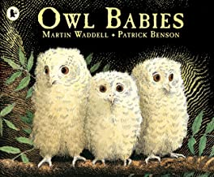  Five Minutes Peace  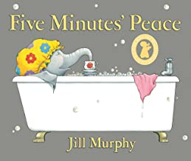  Talk for Writing:  Walking Through the Jungle | Talk Through Stories:  Room on the Broom  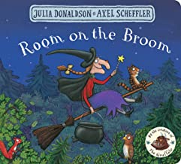  Six Dinner Sid  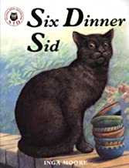  Talk for Writing:  We’re Going on a Bear Hunt | Talk Through Stories:  One Snowy Night  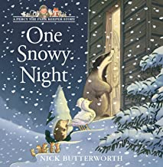  Stick Man  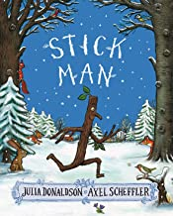  Talk for Writing:  The Gingerbread Man | Talk Through Stories:  Handa’s Hen  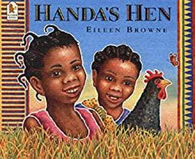  Elmer  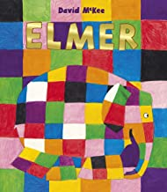  Talk for Writing:  The Enormous Turnip  Handa’s Surprise | Talk Through Stories:  Where The Wild Things Are  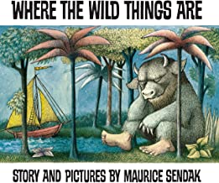  Tiddler  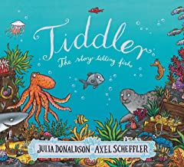  Talk for Writing:  The Three Little Pigs | Talk Through Stories:  The Rainbow Fish  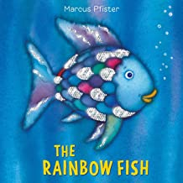  Ruby’s Worry  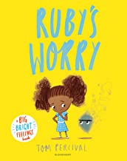  Talk for Writing:  The Rainbow Fish
 | Variety of nursery rhymes and short poems to be shared across the year
CYCLE A - Autumn Term
Key Stage 1
 | Class 1 |  | Class 1/2 |  | Class 2
Narrative: Core Text | 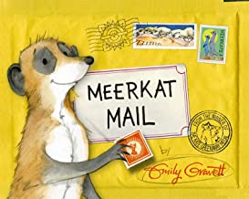  Meerkat Mail – Emily Gravett |  | 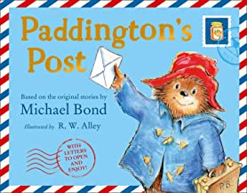  Paddington’s Post – Michael Bond |  | 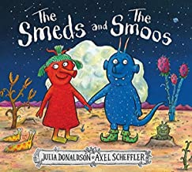  The Smeds and the Smoos – Julia Donaldson
Non-Fiction | Letters  Information texts linked to History and/or Geography
Poetry | Nursery Rhymes | Christmas Poems (Shape Poems) | Nursery Rhymes | Christmas Poems (Acrostic) | On the Ning Nang Nong – Spike Milligan | Twinkle, Twinkle, Little Star – Jane Taylor

CYCLE A - Autumn Term
Key Stage 2
 | Class 3 |  | Class 3/4 |  | Class 4 |  | Class 5 |  | Class 5/6 |  | Class 6
Narrative: Core Text | 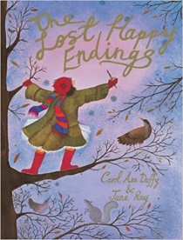  The Lost Happy Endings – Carol Ann Duffy |  | 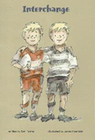  Interchange – Tom Palmer |  | 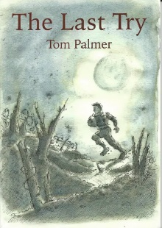  The Last Try – Tom Palmer |  | 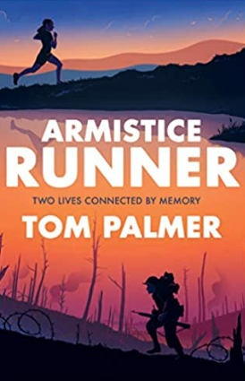  Armistice Runner – Tom Palmer |  | 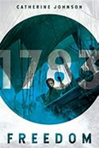  Freedom – Catherine Johnson |  | 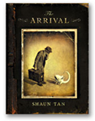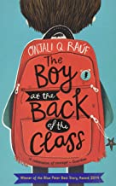  The Arrival – Shaun Tan  The Boy at the Back of the Class – Onjali Rauf
Non-Fiction | Instructions  Adverts  Information texts linked to History and/or Geography |  |  |  |  |  | Adverts  Historical Recount  Information texts linked to History and/or Geography
Poetry | Please Mrs Butler – Allan Ahlberg | The Magic Box – Kit Wright | The School Kid’s Rap – John Foster | The Night Before Christmas – Clement Clark Moore | The River – Valerie Bloom | Jabberwocky – Lewis Carroll | Budapest – Billy Collins | The Road Not Taken – Robert Frost | The Tyger – William Blake | What Has Happened to Lulu? – Charles Causely | The Inchcape Rock – Robert Southey | The Listeners – Walter De La Mare
CYCLE A - Spring Term
Key Stage 1
 | Class 1 |  | Class 1/2 |  | Class 2
Narrative: Core Text | 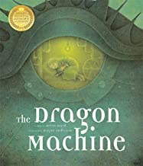  The Dragon Machine – Helen Ward |  | 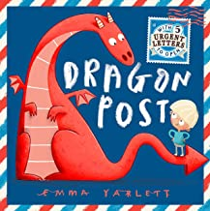  Dragon Post – Emma Yarlett |  | 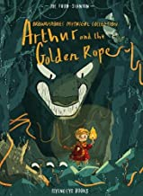  Arthur and the Golden Rope – Joe Todd Stanton
Non-Fiction | Instructions  Information texts linked to History and/or Geography
Poetry | At The Zoo – William Makepeace Thackeray | Wind on the Hill – A. A. Milne | At The Zoo – William Makepeace Thackeray | Wind on the Hill – A. A. Milne | Chocolate Cake – Michael Rosen | Who Has Seen the Wind? - Christina Rossetti

CYCLE A - Spring Term
Key Stage 2
 | Class 3 |  | Class 3/4 |  | Class 4 |  | Class 5 |  | Class 5/6 |  | Class 6
Narrative: Core Text | 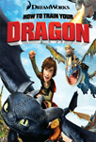  How To Train Your Dragon – Cressida Cowell |  | 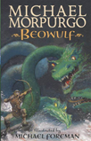  Beowulf – Michael Morpurgo |  | 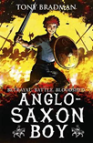  Anglo-Saxon Boy – Tony Bradman |  | 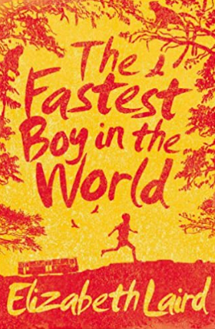  The Fastest Boy in the World – Elizabeth Laird |  | 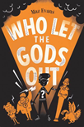  Who Let the Gods Out? – Maz Evans |  | 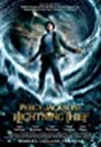  Percy Jackson and the Lightning Thief – Rick Riordan
Non-Fiction | Newspaper Reports  Letters  Information texts linked to History and/or Geography |  |  |  |  |  | Book Review  Explanation Texts  Information texts linked to History and/or Geography
Poetry | Limericks | Macavity: The Mystery Cat – T. S. Eliot | Kennings | Bed in Summer – Robert Louis Stevenson | Kennings | Daffodils – William Wordsworth | Haiku | Silver – Walter de la Mare | Haiku | Body Talk – Benjamin Zephania | Free Verse | If – Rudyard Kipling
CYCLE A - Summer Term
Key Stage 1
 | Class 1 |  | Class 1/2 |  | Class 2
Narrative: Core Text | 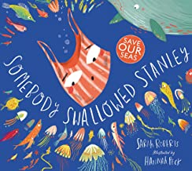  Somebody Swallowed Stanley – Sarah Roberts |  | 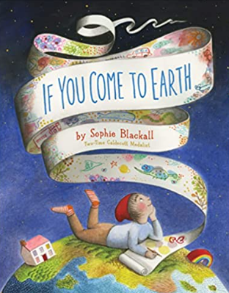  If You Come to Earth – Sophie Blackall |  | 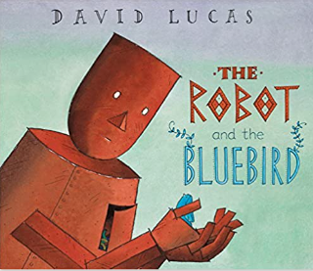  The Robot and the Bluebird – David Lucas
Non-Fiction | Explanation Texts  Information texts linked to Science
Poetry | The Morning Rush – John Foster | Buckingham Palace – A. A. Milne | The Morning Rush – John Foster | Buckingham Palace – A. A. Milne | The Sound Collector – Roger McGough | Little Red Riding Hood and the Wolf – Roald Dahl
CYCLE A - Summer Term
Key Stage 2
 | Class 3 |  | Class 3/4 |  | Class 4 |  | Class 5 |  | Class 5/6 |  | Class 6
Narrative: Core Text | 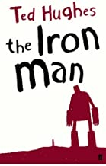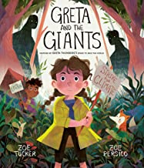  The Iron Man – Ted Hughes  Greta and the Giants – Zoe Tucker |  | 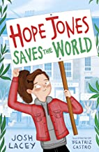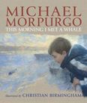  Hope Jones Saves the World – Josh Lacey  The Morning I Met a Whale – Michael Morpurgo |  | 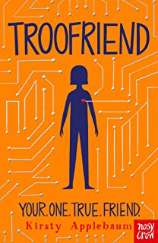  Troo Friend – Kirsty Applebaum |  | 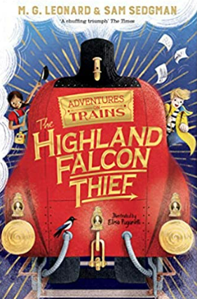  The Highland Falcon Thief – MG Leonard |  | 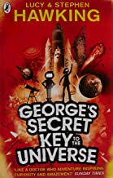  George’s Secret Key to the Universe – Lucy & Stephen Hawking |  | 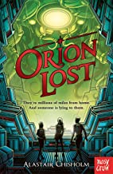  Orion Lost – Alastair Chisholm
Non-Fiction | Explanation Texts  Historical Recount  Information texts linked to History and/or Geography |  |  |  |  |  | Blogs  Arguments  Information texts linked to History and/or Geography
Poetry | Aliens Stole My Underpants – Brian Moses | Granny Can You Rap? – Jack Ousby | The Owl and the Pussycat – Edward Lear | From a Railway Carriage – Robert Louis Stevenson | Colonel Fazackerley Butterworth-Toast – Charles Causley | The Night Mail – W. H. Auden | The Highway Man – Alfred Noyes | The Blind Men and the Elephant – John G Saxe | A Smuggler’s Song – Rudyard Kipling | The Lady of Shalott – Alfred Lord Tennyson | The Spider and the Fly – Mary Howitt & Tony Di Terlizzi | The Raven – Edgar Allan Poe
CYCLE B - Autumn Term
Key Stage 1
 | Class 1 |  | Class 1/2 |  | Class 2
Narrative: Core Text | 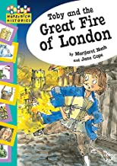  Toby and the Great Fire of London – Margaret Nash |  | 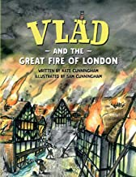  Vlad and the Great Fire of London – Kate Cunningham |  | 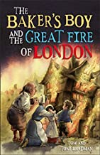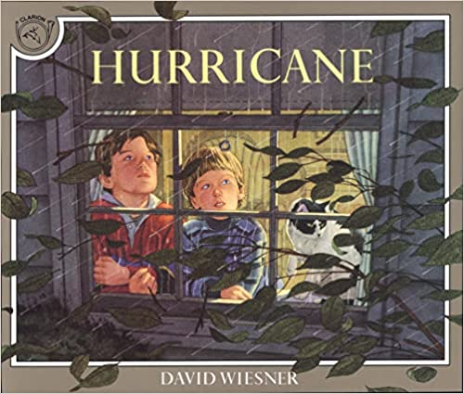  The Baker Boys and the Great Fire – Tom Bradman  Hurricane – David Wiesner
Non-Fiction | Historical Recount  Information texts linked to History and/or Geography
Poetry | Nursery Rhymes | Christmas Poems (Shape Poems) | Nursery Rhymes | Christmas Poems (Acrostic) | On the Ning Nang Nong – Spike Milligan | Twinkle, Twinkle, Little Star – Jane Taylor
CYCLE B - Autumn Term
Key Stage 2
 | Class 3 |  | Class 3/4 |  | Class 4 |  | Class 5 |  | Class 5/6 |  | Class 6
Narrative: Core Text | 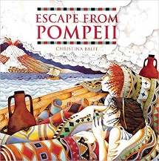  Escape from Pompeii – Christina Balit |  | 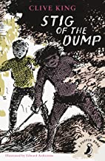  Stig of the Dump – Clive King |  | 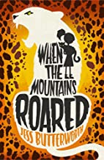  When the Mountains Roared – Jess Butterworth |  | 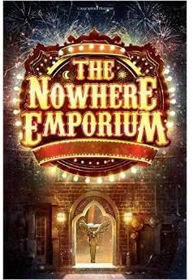  The Nowhere Emporium – Ross MacKenzie |  | 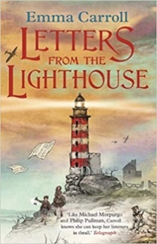  Letters from the Lighthouse – Emma Carroll |  | 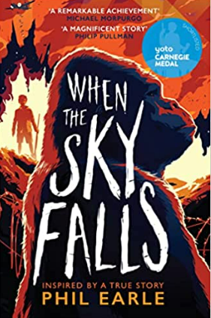  When the Sky Falls – Phil Earle
Non-Fiction | Diary  Newspaper Reports  Information texts linked to History and/or Geography |  |  |  |  |  | Book Review  Biographies  Information texts linked to History and/or Geography
Poetry | Please Mrs Butler – Allan Ahlberg | The Magic Box – Kit Wright | The School Kid’s Rap – John Foster | The Night Before Christmas – Clement Clark Moore | The River – Valerie Bloom | Jabberwocky – Lewis Carroll | Budapest – Billy Collins | The Road Not Taken – Robert Frost | The Tyger – William Blake | What Has Happened to Lulu? – Charles Causely | The Inchcape Rock – Robert Southey | The Listeners – Walter De La Mare
CYCLE B - Spring Term
Key Stage 1
 | Class 1 |  | Class 1/2 |  | Class 2
Narrative: Core Text | 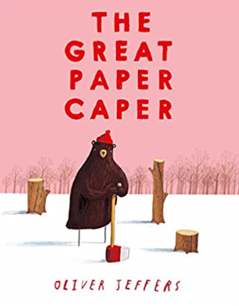  The Great Paper Caper – Oliver Jeffers |  | 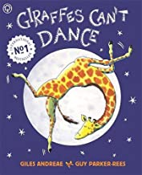  Giraffe’s Can’t Dance – Giles Andreae |  | 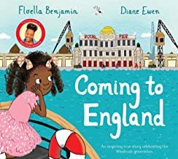  Coming to England – Floella Benjamin
Non-Fiction | Diary  Information texts linked to History and/or Geography
Poetry | At The Zoo – William Makepeace Thackeray | Wind on the Hill – A. A. Milne | At The Zoo – William Makepeace Thackeray | Wind on the Hill – A. A. Milne | Chocolate Cake – Michael Rosen | Who Has Seen the Wind? – Christina Rossetti
CYCLE B - Spring Term
Key Stage 2
 | Class 3 |  | Class 3/4 |  | Year 4 |  | Class 5 |  | Class 5/6 |  | Class 6
Narrative: Core Text | 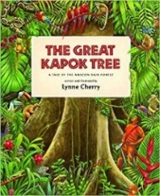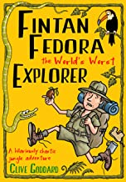  The Great Kapok Tree – Lynne Cherry  Fintan Fedora the World’s Worst Explorer – Clive Goddard |  | 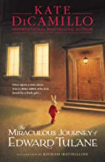  The Miraculous Journey of Edward Tulane – Kate DiCamillo |  | 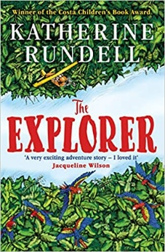  The Explorer – Katherine Rundell |  | 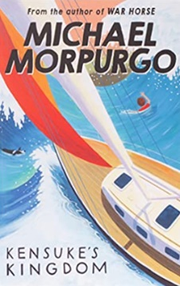  Kensuke’s Kingdom – Michael Morpurgo |  | 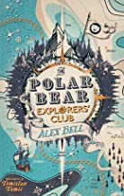  The Polar Bear Explorers’ Club – Alex Bell |  | 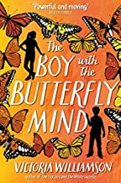  The Boy with the Butterfly Mind –  Victoria Williamson
Non-Fiction | Historial Recount  Instructions  Information texts linked to History and/or Geography |  |  |  |  |  | Persuasive Texts  Letters  Information texts linked to History and/or Geography
Poetry | Limericks | Macavity: The Mystery Cat – T. S. Eliot | Kennings | Bed in Summer – Robert Louis Stevenson | Kennings | Daffodils – William Wordsworth | Haiku | Silver – Walter de la Mare | Haiku | Body Talk – Benjamin Zephania | Free Verse | If – Rudyard Kipling
CYCLE B – Summer Term
Key Stage 1
 | Class 1 |  | Class 1/2 |  | Class 2
Narrative: Core Text | 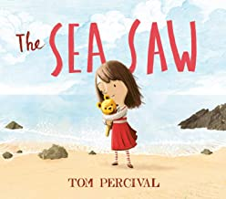  The Sea Saw – Tom Percival |  | 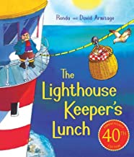  The Lighthouse Keeper’s Lunch – Ronda & David Armitage |  | 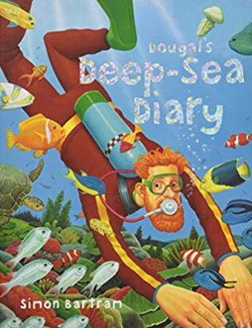  Dougal’s Deep Sea Diary – Simon Bartram
Non-Fiction | Newspaper Report  Information texts linked to History and/or Geography
Poetry | The Morning Rush – John Foster | Buckingham Palace – A. A. Milne | The Morning Rush – John Foster | Buckingham Palace – A. A. Milne | The Sound Collector – Roger McGough | Little Red Riding Hood and the Wolf – Roald Dahl
CYCLE B – Summer Term
Key Stage 2
 | Class 3 |  | Class 3/4 |  | Class 4 |  | Class 5 |  | Class 5/6 |  | Class 6
Narrative: Core Text | 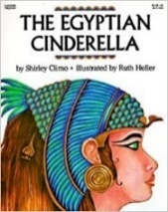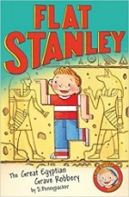  The Egyptian Cinderella – Shirley Climo  Flat Stanley and the Great Egyptian Grave Robbery – Sarah Pennypacker |  | 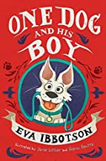  One Dog and His Boy – Eva Ibbotson |  | 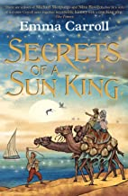  Secrets of a Sun King – Emma Carroll |  | 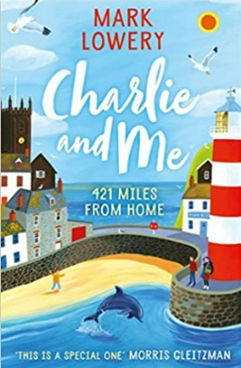  Charlie and Me – Mark Lowrey |  | 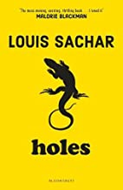  Holes – Louis Sachar |  | 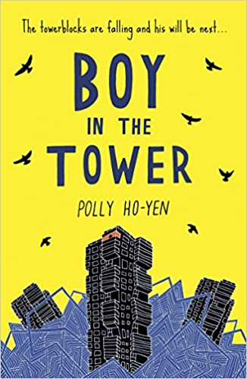  The Boy in the Tower – Polly Ho Yen
Non-Fiction | Persuasive Texts  Explanation Texts  Information texts linked to History and/or Geography |  |  |  |  |  | Historical Recount  Arguments  Information texts linked to History and/or Geography
Poetry | Aliens Stole My Underpants – Brian Moses | Granny Can You Rap? – Jack Ousby | The Owl and the Pussycat – Edward Lear | From a Railway Carriage – Robert Louis Stevenson | Colonel Fazackerley Butterworth-Toast – Charles Causley | The Night Mail – W. H. Auden | The Highway Man – Alfred Noyes | The Blind Men and the Elephant – John G Saxe | A Smuggler’s Song – Rudyard Kipling | The Lady of Shalott – Alfred Lord Tennyson | The Spider and the Fly – Mary Howitt & Tony Di Terlizzi | The Raven – Edgar Allan Poe
National Curriculum Objective Mapping
The below objectives are mapped directly from the National Curriculum for each year group, split across narrative, non-fiction and poetry.
Each objective should be included in the planning for each genre and covered each term.
 | Year 1
Word Reading
Pupils should be taught to:
- apply phonic knowledge and skills as the route to decode words
- respond speedily with the correct sound to graphemes (letters or groups of letters) for all 40+ phonemes, including, where applicable, alternative sounds for graphemes
- read accurately by blending sounds in unfamiliar words containing GPCs that have been taught
- read common exception words, noting unusual correspondences between spelling and sound and where these occur in the word
- read words containing taught GPCs and –s, –es, –ing, –ed, –er and –est endings
- read other words of more than one syllable that contain taught GPCs
- read words with contractions [for example, I’m, I’ll, we’ll], and understand that the apostrophe represents the omitted letter(s)
- read aloud accurately books that are consistent with their developing phonic knowledge and that do not require them to use other strategies to work out words
- re-read these books to build up their fluency and confidence in word reading
Narrative: Core Text | Comprehension  Pupils should be taught to:  - develop pleasure in reading, motivation to read, vocabulary and understanding by:  - listening to and discussing a wide range of poems, stories and non-fiction at a level beyond that at which they can read independently  - being encouraged to link what they read or hear read to their own experiences  - becoming very familiar with key stories, fairy stories and traditional tales, retelling them and considering their particular characteristics  - recognising and joining in with predictable phrases  - discussing word meanings, linking new meanings to those already known  - understand both the books they can already read accurately and fluently and those they listen to by:  - drawing on what they already know or on background information and vocabulary provided by the teacher  - checking that the text makes sense to them as they read and correcting inaccurate reading  - discussing the significance of the title and events  - making inferences on the basis of what is being said and done  - predicting what might happen on the basis of what has been read so far  - participate in discussion about what is read to them, taking turns and listening to what others say  - explain clearly their understanding of what is read to them.
Non-Fiction | Comprehension  Pupils should be taught to:  - develop pleasure in reading, motivation to read, vocabulary and understanding by:  - listening to and discussing a wide range of poems, stories and non-fiction at a level beyond that at which they can read independently  - being encouraged to link what they read or hear read to their own experiences  - discussing word meanings, linking new meanings to those already known  - understand both the books they can already read accurately and fluently and those they listen to by:  - drawing on what they already know or on background information and vocabulary provided by the teacher  - checking that the text makes sense to them as they read and correcting inaccurate reading  - participate in discussion about what is read to them, taking turns and listening to what others say  - explain clearly their understanding of what is read to them.
Poetry | Comprehension  Pupils should be taught to:  - develop pleasure in reading, motivation to read, vocabulary and understanding by:  - listening to and discussing a wide range of poems, stories and non-fiction at a level beyond that at which they can read independently  - learning to appreciate rhymes and poems, and to recite some by heart  - discussing word meanings, linking new meanings to those already known  - understand both the books they can already read accurately and fluently and those they listen to by:  - drawing on what they already know or on background information and vocabulary provided by the teacher  - checking that the text makes sense to them as they read and correcting inaccurate reading  - participate in discussion about what is read to them, taking turns and listening to what others say  explain clearly their understanding of what is read to them.

 | Year 2
Word Reading
Pupils should be taught to:
- continue to apply phonic knowledge and skills as the route to decode words until automatic decoding has become embedded and reading is fluent
- read accurately by blending the sounds in words that contain the graphemes taught so far, especially recognising alternative sounds for graphemes
- read accurately words of two or more syllables that contain the same graphemes as above
- read words containing common suffixes
- read further common exception words, noting unusual correspondences between spelling and sound and where these occur in the word
- read most words quickly and accurately, without overt sounding and blending, when they have been frequently encountered
- read aloud books closely matched to their improving phonic knowledge, sounding out unfamiliar words accurately, automatically and without undue hesitation
- re-read these books to build up their fluency and confidence in word reading.
Narrative: Core Text | Comprehension  Pupils should be taught to:  - develop pleasure in reading, motivation to read, vocabulary and understanding by:  - listening to, discussing and expressing views about a wide range of contemporary and classic poetry, stories and non-fiction at a level beyond that at which they can read independently  - discussing the sequence of events in books and how items of information are related  - becoming increasingly familiar with and retelling a wider range of stories, fairy stories and traditional tales  - recognising simple recurring literary language in stories and poetry  - discussing and clarifying the meanings of words, linking new meanings to known vocabulary  - discussing their favourite words and phrases  - understand both the books that they can already read accurately and fluently and those that they listen to by:  - drawing on what they already know or on background information and vocabulary provided by the teacher  - checking that the text makes sense to them as they read and correcting inaccurate reading  - making inferences on the basis of what is being said and done  - answering and asking questions  - predicting what might happen on the basis of what has been read so far  - participate in discussion about books, poems and other works that are read to them and those that they can read for themselves, taking turns and listening to what others say  - explain and discuss their understanding of books, poems and other material, both those that they listen to and those that they read for themselves.
Non-Fiction | Comprehension  Pupils should be taught to:  - develop pleasure in reading, motivation to read, vocabulary and understanding by:  - listening to, discussing and expressing views about a wide range of contemporary and classic poetry, stories and non-fiction at a level beyond that at which they can read independently  - discussing the sequence of events in books and how items of information are related  - being introduced to non-fiction books that are structured in different ways  - discussing and clarifying the meanings of words, linking new meanings to known vocabulary  - understand both the books that they can already read accurately and fluently and those that they listen to by:  - drawing on what they already know or on background information and vocabulary provided by the teacher  - checking that the text makes sense to them as they read and correcting inaccurate reading  - answering and asking questions  - participate in discussion about books, poems and other works that are read to them and those that they can read for themselves, taking turns and listening to what others say  - explain and discuss their understanding of books, poems and other material, both those that they listen to and those that they read for themselves.
Poetry | Comprehension  Pupils should be taught to:  - develop pleasure in reading, motivation to read, vocabulary and understanding by:  - listening to, discussing and expressing views about a wide range of contemporary and classic poetry, stories and non-fiction at a level beyond that at which they can read independently  - recognising simple recurring literary language in stories and poetry  - discussing and clarifying the meanings of words, linking new meanings to known vocabulary  - discussing their favourite words and phrases  - continuing to build up a repertoire of poems learnt by heart, appreciating these and reciting some, with appropriate intonation to make the meaning clear  - understand both the books that they can already read accurately and fluently and those that they listen to by:  - drawing on what they already know or on background information and vocabulary provided by the teacher  - checking that the text makes sense to them as they read and correcting inaccurate reading  - answering and asking questions  - participate in discussion about books, poems and other works that are read to them and those that they can read for themselves, taking turns and listening to what others say  - explain and discuss their understanding of books, poems and other material, both those that they listen to and those that they read for themselves.

 | Years 3 and 4
Word Reading
Pupils should be taught to:
- apply their growing knowledge of root words, prefixes and suffixes (etymology and morphology) as listed in English Appendix 1, both to read aloud and to understand the meaning of new words they meet
- read further exception words, noting the unusual correspondences between spelling and sound, and where these occur in the word.
Narrative: Core Text | Comprehension  Pupils should be taught to:  - develop positive attitudes to reading and understanding of what they read by:  - listening to and discussing a wide range of fiction, poetry, plays, non-fiction and reference books or textbooks  - reading books that are structured in different ways and reading for a range of purposes  - using dictionaries to check the meaning of words that they have read  - increasing their familiarity with a wide range of books, including fairy stories, myths and legends, and retelling some of these orally  - identifying themes and conventions in a wide range of books  - discussing words and phrases that capture the reader’s interest and imagination  - understand what they read, in books they can read independently, by:  - checking that the text makes sense to them, discussing their understanding and explaining the meaning of words in context  - asking questions to improve their understanding of a text  - drawing inferences such as inferring characters’ feelings, thoughts and motives from their actions, and justifying inferences with evidence  - predicting what might happen from details stated and implied  - identifying main ideas drawn from more than one paragraph and summarising these  - identifying how language, structure, and presentation contribute to meaning  - participate in discussion about both books that are read to them and those they can read for themselves, taking turns and listening to what others say.
Non-Fiction | Comprehension  Pupils should be taught to:  - develop positive attitudes to reading and understanding of what they read by:  - listening to and discussing a wide range of fiction, poetry, plays, non-fiction and reference books or textbooks  - reading books that are structured in different ways and reading for a range of purposes  - using dictionaries to check the meaning of words that they have read  - discussing words and phrases that capture the reader’s interest and imagination  - understand what they read, in books they can read independently, by:  - checking that the text makes sense to them, discussing their understanding and explaining the meaning of words in context  - asking questions to improve their understanding of a text  - identifying main ideas drawn from more than one paragraph and summarising these  - identifying how language, structure, and presentation contribute to meaning  - retrieve and record information from non-fiction
Poetry | Comprehension  Pupils should be taught to:  - develop positive attitudes to reading and understanding of what they read by:  - listening to and discussing a wide range of fiction, poetry, plays, non-fiction and reference books or textbooks  - using dictionaries to check the meaning of words that they have read  - preparing poems and play scripts to read aloud and to perform, showing understanding through intonation, tone, volume and action  - discussing words and phrases that capture the reader’s interest and imagination  - recognising some different forms of poetry [for example, free verse, narrative poetry]  - understand what they read, in books they can read independently, by:  - checking that the text makes sense to them, discussing their understanding and explaining the meaning of words in context  - identifying how language, structure, and presentation contribute to meaning

 | Years 5 and 6
Word Reading
Pupils should be taught to:
- apply their growing knowledge of root words, prefixes and suffixes (morphology and etymology), as listed in English Appendix 1, both to read aloud and to understand the meaning of new words that they meet.

Narrative: Core Text | Comprehension  Pupils should be taught to:  - maintain positive attitudes to reading and understanding of what they read by:  - continuing to read and discuss an increasingly wide range of fiction, poetry, plays, non-fiction and reference books or textbooks  - reading books that are structured in different ways and reading for a range of purposes  - increasing their familiarity with a wide range of books, including myths, legends and traditional stories, modern fiction, fiction from our literary heritage, and books from other cultures and traditions  - recommending books that they have read to their peers, giving reasons for their choices  - identifying and discussing themes and conventions in and across a wide range of writing  - making comparisons within and across books  - understand what they read by:  - checking that the book makes sense to them, discussing their understanding and exploring the meaning of words in context  - asking questions to improve their understanding  - drawing inferences such as inferring characters’ feelings, thoughts and motives from their actions, and justifying inferences with evidence  - predicting what might happen from details stated and implied  - summarising the main ideas drawn from more than one paragraph, identifying key details that support the main ideas  - identifying how language, structure and presentation contribute to meaning  - discuss and evaluate how authors use language, including figurative language, considering the impact on the reader  - participate in discussions about books that are read to them and those they can read for themselves, building on their own and others’ ideas and challenging views courteously  - explain and discuss their understanding of what they have read, including through formal presentations and debates, maintaining a focus on the topic and using notes where necessary  - provide reasoned justifications for their views.
Non-Fiction | Comprehension  Pupils should be taught to:  - maintain positive attitudes to reading and understanding of what they read by:  - continuing to read and discuss an increasingly wide range of fiction, poetry, plays, non-fiction and reference books or textbooks  - reading books that are structured in different ways and reading for a range of purposes  - identifying and discussing themes and conventions in and across a wide range of writing  - understand what they read by:  - asking questions to improve their understanding  - summarising the main ideas drawn from more than one paragraph, identifying key details that support the main ideas  - identifying how language, structure and presentation contribute to meaning  - discuss and evaluate how authors use language, including figurative language, considering the impact on the reader  - distinguish between statements of fact and opinion  - retrieve, record and present information from non-fiction  - participate in discussions about books that are read to them and those they can read for themselves, building on their own and others’ ideas and challenging views courteously  - explain and discuss their understanding of what they have read, including through formal presentations and debates, maintaining a focus on the topic and using notes where necessary  - provide reasoned justifications for their views.
Poetry | Comprehension  Pupils should be taught to:  - maintain positive attitudes to reading and understanding of what they read by:  - learning a wider range of poetry by heart  - preparing poems and plays to read aloud and to perform, showing understanding through intonation, tone and volume so that the meaning is clear to an audience  - understand what they read by:  - asking questions to improve their understanding  - identifying how language, structure and presentation contribute to meaning  - discuss and evaluate how authors use language, including figurative language, considering the impact on the reader

Progression of Skills
 | EYFS | Year 1 | Year 2 | Year 3 | Year 4 | Year 5 | Year 6
Decoding/ Fluency | Children use phonic knowledge to decode regular words and read them aloud accurately.  They read and understand simple sentences.  September 2020  Children can say a sound for each letter of the alphabet and at least 10 diagraphs.  They read words consistent with their phonic knowledge by sound-blending.  Children can read aloud simple sentences and books that are consistent with their phonic knowledge, including common exception words. | Children read phonetically decodable texts confidently by blending the sounds and GPC that they have been taught so far – by the end of Year 1 they can read all 40 + phonemes.  They have a growing number of words they can read automatically including common suffixes, multi-syllabic words and contractions.  Children are beginning to read using appropriate expression. | Children can read accurately by blending, including alternative sounds for graphemes and multi-syllabic words containing these graphemes. They can read common suffixes and exception words, noting unusual correspondences.  They can read at a speed of 90 words per minute accurately without overt sounding and blending.  Children demonstrate expression when reading aloud, particularly where characters are speaking in a story. | Children can apply their growing knowledge of root words, prefixes and suffixes, both to read aloud and to understand the meaning of new words they meet. They can read further exception words, noting the unusual correspondences between spelling and sound, and where these occur in the word.  Fluency is developed by choral reading in whole class reading and echo reading in small groups where needed. |  | Children apply their growing knowledge of root words, prefixes and suffixes (morphology and etymology).  They can read silently, aloud and chorally automatically recognising and grouping words quickly to help them gain meaning from what they read. Fluent readers read aloud effortlessly and with expression. Their reading sounds natural, as if they are speaking.
Tricky/ Common Exception / High Frequency Words | Phase 2  a, dad, I , mum, big, it, at, is, on, up, back, if, but, of, into, his, to, him, had, in, no, got, the, go, an, as, can, off, not, get, and  Phase 3  will, that, then, now, she, this, with, for, he, them, down, me, my, see, too, was, all, look, we, you, her, be, they, are | Phase 4  went, from, children, little, it’s, just, help, said, were, out, like, one, have, do, when, some, come, there, what, so  Phase 5  Mr, looked, made, your, came, saw, Mrs, don’t, asked, very, make, put, called, old, I’m, by, their, oh, could, about, house, time, day, people, here | door, floor, poor, because, find, kind, mind, behind, child, wild, climb, most, only, both, old, cold, gold, hold, told, every, everybody, even, great, break, steak, pretty, beautiful, after, fast, last, past, father, class, grass, pass, plant, path, bath, hour, move, prove, improve, sure, sugar, eye, could, should, would, who, whole, any, many, clothes, busy, people, water, again, half, money, parents, Christmas | accident, accidentally, actual, actually, address, although, answer, appear, arrive, believe, bicycle, breath, build, busy, business, calendar, caught, centre, century, certain, circle, complete, consider, continue, decide, describe, different, difficult, disappear, early, earth, eight, eighth, enough, exercise, experience, extreme, famous, favourite, February, forward, fruit, grammar, group, guard, guide, heard, heart, height, history, imagine, increase, important, interest, island, knowledge, learn, length, library, material, medicine, mention, minute, natural, naughty, notice, occasion, occasionally, often, opposite, ordinary, particular, perhaps, popular, position, possess, possession, possible, potatoes, pressure, probably, promise, purpose, quarter, question, recent, regular, reign, remember, sentence, separate, special, straight, strange, strength, suppose, surprise, therefore, though, thought, through, various, weight, woman, women |  | accommodate, accompany, according, achieve, aggressive, amateur, ancient, apparent, appreciate, attached, available, average, awkward, bargain, bruise, category, cemetery, committee, communicate, community, competition, conscience, conscious, controversy, convenience, correspond, criticise (critic + ise,), curiosity, definite, desperate, determined, develop, dictionary, disastrous, embarrass, environment, equip (–ped, –ment), especially, exaggerate, excellent, existence, explanation, familiar, foreign, forty, frequently, government, guarantee, harass, hindrance, identity, immediate(ly), individual, interfere, interrupt, language, leisure, lightning, marvellous, mischievous, muscle, necessary, neighbour, nuisance, occupy, occur, opportunity, parliament, persuade, physical, prejudice, privilege, profession, programme, pronunciation, queue, recognise, recommend, relevant, restaurant, rhyme, rhythm, sacrifice, secretary, shoulder, signature, sincere(ly), soldier, stomach, sufficient, suggest, symbol, system, temperature, thorough, twelfth, variety, vegetable, vehicle, yacht
Range and familiarity of reading | Children listen to and discuss poems, stories and non-fiction at a level beyond that at which they can independently read.  They are encouraged to link what they hear or read to their own experiences  Children are becoming very familiar with key stories and traditional tales and can re-tell them through role-play. They can join in with well-known or repeated phrases in stories. | Children listen to and can discuss a wide range of poems, stories and non-fiction at a level beyond that at which they can independently read.  They are encouraged to link what they read or hear read to their own experiences  Children are becoming very familiar with key stories and traditional tales, retelling them and considering their particular characteristics.  They recognise and join in with predictable phrases. | Children listen to, discuss and express views about a wide range of poetry, stories and non-fiction at a level beyond that at which they can read independently.  Children are becoming increasingly familiar with and retelling a wider range of stories and traditional tales.  They recognise simple recurring literary language in stories and poetry. | Children listen to and discuss a wide range of fiction, poetry, plays, non-fiction, reference books and textbooks.  Their reading books that are structured in different ways and they are given opportunities to read for a range of purposes across the curriculum.  Children are increasing their familiarity with a wide range of books, including key stories, traditional tales, myths, and legends – they are able to retell some of these orally.  They are beginning to identify themes and conventions in a wide range of books. |  | Children continue to read and discuss an increasingly wide range of fiction, poetry, plays, non-fiction, reference books and textbooks.  Their reading books that are structured in different ways and they are given opportunities to read for a range of purposes across the curriculum. They are able to make comparisons within and across books.  Children are increasing their familiarity with a wide range of books, including myths and legends modern fiction, fiction from our literary heritage, and books from other cultures and traditions.  They are able to identify and discuss themes and conventions in and across a wide range of writing.
Vocabulary | Children use talking about books to clarify their thinking, ideas and feelings.  E.g. linking to their own experiences. | Children discuss new word meanings and link them to words they already know. | Children begin to find the meaning of new words using the context of the sentence. They use pictures to help support this skill. | Children begin to find the meaning of new words using substitution within a sentence. They are able to use their growing vocabulary to suggest synonyms. | Children find the meaning of new words using the context of the sentence. They also link new words to other words they already know. | Children ‘read around the word’ and explore its meaning in the broader context of a section or paragraph. They are also able to draw on the understanding of the morphology and etymology of language to support their understanding.
Inference | Children can infer meaning about characters’ feelings using pictures and verbally link these to their own experience. | Children make inferences about characters’ feelings using what they say and do to infer basic points with direct reference to the pictures and words in the text. | Children make inferences about characters’ feelings using what they say and do to infer basic points and begin, with support to pick up on more subtle references. | Children can infer characters’ feelings, thoughts and motives from their stated actions. They begin to justify their opinion by referencing a specific point in the text. | Children can infer characters’ feelings, thoughts and motives from their stated actions. They are beginning to understand the author’s use of setting to influence the mood of a text. They will consolidate the skill of justifying their opinion using a specific reference point in the text. | Children can infer characters’ feelings, thoughts and motives, giving one or two pieces of evidence to support the point they are making. They begin to draw evidence from more than one place across a text.
Prediction | Children make suggestions about what might happen next or how a story might end based on events so far.  Innovate stories through role-play and small world play. | Children make simple predictions based on the story and on their own life experience. They can begin to explain these ideas verbally or though pictures. | Children make predictions using their own knowledge as well as what has happened so far to make logical predictions and give explanations of them. | Children use relevant prior knowledge to make predictions and justify them. They are taught the skill of using details from the text to form further predictions. | Children use relevant prior knowledge as well as details from the text to form predictions and to justify them. They begin to monitor these predictions and compare them with the text as they read on. | Predictions are supported by relevant evidence from the text. Children confirm and modify predictions as they read on.
Explain | Children can begin to explain who their favourite character is and why. They can say whether or not they like a story and begin to explain why. | Children can say whether or not they like a story, who their favourite character is and explain why. They can begin to make links to their own experiences, other stories and characters. | Children explain their reasons for story and character preferences and make suggestions for improving a text. They can begin to make links to their own experiences, other stories and characters. | Children are able to describe which section of the text was the most interesting/exciting and explain their choice making links to prior reading. They can find and copy words and phrases to describe characters, setting and mood. Children can begin to identify the structure of a text, how it links and its purpose. | Children beginning to recognize the author’s use of language affects the readers understanding of character, setting, and mood.  They can identify changes in mood across a text.  Children can the recognise structure and purpose and explain why a text is arranges in a particular way. | Children can explain how content is related and contributes to the meaning as a whole.  They are able to describe how the author’s use of language affects the readers understanding of character, setting, and mood. They can describe and justify the author’s choice of vocabulary and explain how it enhances meaning.  Children are able to explain how the themes and patterns develop across a text.  They can explain how information links and contributes to the overall experience of reading a text.
Retrieval | Children can answer simple recall questions about stories without pictures or prompts. | Children can answer questions about what has just happened in a story. | Children can explain their understanding of independent reading by answering simple questions about what they have just read. Children begin to learn the skill of ‘skim and scan’ to retrieve details. | Children use the skill of ‘skim and scan’ to retrieve details quickly.  Children begin to use quotations from the text. | Children confidently skim and scan texts to record details, using relevant quotes to support their answers to questions. | Children confidently skim and scan, and use the skill of reading before and after to retrieve information. They use evidence from across larger sections of text. | Children confidently skim and scan, and use the skill of reading before and after to retrieve information. They use evidence from across whole chapters or texts.
Sequence/ Summarise | Children recall and order key events from the text. They use a story line or narrative in their role-play and small world play. | Children retell and order events from the text. They begin to discuss how events are linked. | Children retell and order events from the text. They begin to discuss how events are linked. They are able to focus on the main content of the story. | Children begin to distinguish between the important and less important information in a text. They are able to give a brief verbal summary of texts that they are familiar with. | Children are able to write a brief summary of main points, identifying and using important information. | Children begin to make connections between information across the text and include this information in their written summaries. | Children summarise information from across a text and link information by analysing and evaluating ideas between sections of the text.
Questioning | With support, children can generate simple questions using who, when, what, how and why. | Children can generate literal recall questions. They are taught how to ask questions before, during and after reading. | Children generate literacy recall questions of their own, which go with the text they are reading before, during and after reading. Children can use their own question words and begin to be able to change their questions as they progress through the text | Children generate a variety of questions – recall and inferential to help them understand the text further.  Introduce the idea of ‘story themes’  Love, friendship, revenge, learn a lesson, good vs evil etc. | Children generate a variety of questions – recall and inferential and questions about the deeper meaning of a text to help them understand the text further.  Develop the idea of story themes.  Courage, overcoming obstacles etc. | Children actively generate a variety of questions to focus the reading and adjust questions in light of evidence from the text. Adults model the use of critical thinking skills that take the discussion deeper and beyond the text. | Children actively generate a variety of questions to focus the reading and adjust questions in light of evidence from the text. They ask their own critical thinking questions that take the discussion beyond the text.

VIPERS
Reading lessons in Years 1-6 incorporate the VIPERS method to ensure coverage of the reading curriculum. VIPERS is an acronym to aid the recall of the 6 reading domains. They are the key areas which children need to know and understand in order to improve their comprehension of texts.
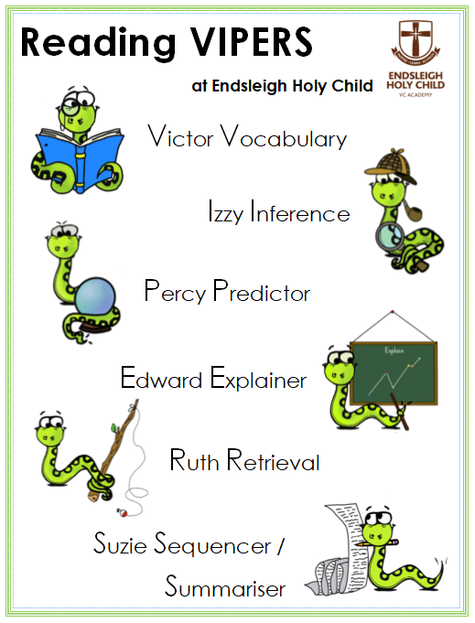
The 6 domains focus on the comprehension aspect of reading and not the mechanics: decoding, fluency, prosody etc. As such, VIPERS is not a reading scheme but rather a method of ensuring that teachers ask, and students are familiar with, a range of questions. They allow the teacher to track the type of questions asked and the children’s responses to these which allows for targeted questioning afterwards.

We expect class teachers to plan for coverage of the reading domains, through the use of VIPERS and that the characters are used in classes from Years 1-6. Taking on the role of the VIPERS ‘characters’ will help the children to understand and apply their reading skills. We expect the VIPERS imagery to be used on lesson PowerPoints and printed materials to support pupils’ understanding.

Examples of progression in question stems (VIPERS)
 | KS1 |  | KS2
Vocabulary  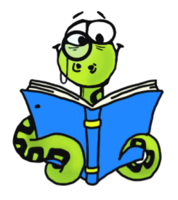 | What does the word ………. mean in this sentence?  Find and copy a word, which means ……….  What does this word or phrase tell you about ………?  Which word in this section do you think is the most important? Why?  Which of the words best describes the character/setting/mood etc?  Can you think of any other words the author could have used to describe this?  Why do you think ………. is repeated in this section? |  | What do the words ...... and …… suggest about the character, setting and mood?  Which word tells you that….?  Which keyword tells you about the character/setting/mood?  Find one word in the text, which means……  Find and highlight the word that is closest in meaning to…….  Find a word or phrase which shows/suggests that…….
Infer  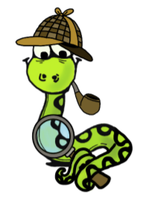 | Why was……. feeling……..?  Why did ………… happen?  Why did ………. say ……….?  Can you explain why……….?  What do you think the author intended when they said……….?  How does ………. make you feel? |  | Find and copy a group of words which show that…  How do these words make the reader feel? How does this paragraph suggest this?  How do the descriptions of …… show that they are ……..  How can you tell that……?  What impression of …… do you get from these paragraphs?  What voice might these characters use?  What was …. thinking when…..?  Who is telling the story?
Predict  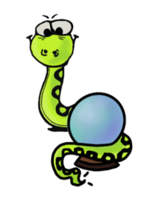 | Look at the book cover/blurb – what do you think this book will be about?  What do you think will happen next? What makes you think this?  How does the choice of character or setting affect what will happen next?  What is happening? What do you think happened before? What do you think will happen after?  What do you think the last paragraph suggests will happen next? |  | From the cover what do you think this text is going to be about?  What is happening now? What happened before this?  What will happen after?  What does this paragraph suggest will happen next?  What makes you think this?  Do you think the choice of setting will influence how the plot develops?  Do you think… will happen? Yes, no or maybe? Explain your answer using evidence from the text.
Explain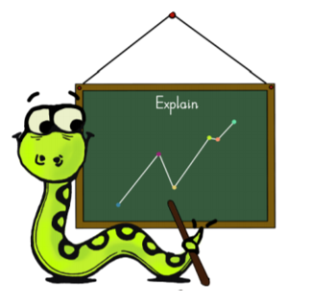 | Who is your favourite character? Why?  Why do you think all the main characters are girls in this book?  Would you like to live in this setting? Why/why not?  Is there anything you would change about this story?  Do you like this text? What do you like about it? |  | Why is the text arranged in this way?  What structures has the author used?  What is the purpose of this text feature?  Is the use of ….. effective?  The mood of the character changes throughout the text.  Find and copy the phrases, which show this.  What is the author’s point of view?  What affect does ….. have on the audience?  How does the author engage the reader here?  Which words and phrases did ….. effectively?  Which section was the most interesting/exciting part?  How are these sections linked?
Retrieve  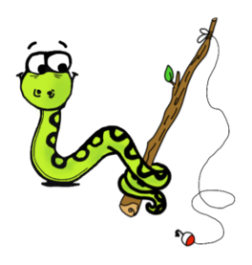 | What kind of text is this?  Who did…..?  Where did…..?  When did…..?  What happened when…..? | Why did …….. happen?  How did …….?  How many…..?  What happened to……? | How would you describe this story/text? What genre is it? How do you know?  How did…?  How often…?  Who had…? Who is…? Who did….?  What happened to…? | What does…. do?  How ….. is ……..?  What can you learn from …… from this section?  Give one example of……  The story is told from whose perspective?
Sequence/ Summarise  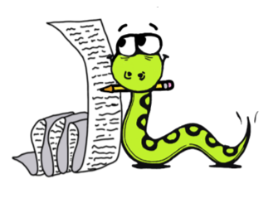 | Can you number these events 1-5 in the order that they happened?  What happened after …….?  What was the first thing that happened in the story?  Can you summarise in a sentence the opening/middle/end of the story?  In what order do these chapter headings come in the story? |  | Can you number these events 1-5 in the order that they happened?  What happened after …….?  What was the first thing that happened in the story?  Can you summarise in a sentence the opening/middle/end of the story?  In what order do these chapter headings come in the story?

Reading Assessment
It is expected that each class teacher will have a Reading Tracker. These are to be saved in Staff Shared – Assessment – 2022-2023 – Trust Trackers – Reading.
This assessment tracker will contain information about each child in the class. Split classes will require one tracker per year group.
The assessment tracker needs to be used as a reflective tool to consider which objectives have been covered, and how well individual children have met the objectives. For the majority of the curriculum, objectives can not be ‘ticked off’, having been taught once or twice. They are ongoing and will be revisited frequently throughout the term.
The assessment tracker needs to be updated at least half termly, to ensure attainment is being recorded, and progress can be tracked. Class teachers may choose to update the documents more frequently.
The boxes on the document should be rated to show when the child has independently met a learning objective, and the level to which the objective has been met (GDS, ARE, BARE).
The assessment tracker will be used to monitor attainment against the National Curriculum and inform teacher assessment judgements for summative assessment purposes.
It will be expected that the trackers will be used as evidence during Pupil Progress Meetings and Quality Assurance Meetings.

Reading Spine
Introduction:
At Endsleigh Holy Child VC Academy, we strive to create a love of reading. One of the ways we achieve this is through our Reading Spine, from the very beginning of a child’s journey at Endsleigh in Foundation 1, all the way to Year 6.
The Reading Spine is a list of ‘essential reads’; a store of classics to create a living library inside a child’s mind. The Reading Spine builds a common bank of stories that binds the community at Endsleigh Holy Child VC Academy together, through shared and deeply-imagined common experiences.
The purpose of the Reading Spine is to give pupils access to books that build the imagination and equip the reader with language. Around 75% of our vocabulary comes from reading. Reading also develops the ability to think in the abstract; to follow lines of thought.
The Reading Spine should be a central reference point from which teachers select books to share with their class, but should also be supplemented by many other books.
The list of suggested books leaves enough space for teachers to add their own enthusiasms and new finds.

Expectations:
- Teachers should read from the class novel or picture book on a daily basis.
- Teachers of split classes should ensure that a selection of stories from both year groups’ books are read.
- It is worth taking the time to read the books through beforehand and think about where you might wish to stop for discussion, or possibly, some kind of activity. The key is to halt at moments where an activity or discussion is needed to deepen engagement and understanding. There is no expectation for written activities.

Reading Spine:
Foundation
Nursery  - Where’s Spot? (Eric Hill)  - Dear Zoo (Rod Campbell)  - You Choose (Pippa Goodhart and Nick Sharratt)  - We’re Going on a Bear Hunt (Michael Rosen)  - Brown Bear, Brown Bear, What Do You See? (Bill Martin Jnr and Eric Carle)  - Jasper’s Beanstalk (Nick Butterworth and Mick Inkpen)  - The Very Hungry Caterpillar (Eric Carle)  - Hairy Maclary from Donaldson’s Dairy (Lynley Dodd)  - Each Peach Pear Plum (Allan and Janet Ahlberg)  - Hug (Jez Alborough)  - The Train Ride (June Crebbin)  - Come on, Daisy! (Jane Simmons) | Reception  - Owl Babies (Martin Waddell)  - The Gruffalo (Julia Donaldson)  - Handa’s Surprise (Eileen Browne)  - Mr Grumpy’s Outing (John Burningham)  - Rosie’s Walk (Pat Hutchins)  - Six Dinner Sid (Inga Moore)  - Mrs Armitage (Quentin Blake)  - Whatever Next (Jill Murphy)  - On the Way Home (Jill Murphy)  - Farmer Duck (Martin Waddell)  - Goodnight Moon (Margaret Wise Brown)  - Shhh! (Sally Grindley)

Note: The 2020-2021 academic year will follow Cycle A. The 2021-2022 academic year will follow Cycle B, and so on. The picture books are repeated in both cycles.
Year 1
Cycle A  - Peace at Last (Jill Murphy)  - Where the Wild Things Are (Maurice Sendak)  - Avocado Baby (John Burningham)  - Lost and Found (Oliver Jeffers)  - Beegu (Alexis Deacon)  - Cops and Robbers (Allan and Janet Ahlberg) | Cycle B  - Can’t You Sleep Little Bear? (Martin Waddell)  - The Elephant and the Bad Baby (Elfrida Vipont and Raymond Briggs)  - The Tiger Who Came to Tea (Judith Kerr)  - Knuffle Bunny (Mo Willems)  - Dogger (Shirley Hughes)  - Elmer (David McKee)

Year 2
Cycle A  - Traction Man is Here (Mini Grey)  - Amazing Grace (Mary Hoffman)  - Who’s Afraid of the Big Bad Book? (Lauren Child)  - Not Now Bernard (David McKee)  - The Flower (John Light)  - Emily Brown and The Thing (Cressida Cowell)  - The Owl Who Was Afraid of the Dark (Jill Tomlinson)  - Fantastic Mr Fox (Roald Dahl)  - Flat Stanley (Jeff Brown) | Cycle B  - Meerkat Mail (Emily Gravett)  - Pumpkin Soup (Helen Cooper)  - Dr Xargle’s Book of Earthlets (Tony Ross)  - Tuesday (David Weisner)  - Gorilla (Anthony Browne)  - Frog and Toad Together (Arnold Lobel)  - The Giraffe, the Pelly and Me (Roald Dahl)  - The Hodgeheg (Dick King-Smith)  - Willa and old Miss Annie (Berlie Doherty)

Year 3
Cycle A  - The Iron Man (Ted Hughes)  - The Sheep-pig (Dick King-Smith)  - The Lion, the Witch and the Wardrobe (CS Lewis)  - Hansel and Gretel (Anthony Browne) | Cycle B  - Cat Tales: Ice Cat (Linda Newberry)  - The Abominables Dick King-Smith)  - The Battle of Bubble and Squeak (Philippa Pearce)  - Hansel and Gretel (Anthony Browne)

Year 4
Cycle A  - Bill’s New Frock (Anne Fine)  - Why the Whales Came (Michael Morpurgo)  - The Snow Walker’s Son (Catherine Fisher)  - Voices in the Park (Anthony Browne) | Cycle B  - Charlotte’s Web (EB White)  - The Firework-Maker’s Daughter (Phillip Pullman)  - Perry Angel’s Suitcase (Glenda Millard)  - Voices in the Park (Anthony Browne)

Year 5
Cycle A  - The Wolves of Willoughby Chase (Joan Aiken)  - Wolf Brother (Michelle Paver)  - The Midnight Fox (Betsy Byars)  - FArTHER (Grahame Baker-Smith) | Cycle B  - Varjak Paw (SF Said)  - Street Child (Berlie Doherty)  - Tom’s Midnight Garden (Philippa Pearce)  - FArTHER (Grahame Baker-Smith)

Year 6
Cycle A  - Holes (Louis Sacher)  - The Hobbit (JRR Tolkein)  - Fireweed (Jill Paton Walsh)  - The Arrival (Shaun Tan) | Cycle B  - Clockwork (Philip Pullman)  - Skellig (David Almond)  - River Boy (Tim Bowler)  - The Arrival (Shaun Tan)

Home Reading
At Endsleigh Holy Child VC Academy, we are determined that every child will learn to read. We have rigorous approaches for reading at home.
Read, Write, Inc. – EYFS and Year 1
Pupils in EYFS and Year 1 learn to read with Read Write Inc. Phonics. In EYFS, children start the year taking home wordless books. Once pupils are able to independently blend sounds in order to read words, pupils take home ‘Sound Blending’ books, allowing them to practise their decoding skills with single words.
When pupils reach the appropriate stage in their phonics, children take home a copy of the storybook that they have read in school with their reading teacher. Pupils will also take home a Book Bag Book. This book builds upon the ideas and many of the words in the storybook that they have just read. The pupils will receive new books once they reach the appropriate stage in their weekly phonics teaching. We encourage pupils to bring their books to school every day, along with their Reading Records, to enable them to be changed at the correct point of learning.
Reading Scheme – Year 2 to Year 6
Pupils generally finish following the Read, Write, Inc. scheme during Year 2, although some children may remain on the scheme for a little longer, if needed. Once they finish the phonics scheme, pupils progress on to the reading scheme books. Our reading scheme books are organised into Book Bands to take account of the age-related expectations at the end of each year within the National Curriculum. Each of the stages are graded by colour and the children are encouraged to read a range of fiction, non-fiction, poetry and plays. Children should be able to read their individual reading books with approximately 95% accuracy to develop their fluency and confidence. All pupils up to and including Year 4 will receive a book from the reading scheme. At an appropriate stage in their learning, pupils in Years 5 and 6 may read a book of their choosing, which will be monitored by the class teacher to ensure that it is appropriately-challenging.
All pupils are able to supplement their reading by accessing books other than the one provided from the reading scheme.
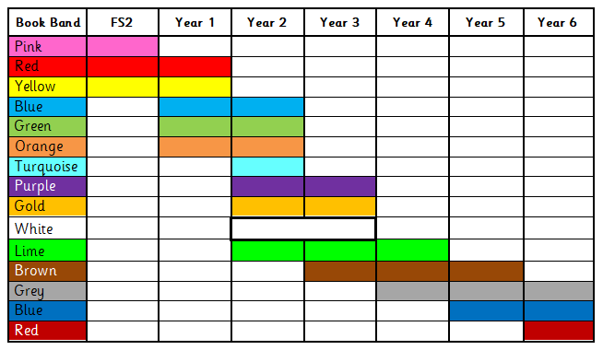
The table below shows the year groups that each colour band relates to:

Some of the colour bands span more than one year group, and some colour bands overlap. This is because children’s reading often develops in fits and starts, where their reading skills develop quite quickly and then this slows as they consolidate them over a period of time. This is reflected in the broader colour bands as the children move through Key Stage 2. Children should be able to read their individual reading books with approximately 95% accuracy to develop their fluency and confidence. Some children may be reading books that are slightly below their year group. This will be necessary to ensure that they are able to read the words confidently and to develop their understanding of the text before moving on. If a child is a very confident reader who is demonstrating a good understanding of text and higher order comprehension skills, they may be reading books in a higher colour band than their chronological age.

