Contents
- Intent Statement
- at EHC on a page
- in EYFS
- LTP
- Skills & Progression
- Year group specific Substantive Knowledge
- Lesson Design
- Lesson sequencing and planning support for each term.

Physical Education

Intent Statement

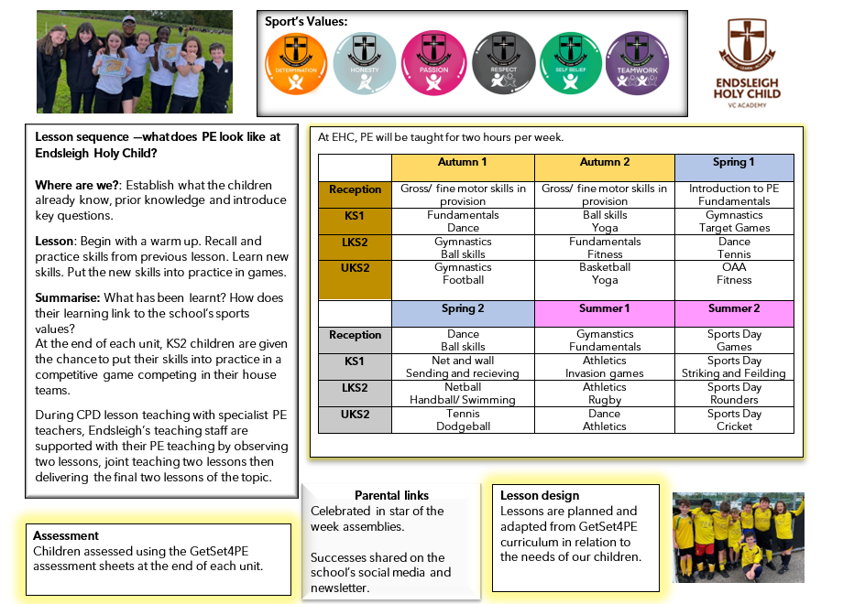
PE on a pag
PE on a page:

Long Term Plan:

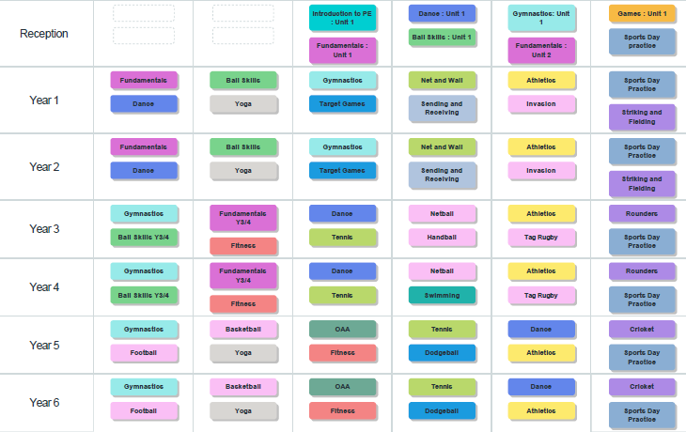

EYFS

Physical development and the EYFS
Physical development is one of the three prime areas within the Early Years Foundation Stage (EYFS). Each prime area is divided into Early Learning Goals, for physical education the main area is:
- Gross Motor Skills
Children at the expected level of development will:
- Negotiate space and obstacles safely, with consideration for themselves and others;
- Demonstrate strength, balance and co-ordination when playing;
- Move energetically, such as running, jumping, dancing, hopping, skipping and climbing.

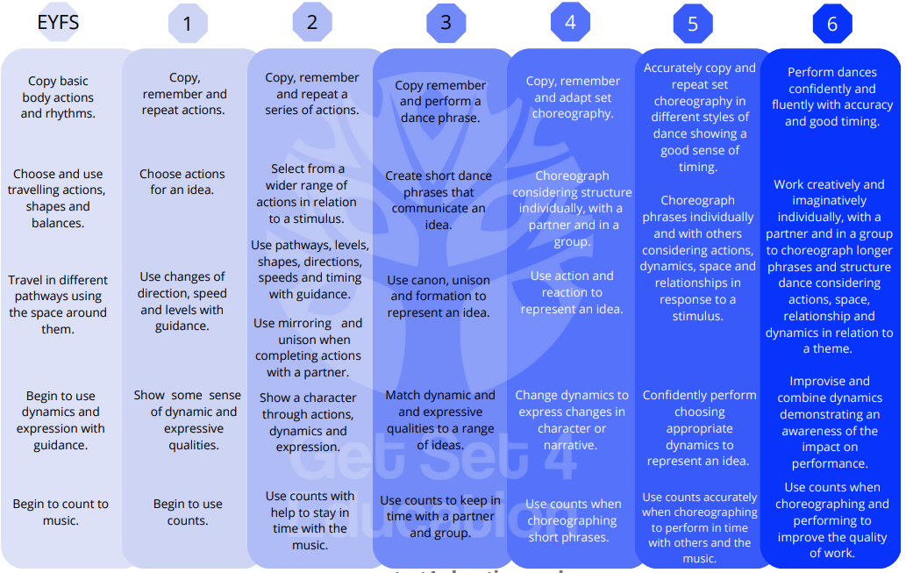
Skills Progression: Dance
Making

F.M.S Fundamentals, Fitness and Athletics
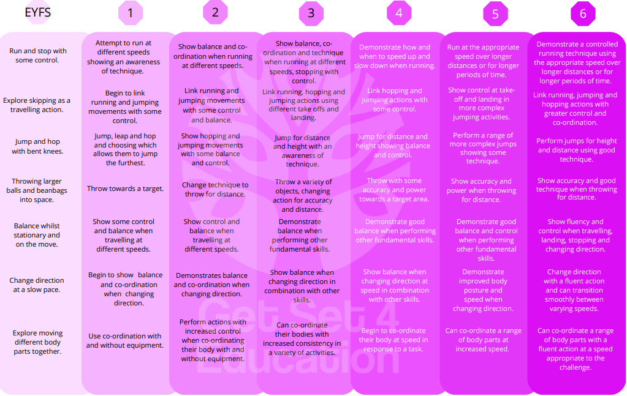Food
Games: through ball skills, sending and receiving, invasion, target, net and wall, striking and fielding games.

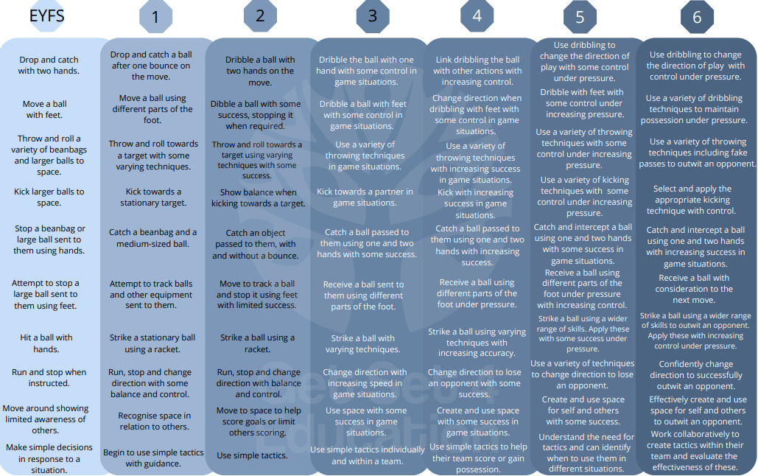
Body management: Yoga and Gymnastics.
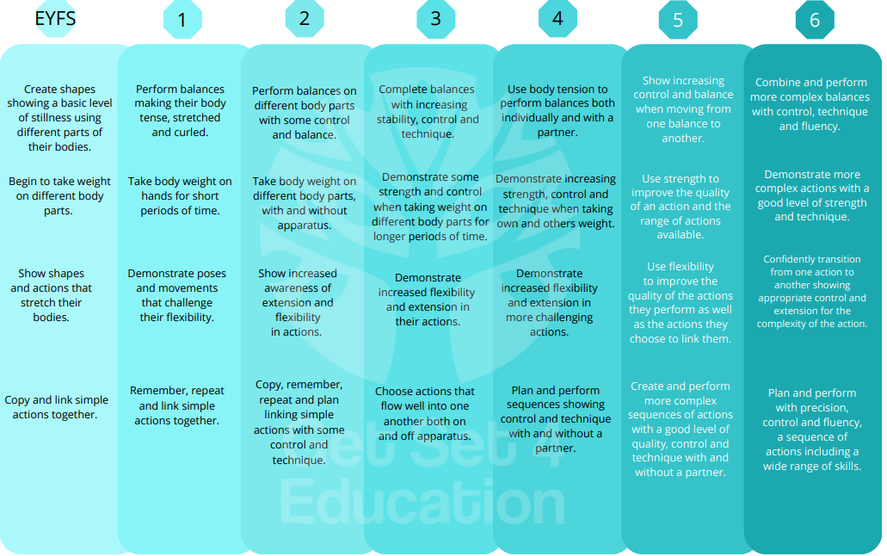

OAA
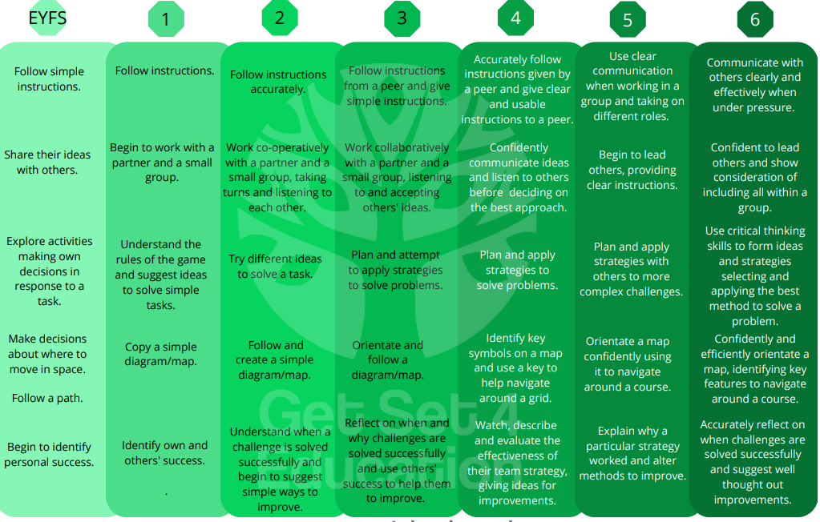
Swimming (KS2)
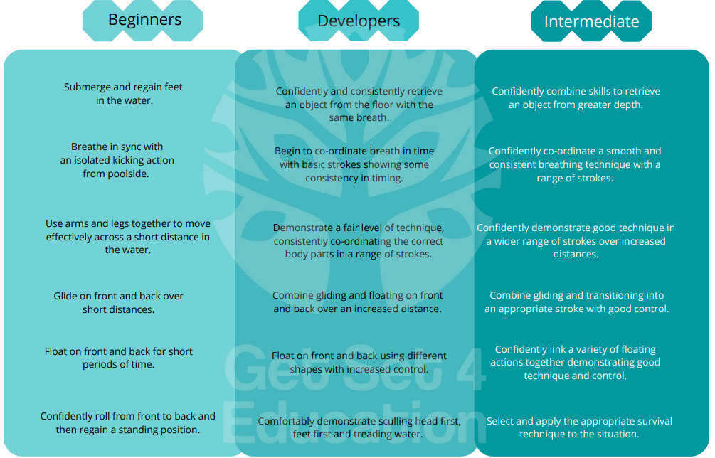

Lesson design:
2 – 2 -2 Lesson Structure |  | Retrieval Practice
1 & 2 | Observe  Working with a PE specialist you should take an active part in the lesson using the 2-2-2 feedback proforma. | All lessons should begin with a ‘Revisit’ on previous learning. This shows the children what they have already achieved and how their new learning will build upon this. Teachers should encourage children to draw on other areas of the PE Curriculum that the skill supports and will build upon.
3 & 4 | Team Teach  Working collaboratively with the PE specialist you should deliver the lessons together. | Challenge & Support
5 &6 | Deliver  Using the PE Specialist as a resource, you will take an active role in delivering the lesson receiving next steps to further develop your practice. | Space, Task, Equipment and People (STEP) is a good model to support pupils to make progress within a lesson. This will ensure that ALL children are able to access the learning and make progress over time.
PE Lessons |  | Marking & Feedback
Children should be appropriately dressed for each lesson. PE lessons should be highly active and engaging. Children should not be queuing or in games where they are ‘out’ often with all children encouraged to engage. Within the lesson pupils should be given opportunities to develop social, emotional and cognitive skills. Technical vocabulary should be used and modelled through teacher and pupils within the lesson. |  | Live feedback should be at the centre of every PE lesson with all adults and children clear on the focus of the lesson and spending time critiquing skills so that WAGOLLs can be celebrated and children can support each other develop their skills.  Self-reflection should be supported so that children can challenge themselves and support can be quickly identified through STEP.

Lesson Design
EYFS:

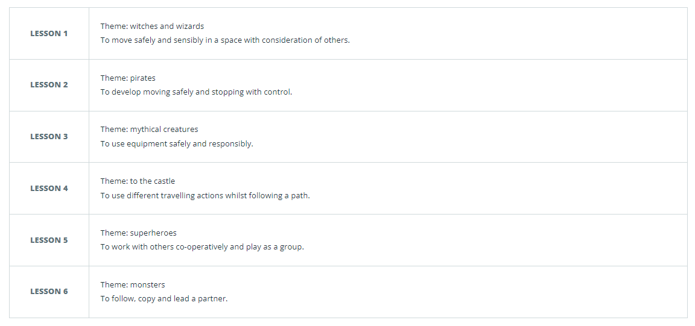
Spring: Introduction to PE Unit 1
KS1 – Pri

nting

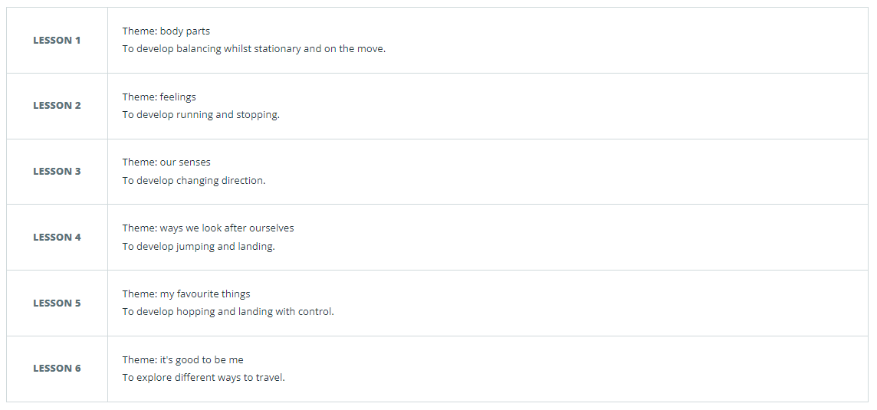
Spring: Fundementals Unit 1

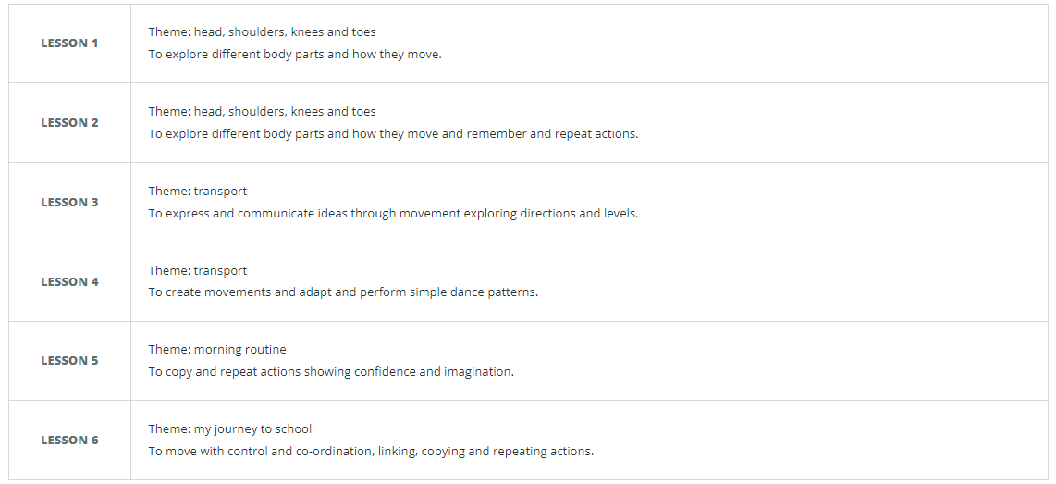
Spring: Dance Unit 1
K

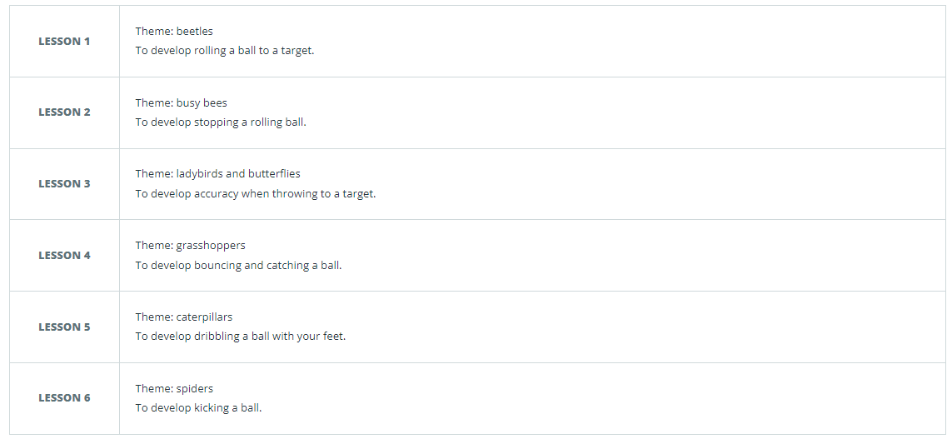
Spring: Ball skills Unit 1
KS1 – Printing S1 – Printing

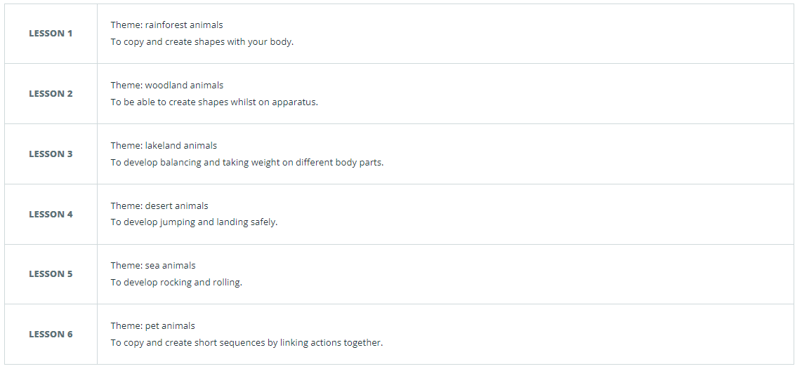
Summer: Gymnastics Unit 1

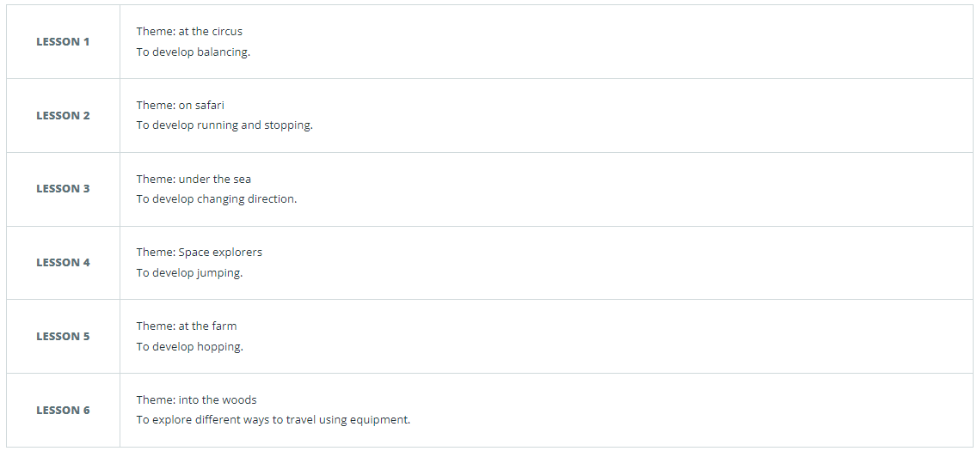
Summer: Fundamentals Unit 2

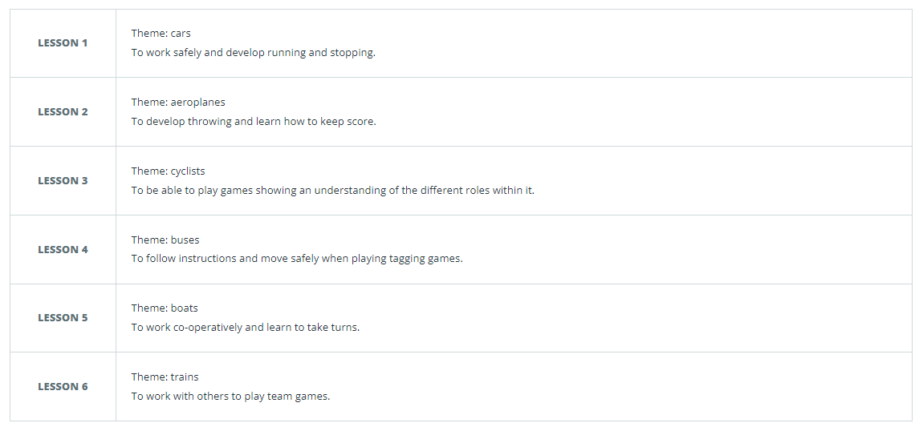
Summer: Games Unit 1

Summer: Fundamentals Unit 2

Year 1:

Autumn: Fundamentals
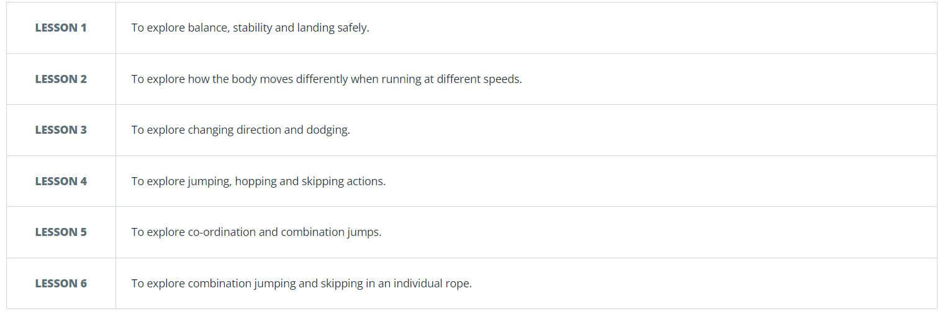
KS1 – Pri

nting

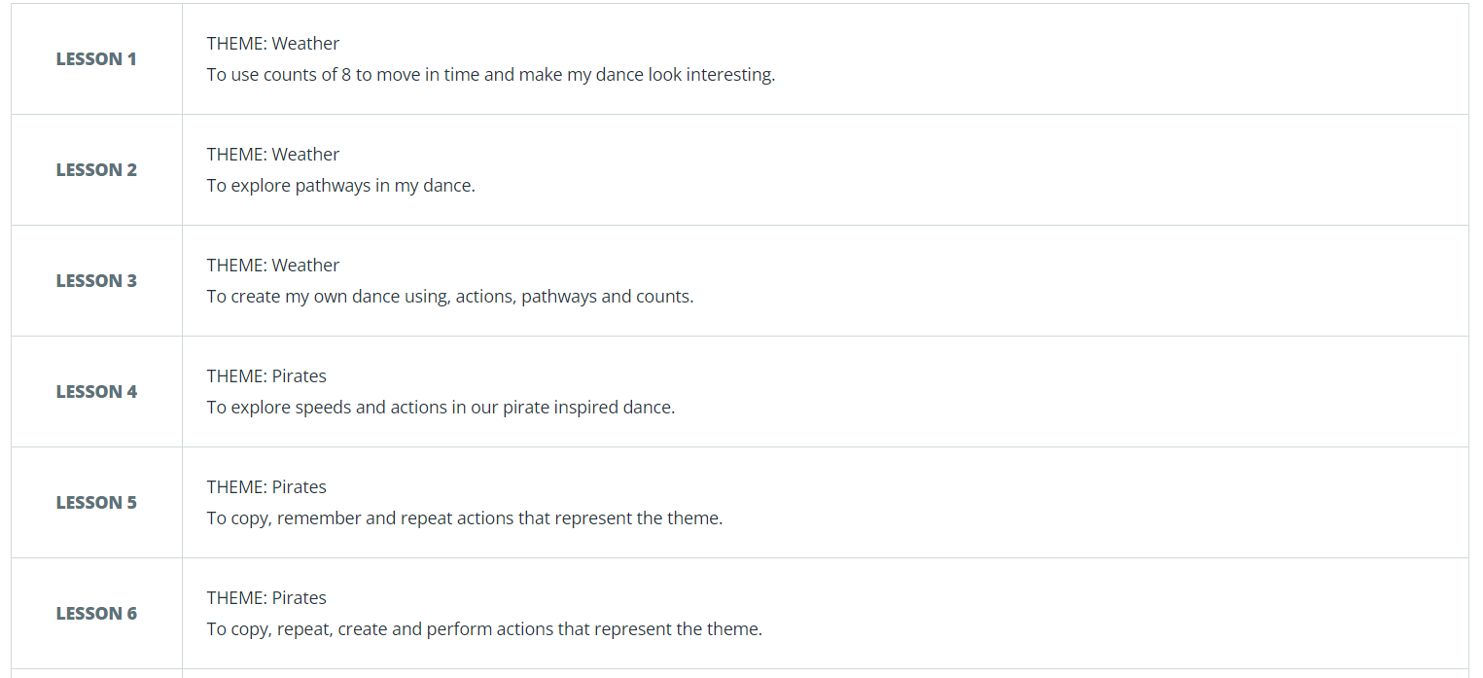
Autumn: Dance
K

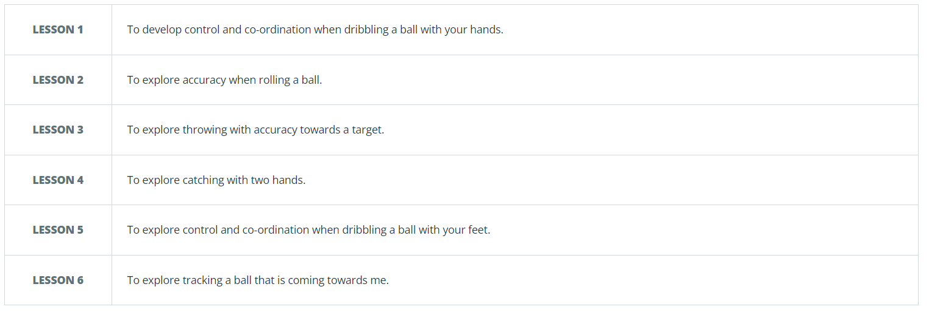
Autumn: Ball skills
KS1 – Printing S1 – Printing

Autumn: Yoga

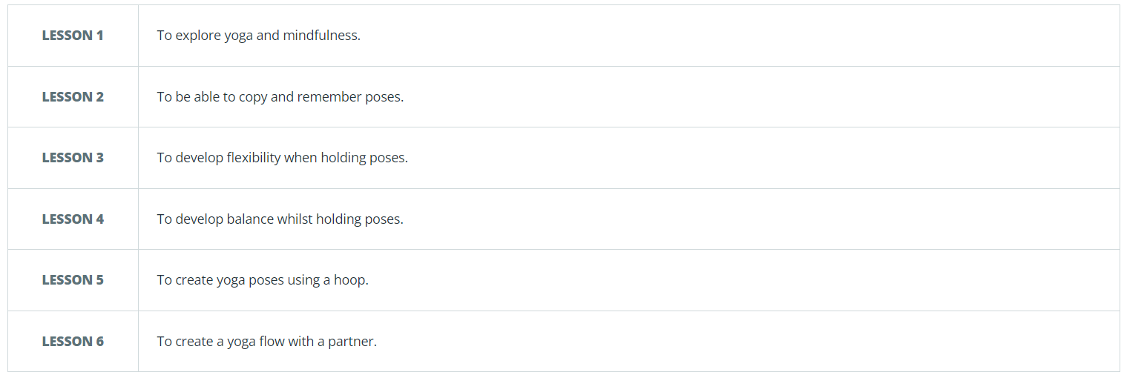

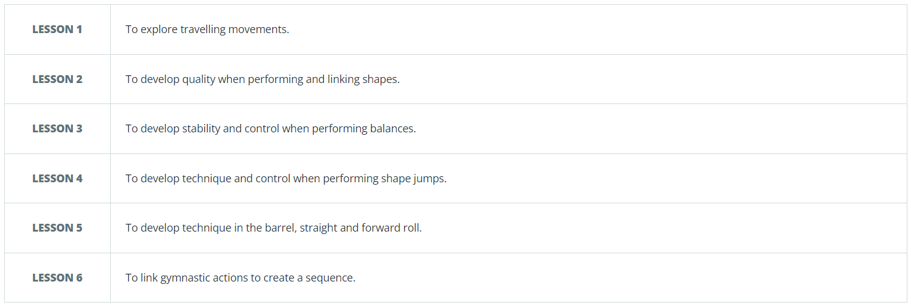
Spring: Gymnastics

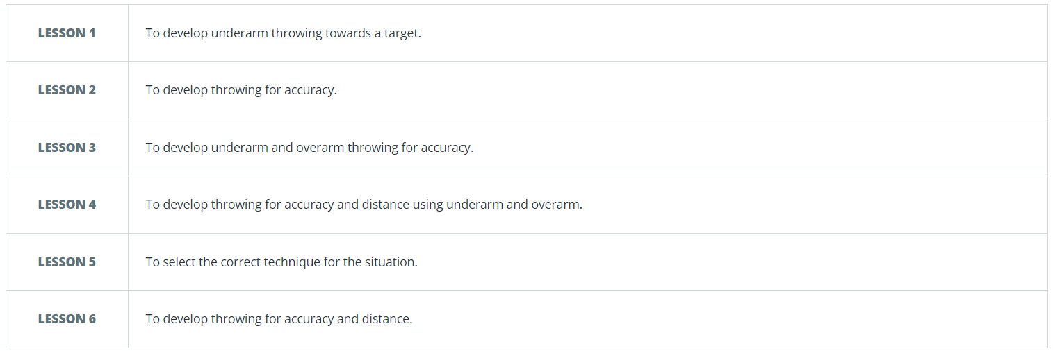
Spring: Target Games
K

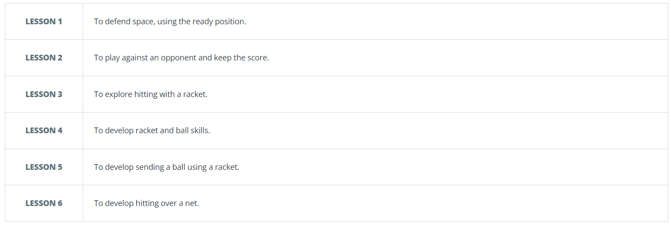
Spring: Net and Wall
KS1 – Printing S1 – Printing

Spring: Sending and Receiving

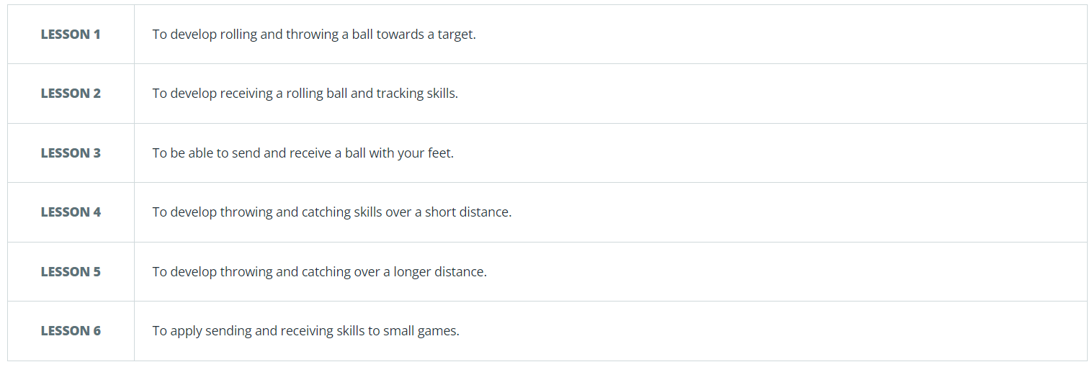

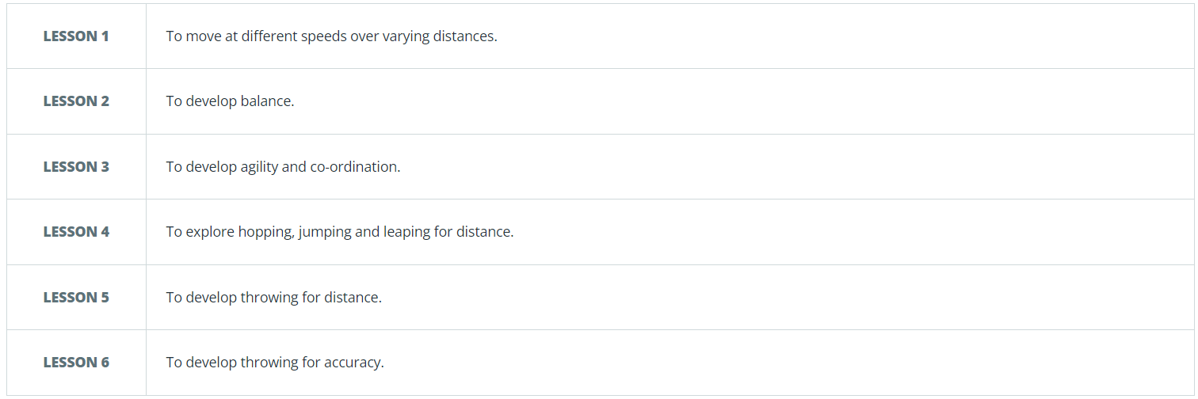
Summer: Athletics

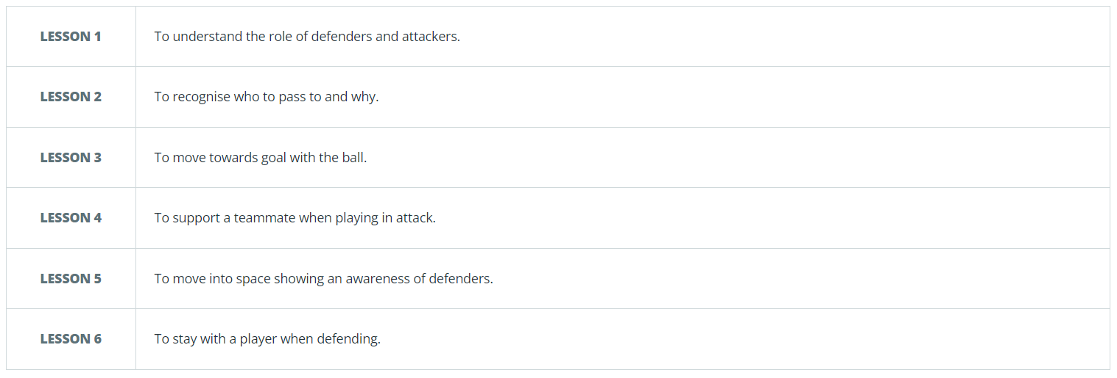
Summer: Invasion

Summer: Striking and fielding
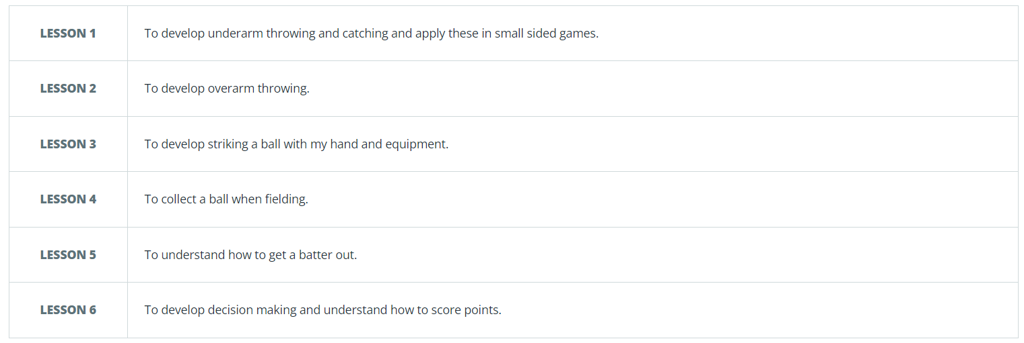

Lesson Design
Year 2:

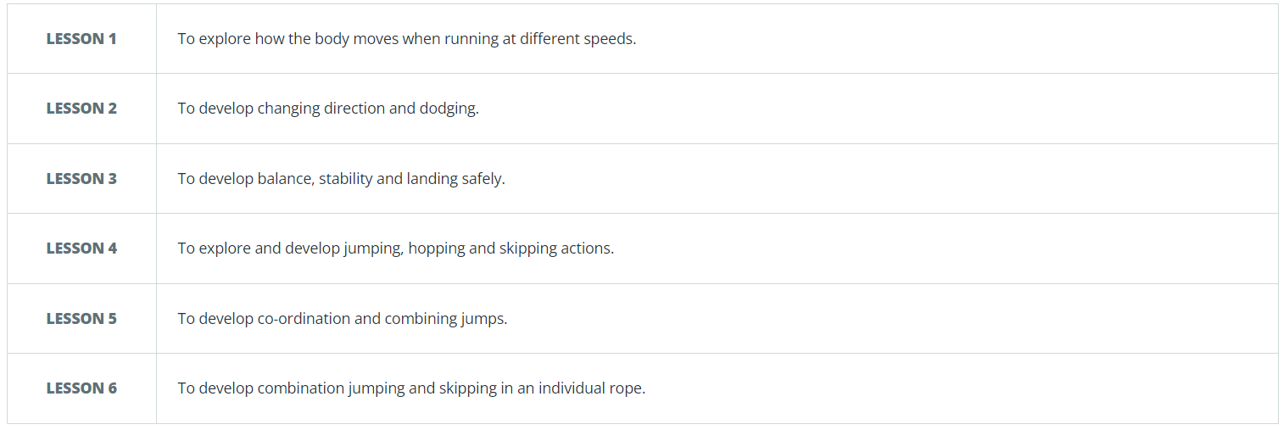
Autumn: Fundamentals
KS1 – Pri

nting

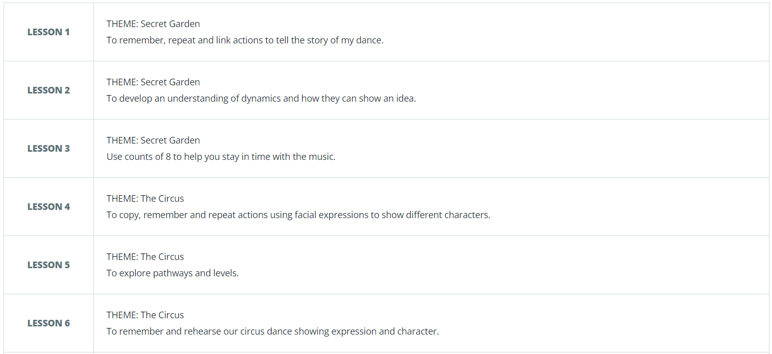
Autumn: Dance
K

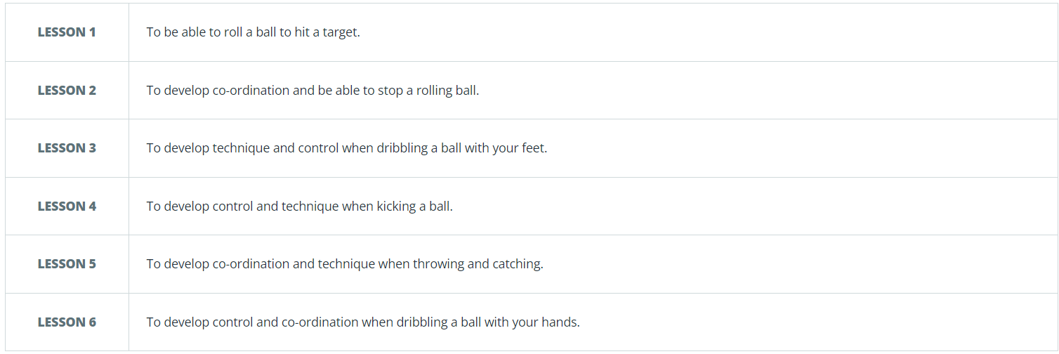
Autumn: Ball skills
KS1 – Printing S1 – Printing

#
Autumn: Yoga

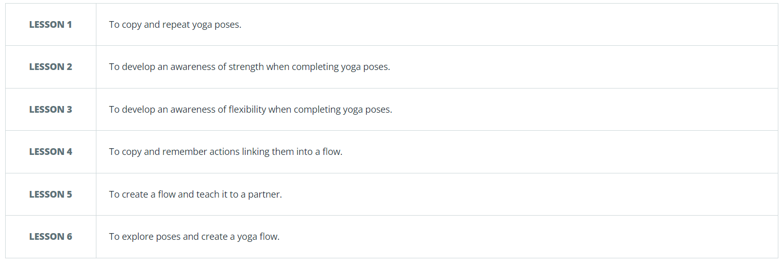

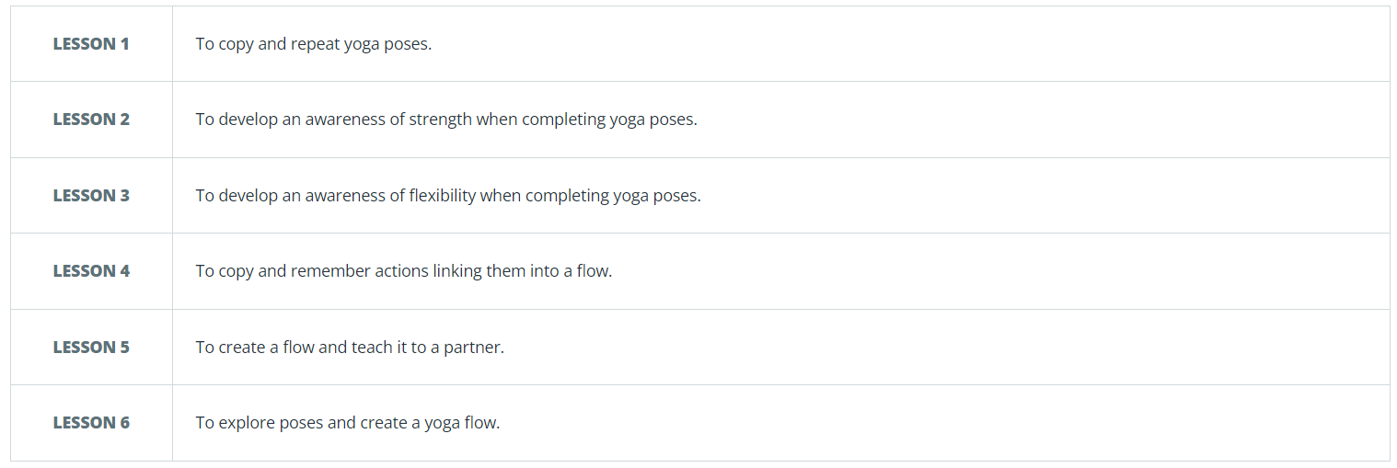
Spring: Gymnastics

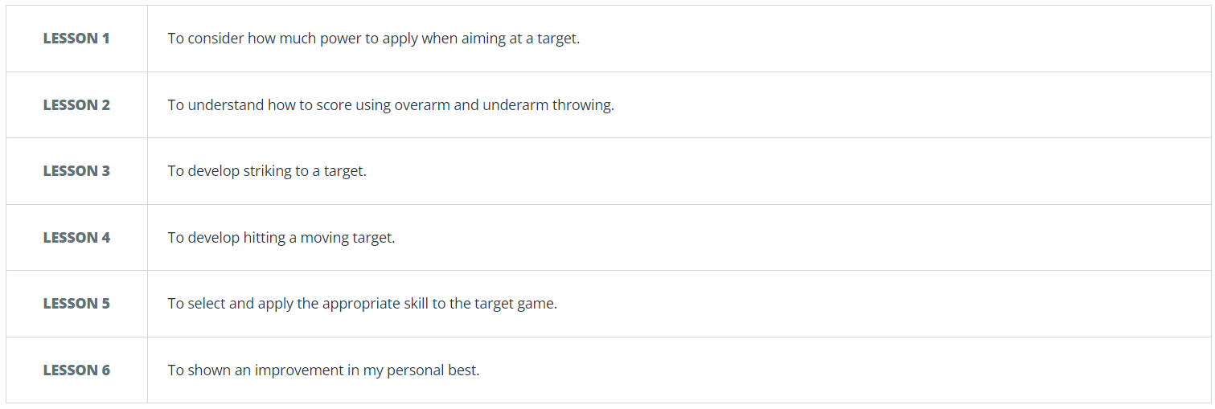
Spring: Target Games
K

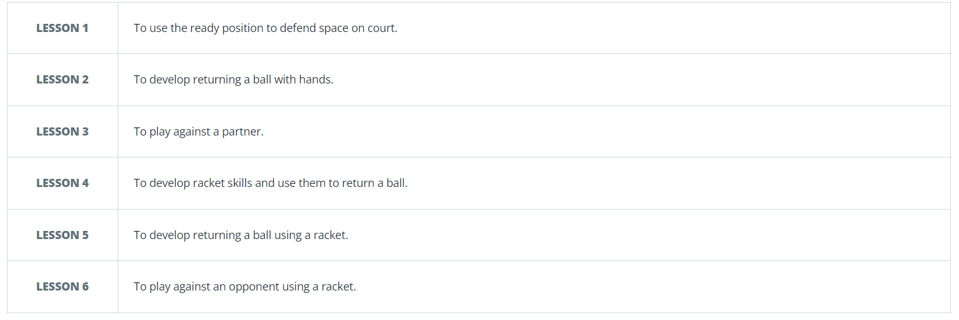
Spring: Net and Wall
KS1 – Printing S1 – Printing

Spring: Sending and Receiving

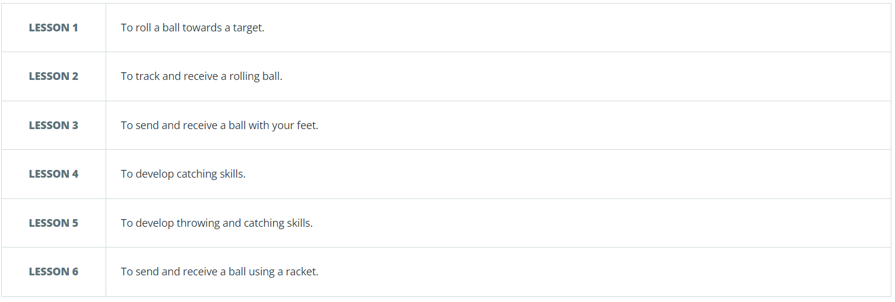

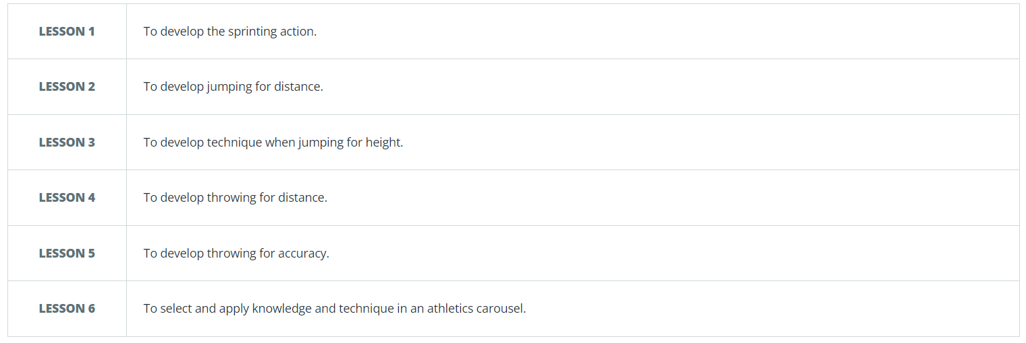
Summer: Athletics

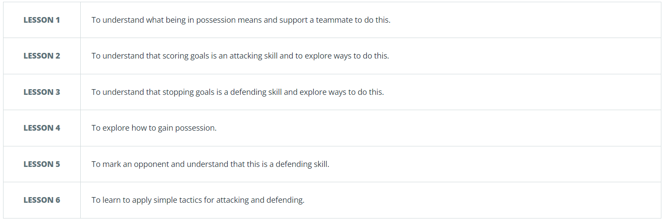
Summer: Invasion

Summer: Striking and fielding
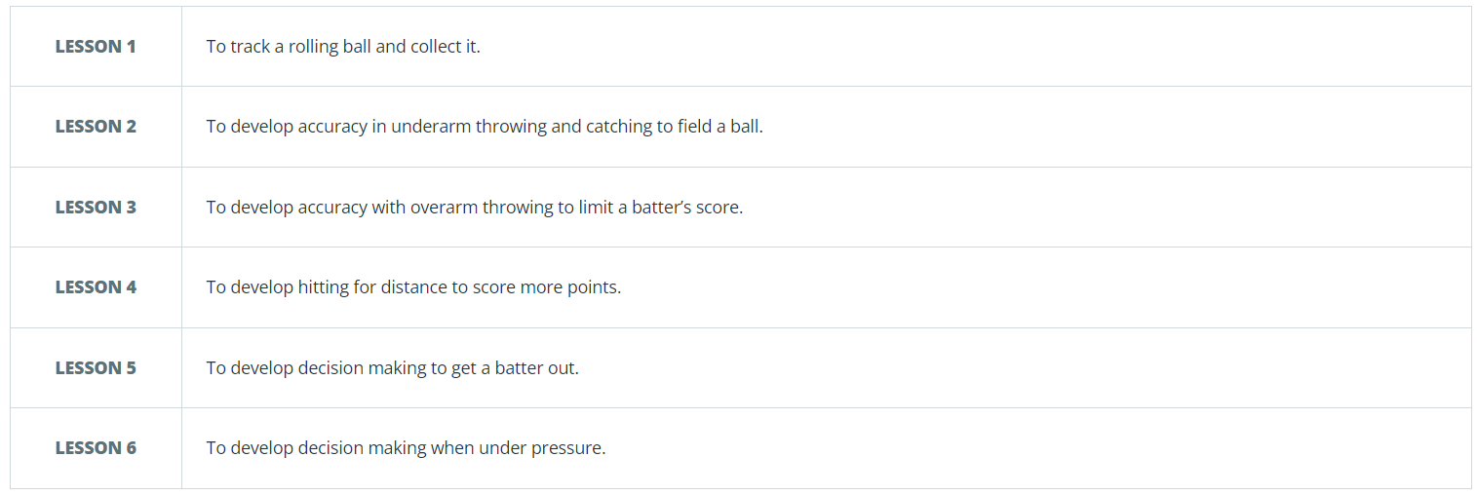

Autumn: Fundamentals
KS1 – Pri

nting

Autumn: Dance
K

Autumn: Ball skills
KS1 – Printing S1 – Printing

#
Autumn: Yoga

Spring: Gymnastics

Spring: Target Games
K

Spring: Net and Wall
KS1 – Printing S1 – Printing

Spring: Sending and Receiving

Summer: Athletics

Summer: Invasion

Summer: Striking and fielding

Year 3
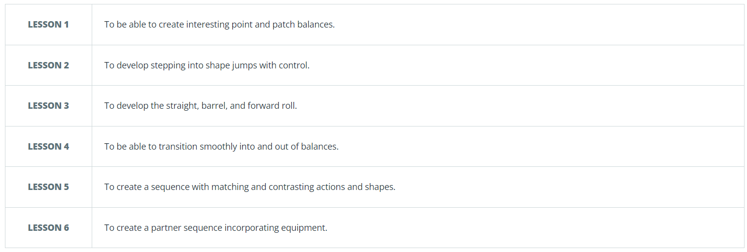
Autumn: Gymnastics
KS1 – Pri

nting

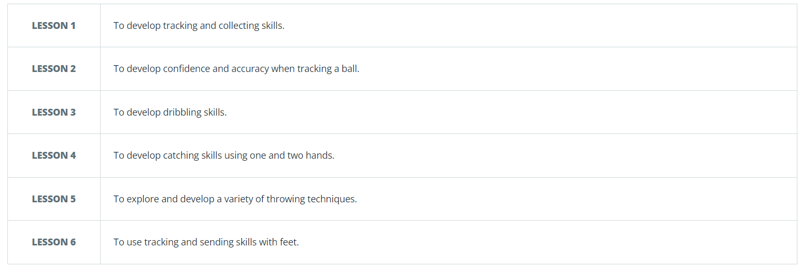
Autumn: Ball skills
K

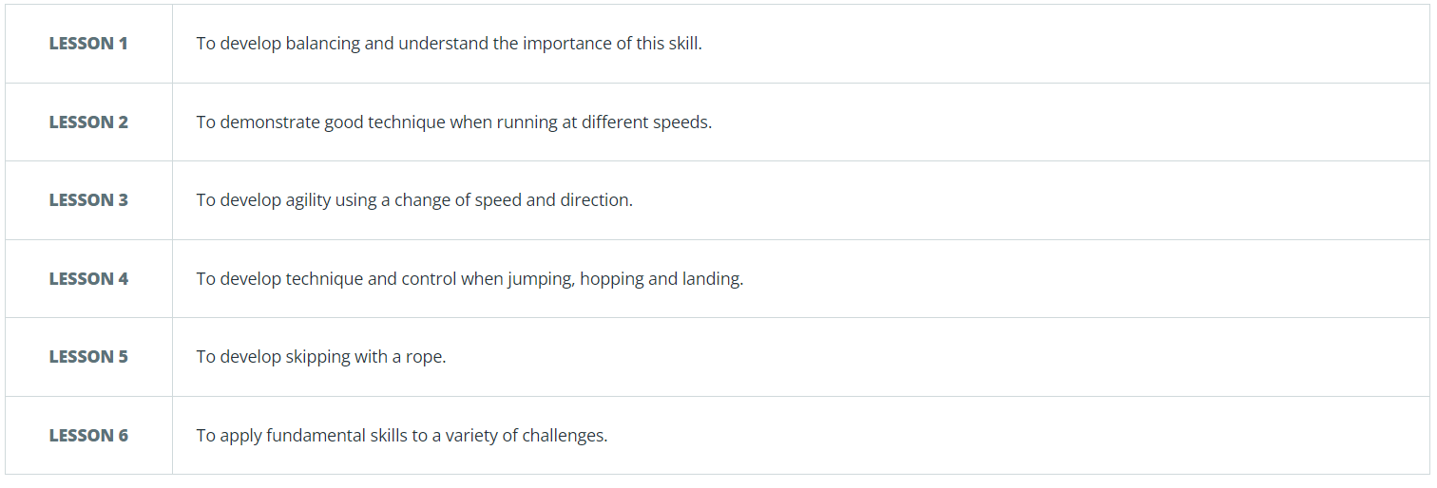
Autumn: Fundamentals
KS1 – Printing S1 – Printing

Autumn: Fitness

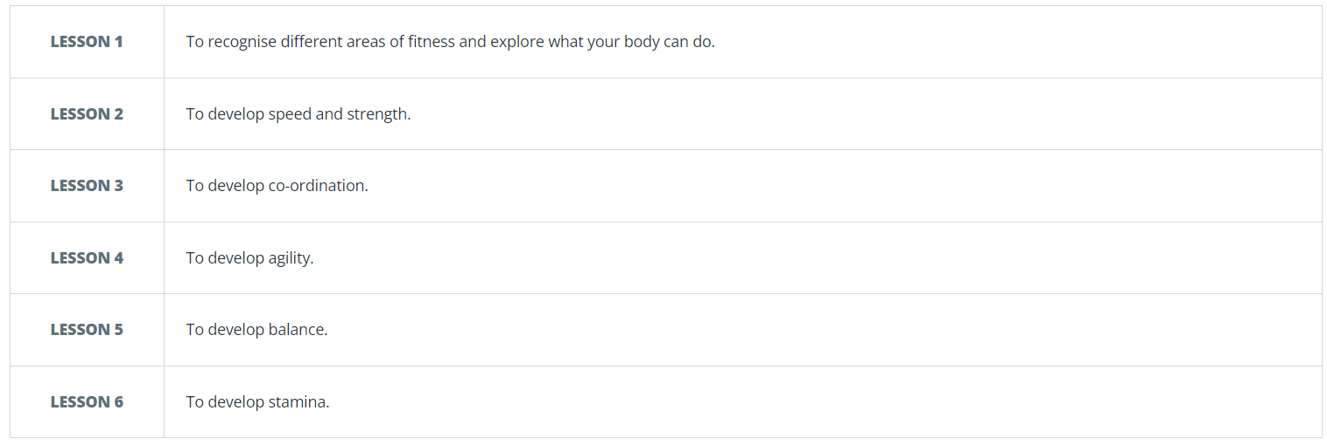

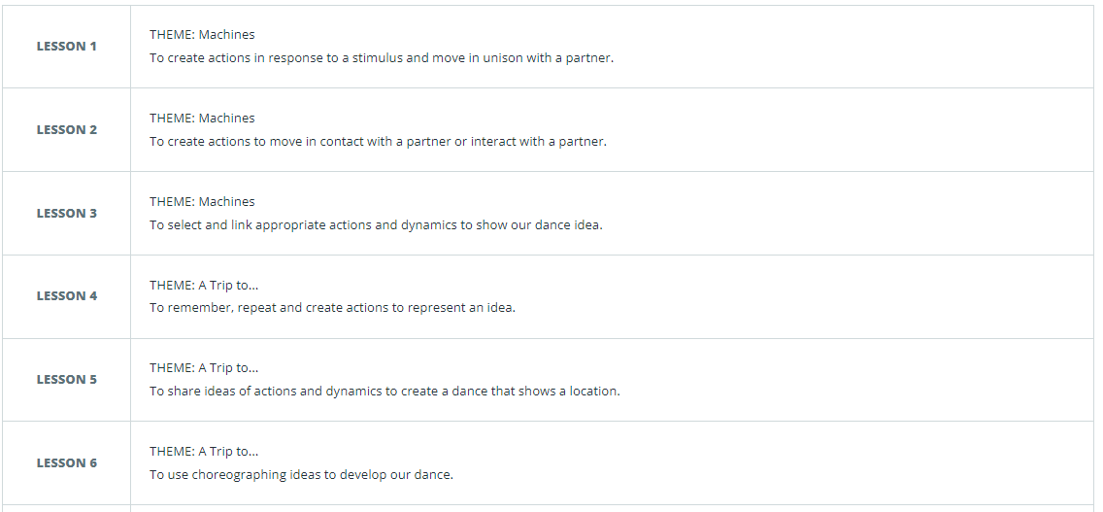
Spring: Dance

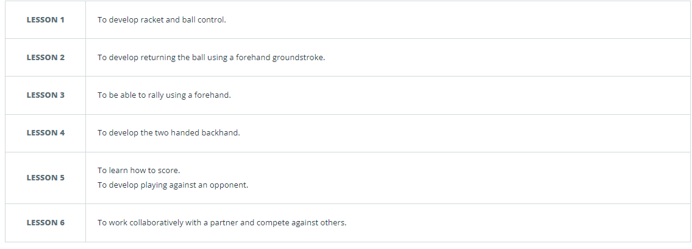
Spring: Tennis
K

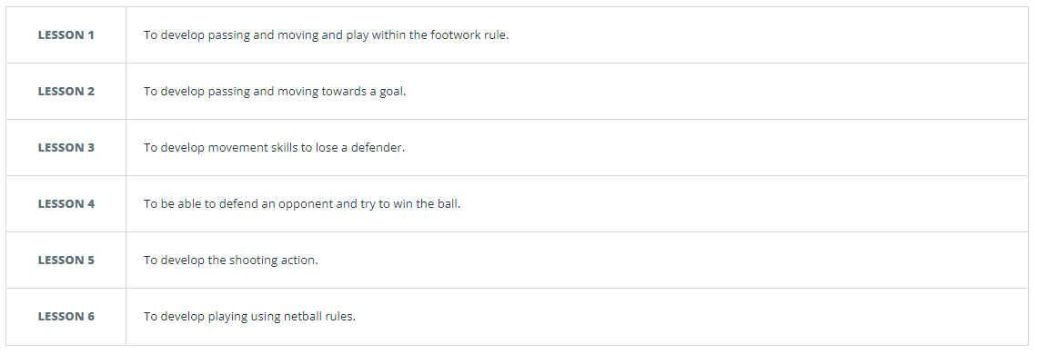
Spring: Netball
KS1 – Printing S1 – Printing

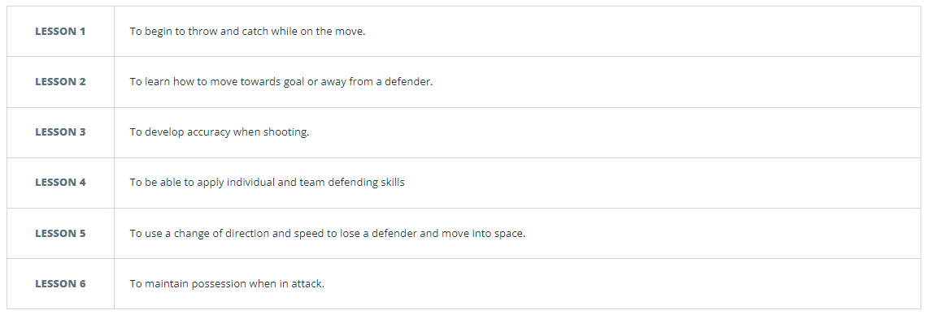
Spring: Handball

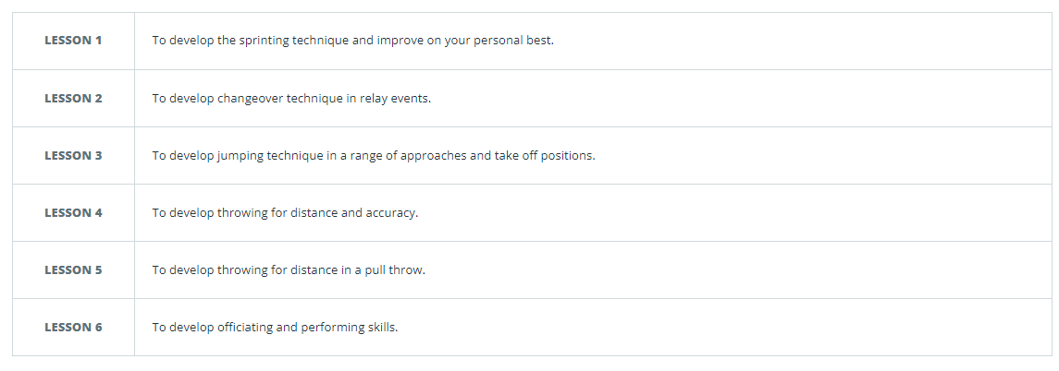
Summer: Athletics

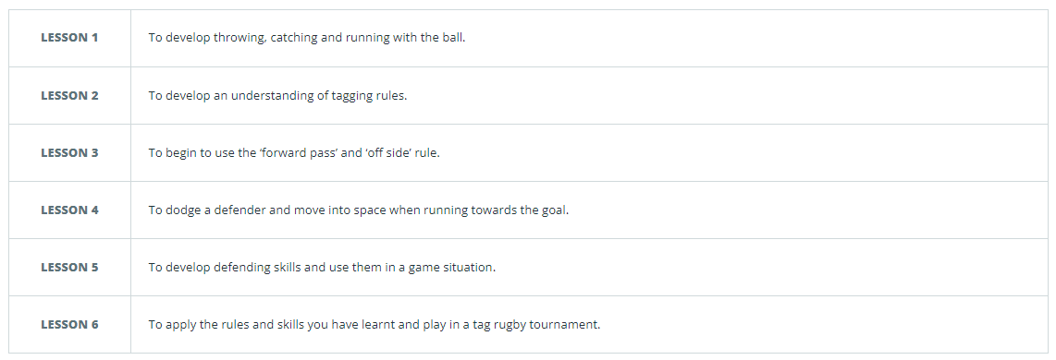
Summer: Tag Rugby

Summer: Rounders
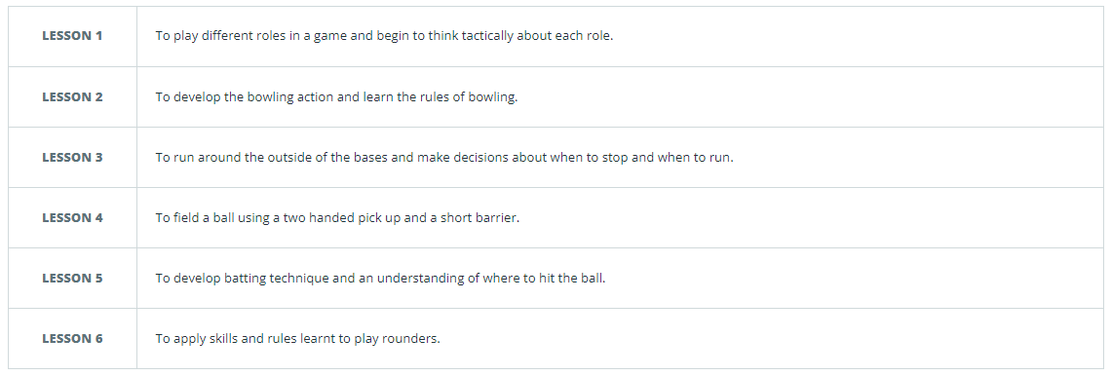

Year 4
Autumn: Gymnastics
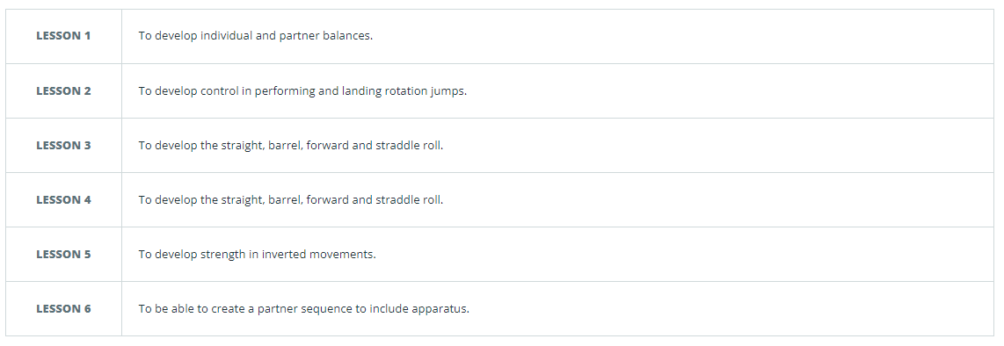
Autumn: Gynastics

Autumn: Ball skills
K

Autumn: Fundamentals
KS1 – Printing S1 – Printing

Autumn: Fitness

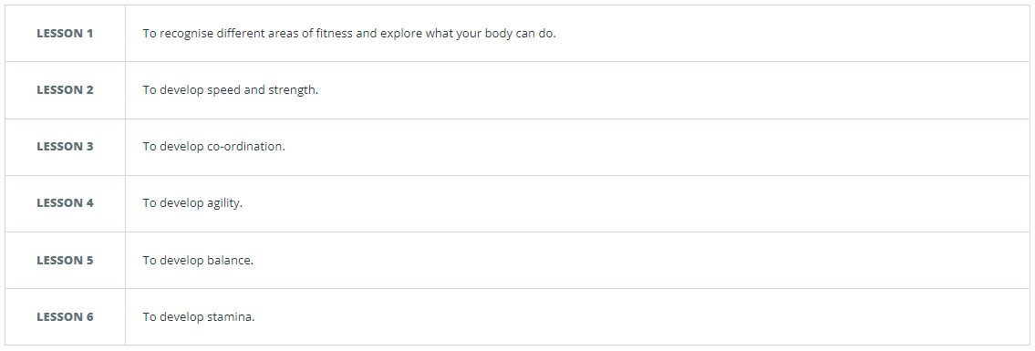

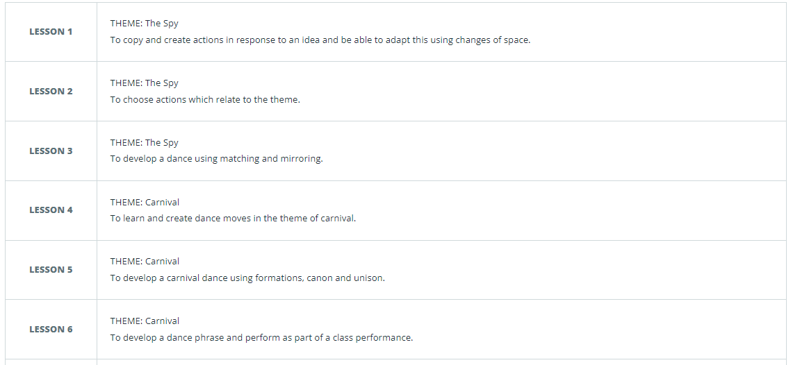
Spring: Dance

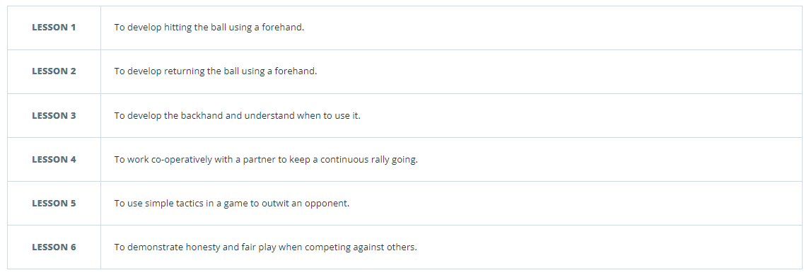
Spring: Tennis
K

Spring: Netball
KS1 – Printing S1 – Printing

Spring: Handball

Summer: Athletics
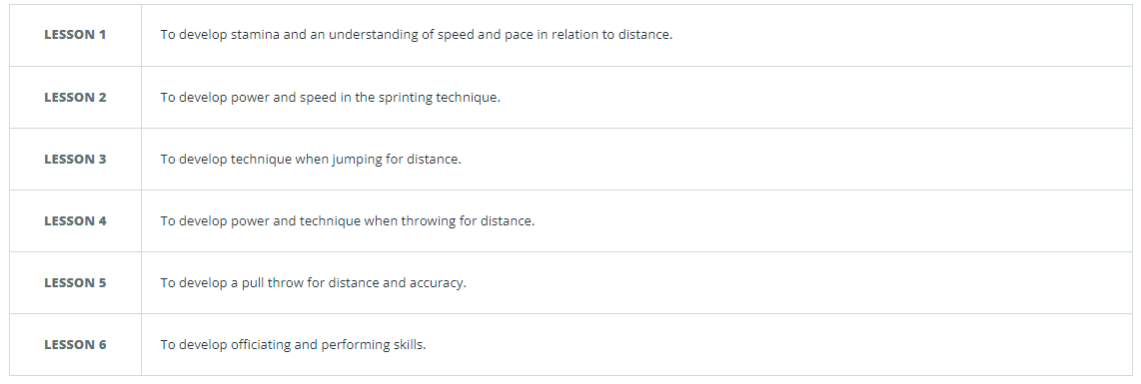

Summer: Tag Rugby

Summer: Rounders

KS1 – Colour Theory, Sketching and Drawing
Year 5
Autumn: Gymnastics
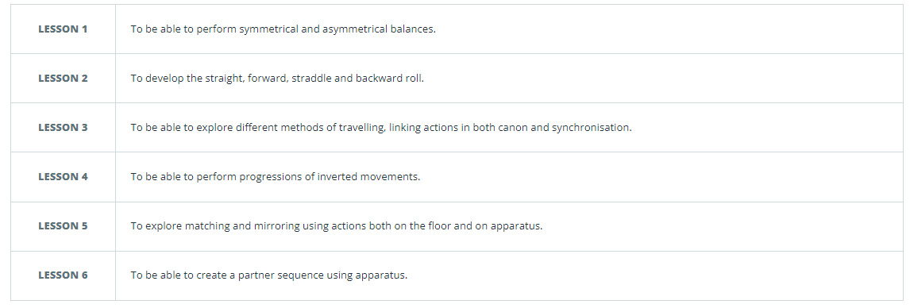
Autumn: Gynastics

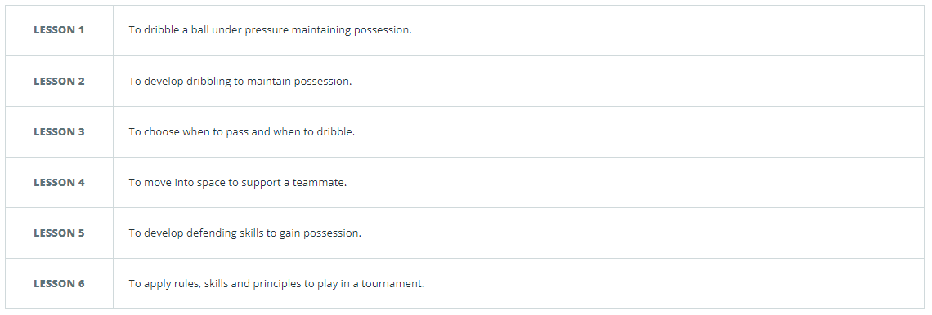
Autumn: Football
K

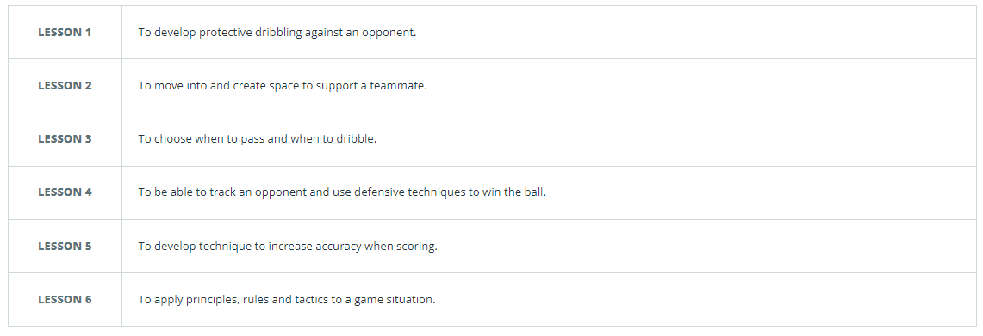
Autumn: Basketball
KS1 – Printing S1 – Printing

Autumn: Yoga

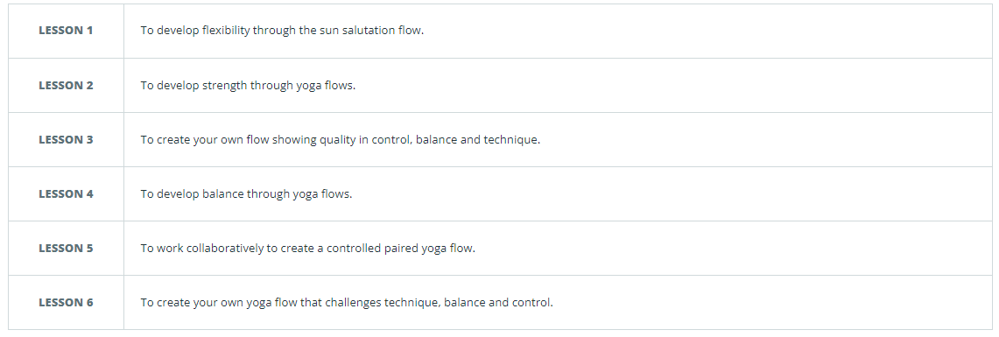

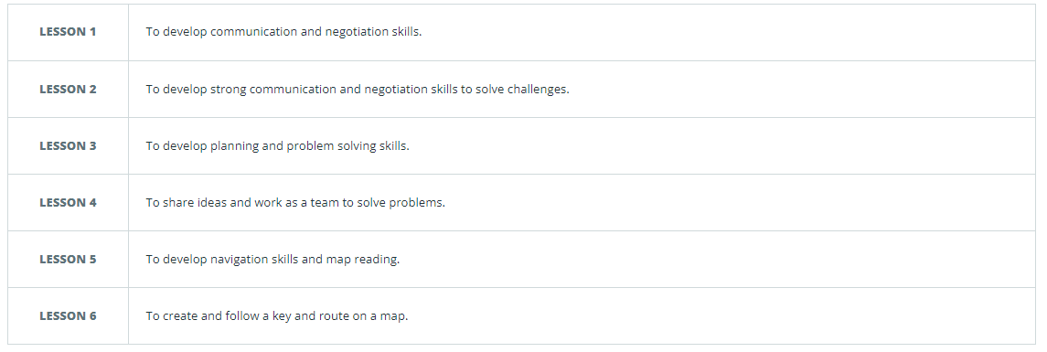
Spring: OAA

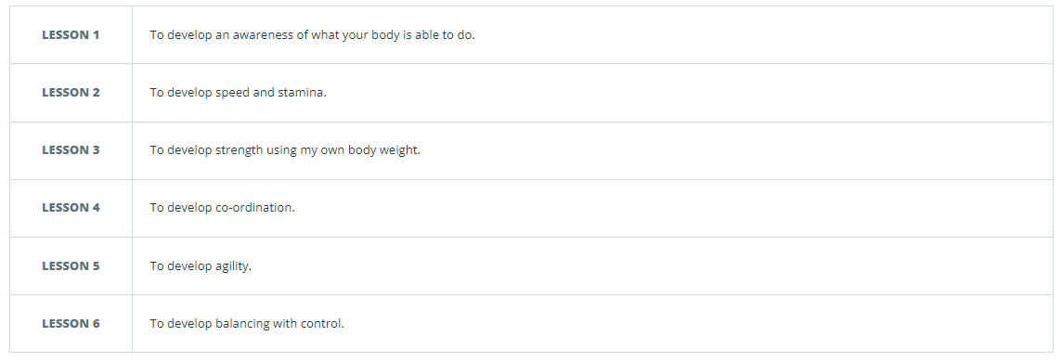
Spring: Fitness
K

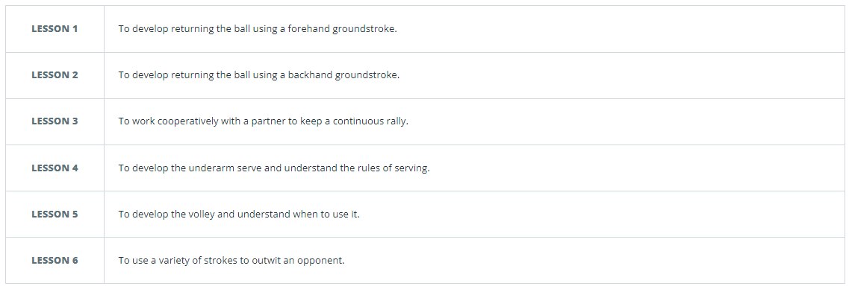
Spring: Tennis
KS1 – Printing S1 – Printing

Spring: Dodgeball
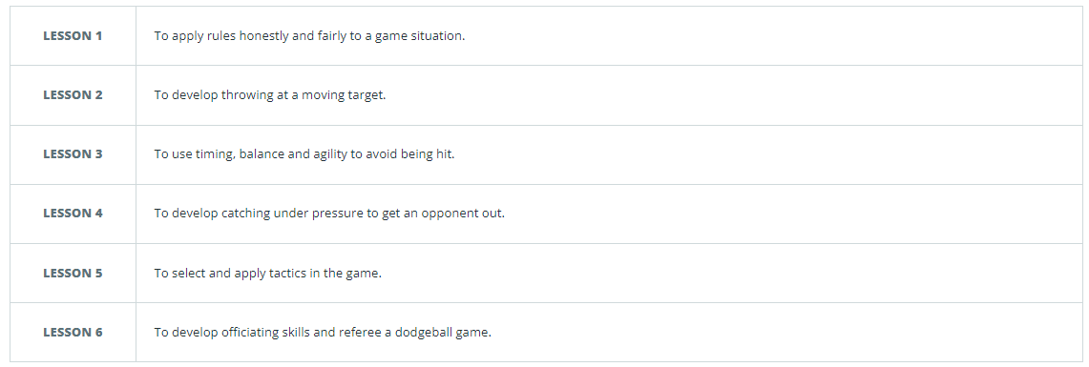

Summer: Dance
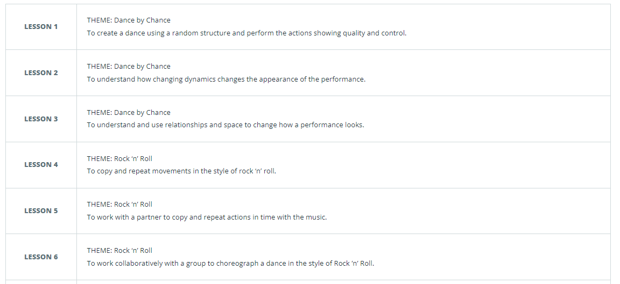

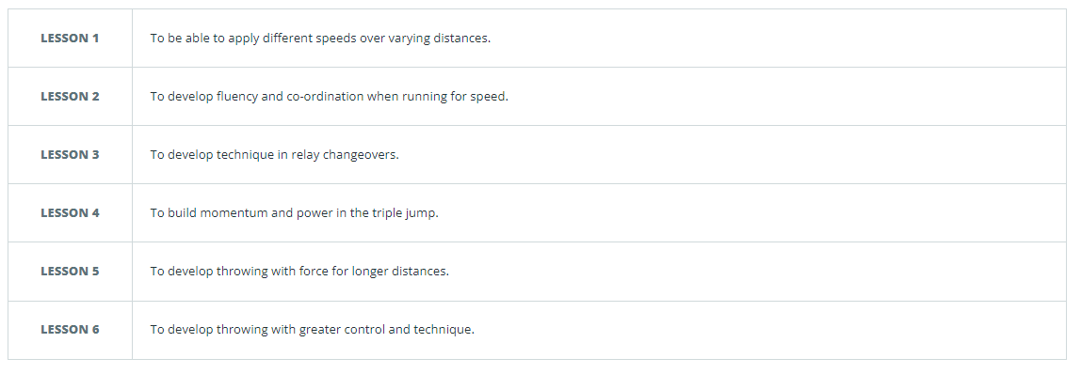
Summer: Athletics

Summer: Cricket
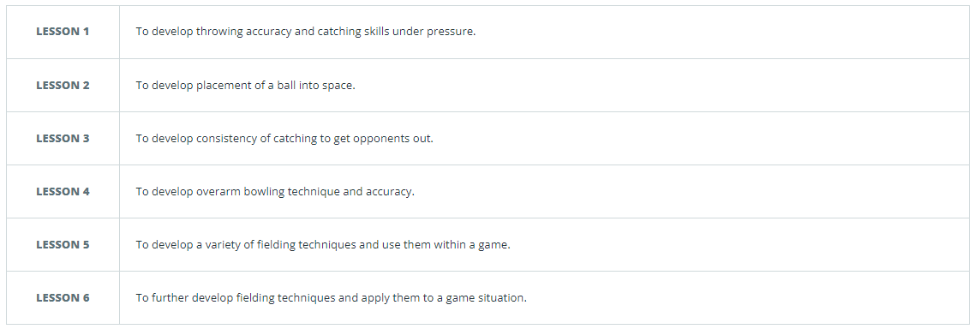

+//
KS1 – Colour Theory, Sketching and Drawing
Year 6
Autumn: Gymnastics
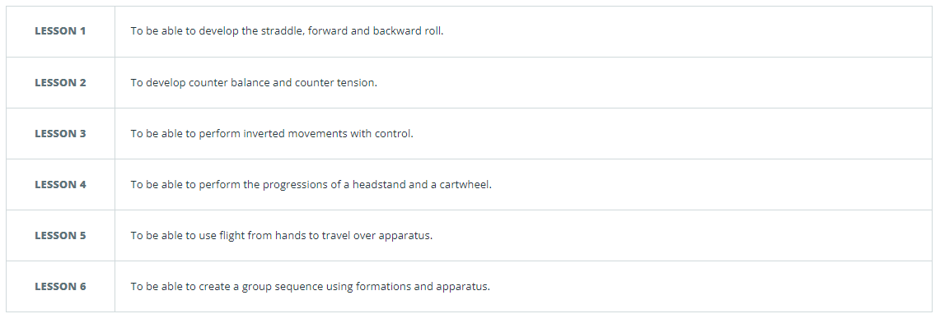
Autumn: Gynastics

Autumn: Football
K

Autumn: Basketball
KS1 – Printing S1 – Printing

Autumn: Yoga

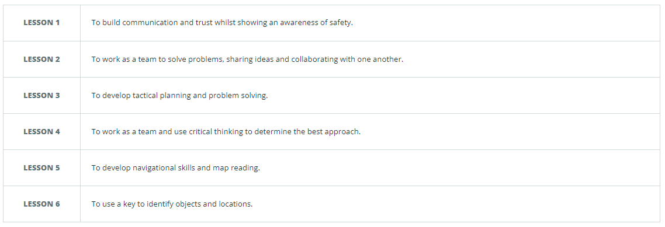
Spring: OAA

Spring: Fitness
K

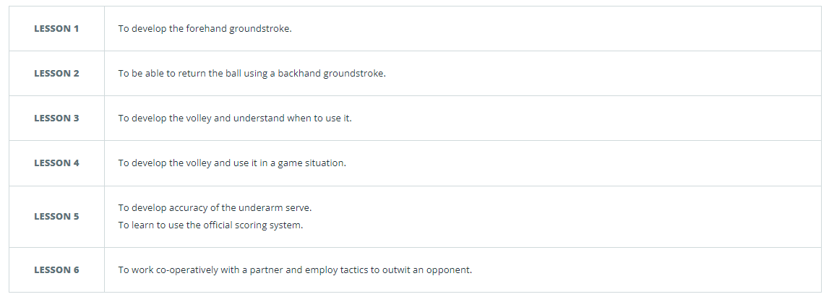
Spring: Tennis
KS1 – Printing S1 – Printing

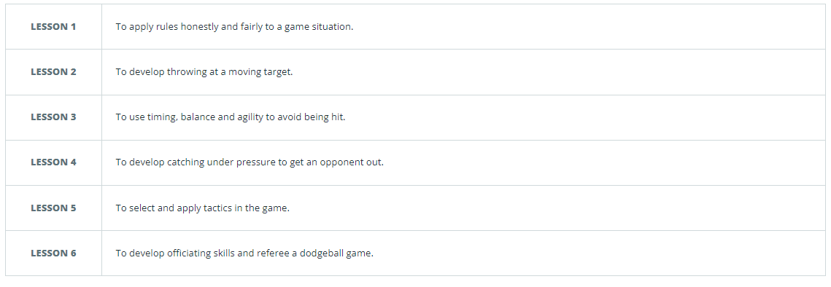
Spring: Dodgeball

Summer: Dance
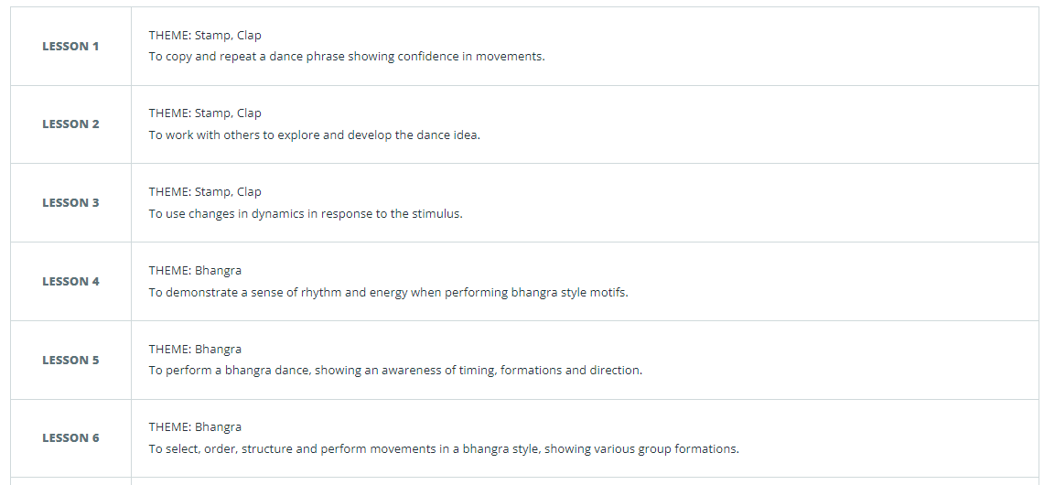

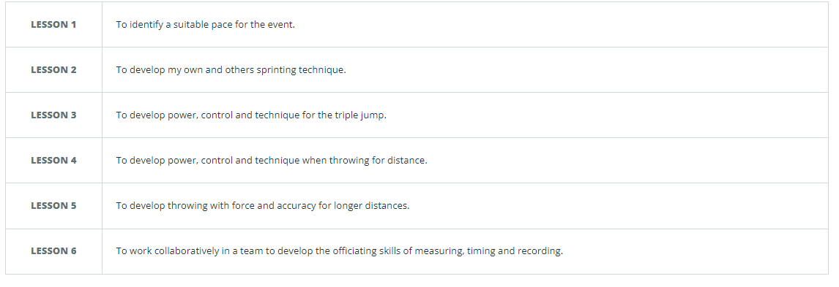
Summer: Athletics

Summer: Cricket

