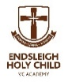

Endsleigh Holy Child VC Academy
Headteacher Mrs. E Barrs
Newsletter 12th December 2025

DATES FOR YOUR DIARY

Year 1 & 2 Nativity Tuesday 16th December
Reception Nativity Wednesday 17th December
Thursday 18th December Christmas Parties – see notice
F1 Parents visiting – 3pm Thursday 18th December
Friday 19th: Christmas Carol Service at St. Anthony’s Church 1.30pm followed by Carols by Candlelight on the playground – all welcome
School Closes for Christmas on Friday 19th December and re-opens on Tuesday 6th January
Spring Half Term – Friday 13th February – Monday 23rd February
Easter Holiday – Friday 27th March – Monday 13th April
May Bank Holiday – Monday 4th May
Summer Half Term – Friday 22nd May – Monday 1st June
Thursday 16th July – Close for the Summer Holiday

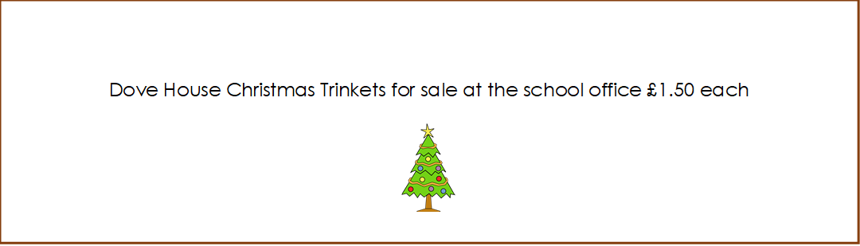

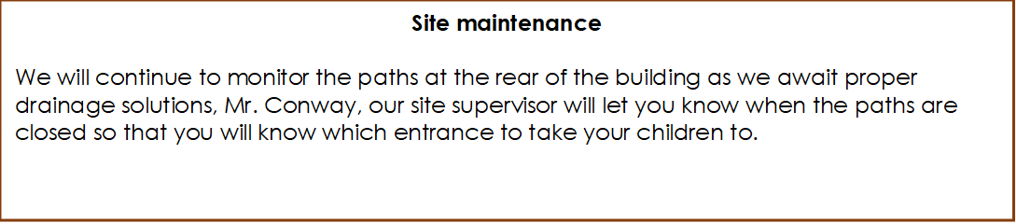
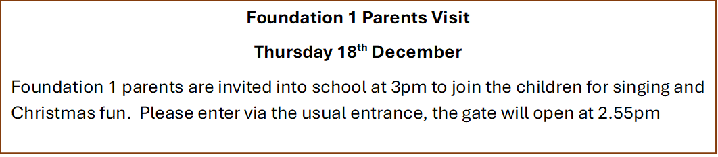

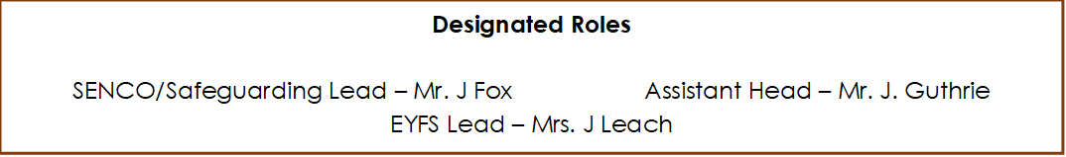
Oliver Twist/visiting theatre
The children thoroughly enjoyed our Theatre visit and the visit from the travelling theatre company, thank you to all parents who have already paid, if your payment is still outstanding please pay as soon as possible so that we can continue to provide these treats for the children
Christmas Party Day
Christmas Parties will take place on the afternoon of Thursday 18th December, children can come to school in their party clothes but please remember that they will be having break times on the playground as usual so clothes and footwear must be suitable. We will provide all the children with a bag of crisps a drink and a bun. If your child has any special dietary requirements could you please contact the office so that we can provide a suitable snack.

