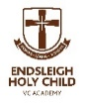

Endsleigh Holy Child VC Academy
Headteacher Mrs. E Barrs
Newsletter 19th December 2025

Dear Parents and Carers,

DATES FOR YOUR DIARY

School re-opens on Tuesday 6th January
Spring Half Term – Friday 13th February – Monday 23rd February
Easter Holiday – Friday 27th March – Monday 13th April
May Bank Holiday – Monday 4th May
Summer Half Term – Friday 22nd May – Monday 1st June
Thursday 16th July – Close for the Summer Holiday

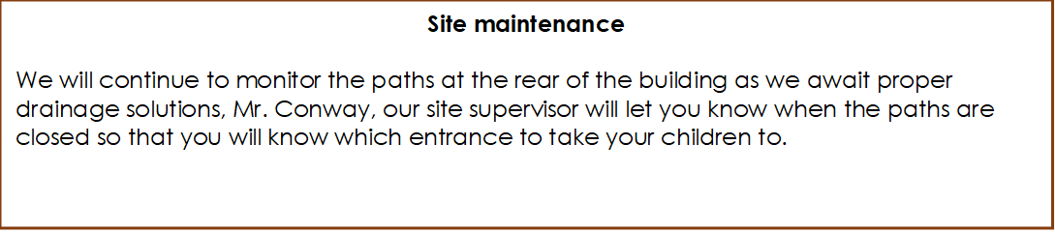



Lunchtime Supervisor

We currently have two vacancies for lunchtime supervisors in school. These will be advertised on the ‘My New Term’ website when we return in January, if you or anyone you know could be interested in these roles please feel free to contact the school office for more details.

