Music Progression at Endsleigh Holy Child
EYFS Expressive Arts and Design (Development Matters)
Exploring Media and Materials
30 – 50 months
To sing a few familiar songs.
To begin to move rhythmically.
To imitate movement in response to music.
To tap out simple repeated rhythms.
To explore and learn how sounds can be changed.
40 – 60 months
To begin to build a repertoire of songs and dances.
To explore the different sounds of instruments.
ELG
To safely use and explore a variety of materials, tools and techniques, experimenting with colour, design, texture, form and function.
Being Imaginative
30 – 50 months
To develop preferences for forms of expression.
To notice what adults do, imitating what is observed and then doing it spontaneously when the adult is not there.
To sing to self and makes up simple songs.
To make up rhythms.
To capture experiences and responses with a range of media, such as music, dance and paint and other materials or words.
40 – 60 months
To create simple representations of events, people and objects.
To initiate new combinations of movement and gesture in order to express and respond to feelings, ideas and experiences.
To play cooperatively as part of a group to develop and act out a narrative
ELG
To use what they have learnt about media and materials in original ways, thinking about uses and purposes. They represent their own ideas, thoughts and feelings through design and technology, art, music, dance, role play and stories.

Key Stage 1 (Year 1 and 2)
National Curriculum Objectives
To perform:
Use their voices expressively and creatively by singing songs and speaking chants and rhymes
Play tuned and untuned instruments musically
To Compose:
Experiment with, create, select and combine sounds using the inter-related dimensions of music
To Transcribe:
Select and combine sounds
To Describe:
Listen with concentration and understanding to a range of high-quality live and recorded music

Key Stage 2 (Year 3, 4, 5 & 6))
National Curriculum Objectives
To perform:
Play and perform in solo and ensemble contexts, using their voices and playing musical instruments with increasing accuracy, fluency, control and expression
Listen with attention to detail and recall sounds with increasing aural memory
To Compose:
Improvise and compose music for a range of purposes using the inter-related dimensions of music
To Transcribe:
Use and understand staff and other musical notations
To Describe:
Appreciate and understand a wide range of high-quality live and recorded music drawn from different traditions and from great composers and musicians
Develop an understanding of the history of music

At Endsleigh Holy Child, we follow the Charanga music scheme from Foundation - Y4 and Music Express in Y5-6 (taught by SMC staff) to ensure progression.

Foundation
Autumn 1 | Autumn 2 | Spring 1 | Spring 2 | Summer 1 | Summer 2
Me! | My Stories | Everyone | Our World | Big Bear Funk | Reflect, Rewind and Replay

Y1-2
Cycle B Charanga Y2
Sept 2020-July 2021 Sept 2022-July 2023
Autumn 1 | Autumn 2 | Spring 1 | Spring 2 | Summer 1 | Summer 2
Hands, Feet, Heart | Little Angel Gets Her Wings | Glockenspiel Stage 1 | I wanna play in a band | Zootime | Reflect, Rewind and Replay

Cycle A Charanga Y1
Sept 2021-July 2022 Sept 2023-July 2024
Autumn 1 | Autumn 2 | Spring 1 | Spring 2 | Summer 1 | Summer 2
Hey You | Little Angel Gets Her Wings | In the Groove | Rhythm in the Way We Walk and Banana Rap | Round and Round | Reflect, Rewind and Replay

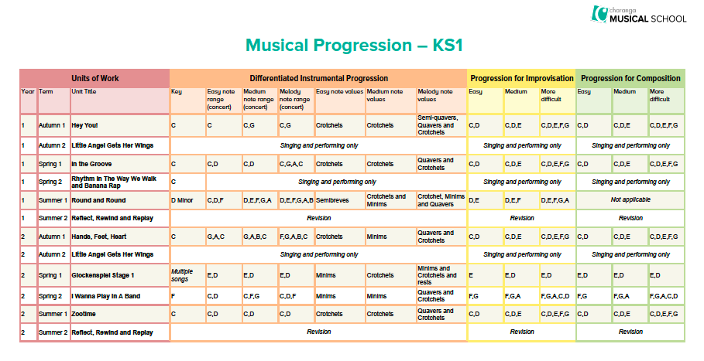
Y3-4
Cycle B Y3 Charanga Sept 2020-July 2021 Sept 2022-July 2023
Autumn 1 | Autumn 2 | Spring 1 | Spring 2 | Summer 1 (Y4) | Summer 2
Three Little Birds | Ho Ho Ho | Glockenspiel Stage 2 | Let your spirit fly | Glockenspiel Stage 3 | Reflect, Rewind and Replay

Cycle A Y4 Charanga Sept 2021-July 2022 Sept 2023-July 2024
Autumn 1 | Autumn 2 | Spring 1 (Y3) | Spring 2 | Summer 1 | Summer 2
Mamma Mia | Five Gold Rings | Benjamin Britten –  there was a monkey | Benjamin Britten – Cuckoo | Lean on Me | Reflect, Rewind and Replay

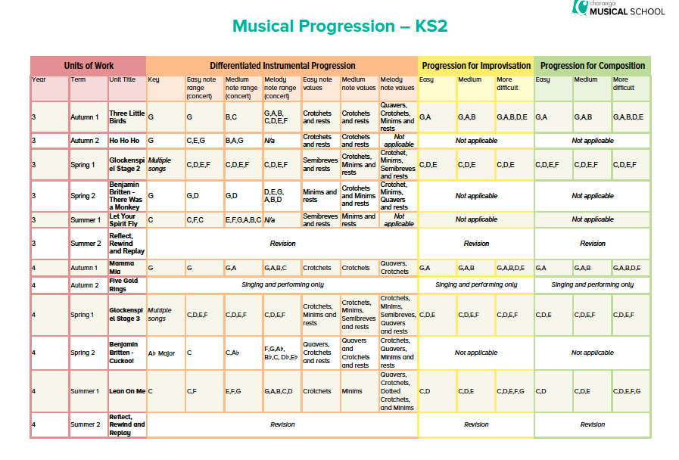
Sept 2021-22 NO SMC teaching
Y5
Music Express
Autumn 1 | Autumn 2 | Spring 1 | Spring 2 | Summer 1 | Summer 2
Our Community | Solar System | Solar System | Life Cycles | Keeping Healthy | At the Movies

Y6
Music Express
Autumn 1 | Autumn 2 | Spring 1 | Spring 2 | Summer 1 | Summer 2
World Unite | Growth | Roots | Roots/  Class Awards | Class Awards/ Journeys | Moving On

