KS1
Mechanisms (sliders and levers)  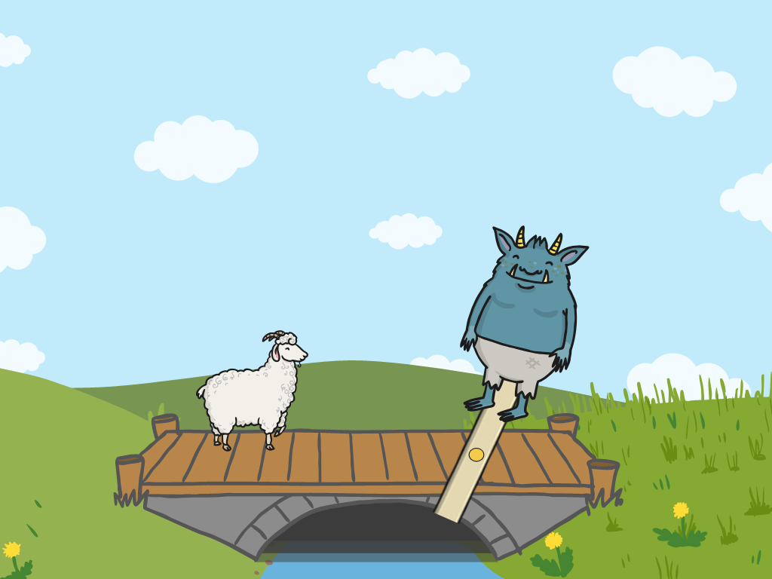  Moving pictures | 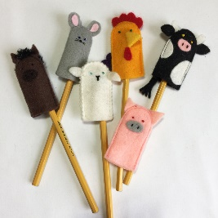  Textiles (joining with glue)  Finger puppets | Cooking and Nutrition  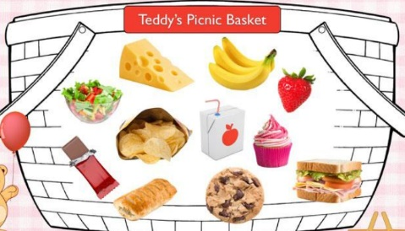  Teddy bear’s picnic
LKS2
Structures  Photoframes | Mechanisms  Pneumatic toys  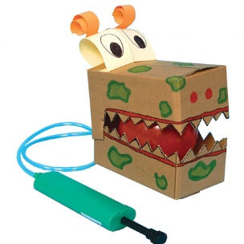 | Textiles  Recycled materials  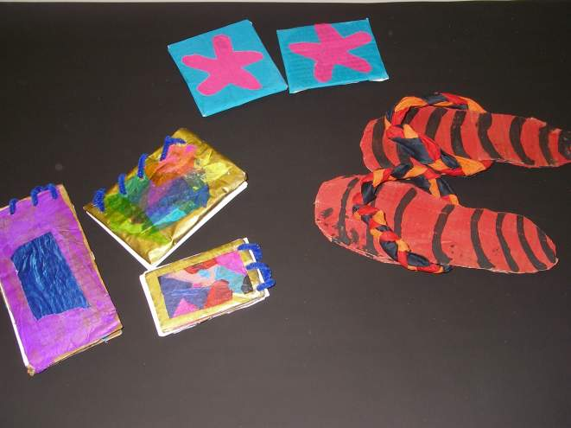
UKS2
Structures  Bridges | 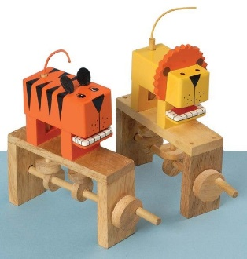  Mechanisms  Automata toys (cams) | Textiles (cross- stitching and sewing)  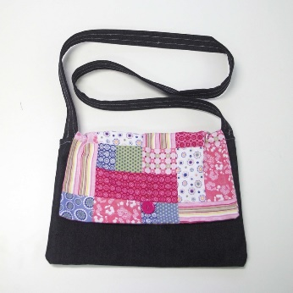  Upcycling – fashion bags

